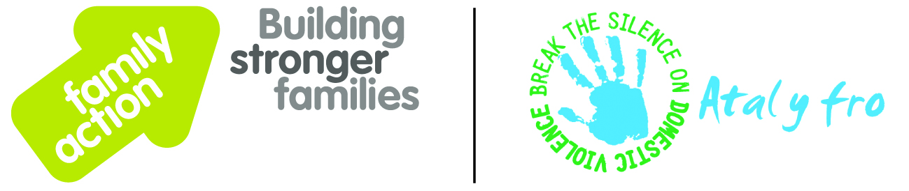

Date: 07 October 2016
New joint service launched to support families across Wales
The charities Atal Y Fro and Family Action announce the launch of a new joint service, the Families Together Project. The service, which is funded by the Welsh Government, will help families across Wales who are in need of support.
This new service will offer integrated and holistic family support for families and children facing multiple and complex needs in three key areas. These include wrap-around family support providing an individually tailored package of support which builds on the strengths of the family together; secondly, advice and help for families affected by domestic violence and abuse (DVA); and thirdly, practical and emotional help for parents who have or are at risk of developing perinatal depression, through volunteer-led peer support.

Minister for Social Services and Public Health, Rebecca Evans, said
“I am very pleased the Welsh Government has been able to award Families Together £1.5 million. The project will provide families with a wide range of tailor-made services, such as support for those who have experienced domestic abuse or perinatal mental health problems. Through working with the whole family unit, the project is improving relationships and helping children and parents overcome complex challenges together.”
Jane Hutt, AM (Vale of Glamorgan), National Assembly for Wales, said
“This important project is being delivered in partnership by Family Action and Atal-Y-Fro. Having helped to set up Women’s Aid refuges in Wales I know there is still so much more we can learn about intervening early to prevent domestic abuse and particularly support children and families. I praise Atal y Fro and Family Action for their dedicated commitment to their work to make the Vale a safer place- especially for women and children.”
Kay Quinn, Director at Atal Y Fro said

“The launch of the Families Together project is an exciting start to a great relationship between Family Action and Atal Y Fro. This offers us the opportunity to provide a tailored, needs-led package to those in need across Wales”
David Holmes CBE, Chief Executive of Family Action added
“Family Action is delighted to be working in Wales with such a respected organisation as Atal Y Fro. Through our partnership and the new Families Together project we hope to make a profound difference to many families in Wales. We are particularly grateful to the Welsh Government for providing funding for three years for this important new project.”
For further information please email familiestogether@family-action.org.uk or call 02902 789732.
- End -

