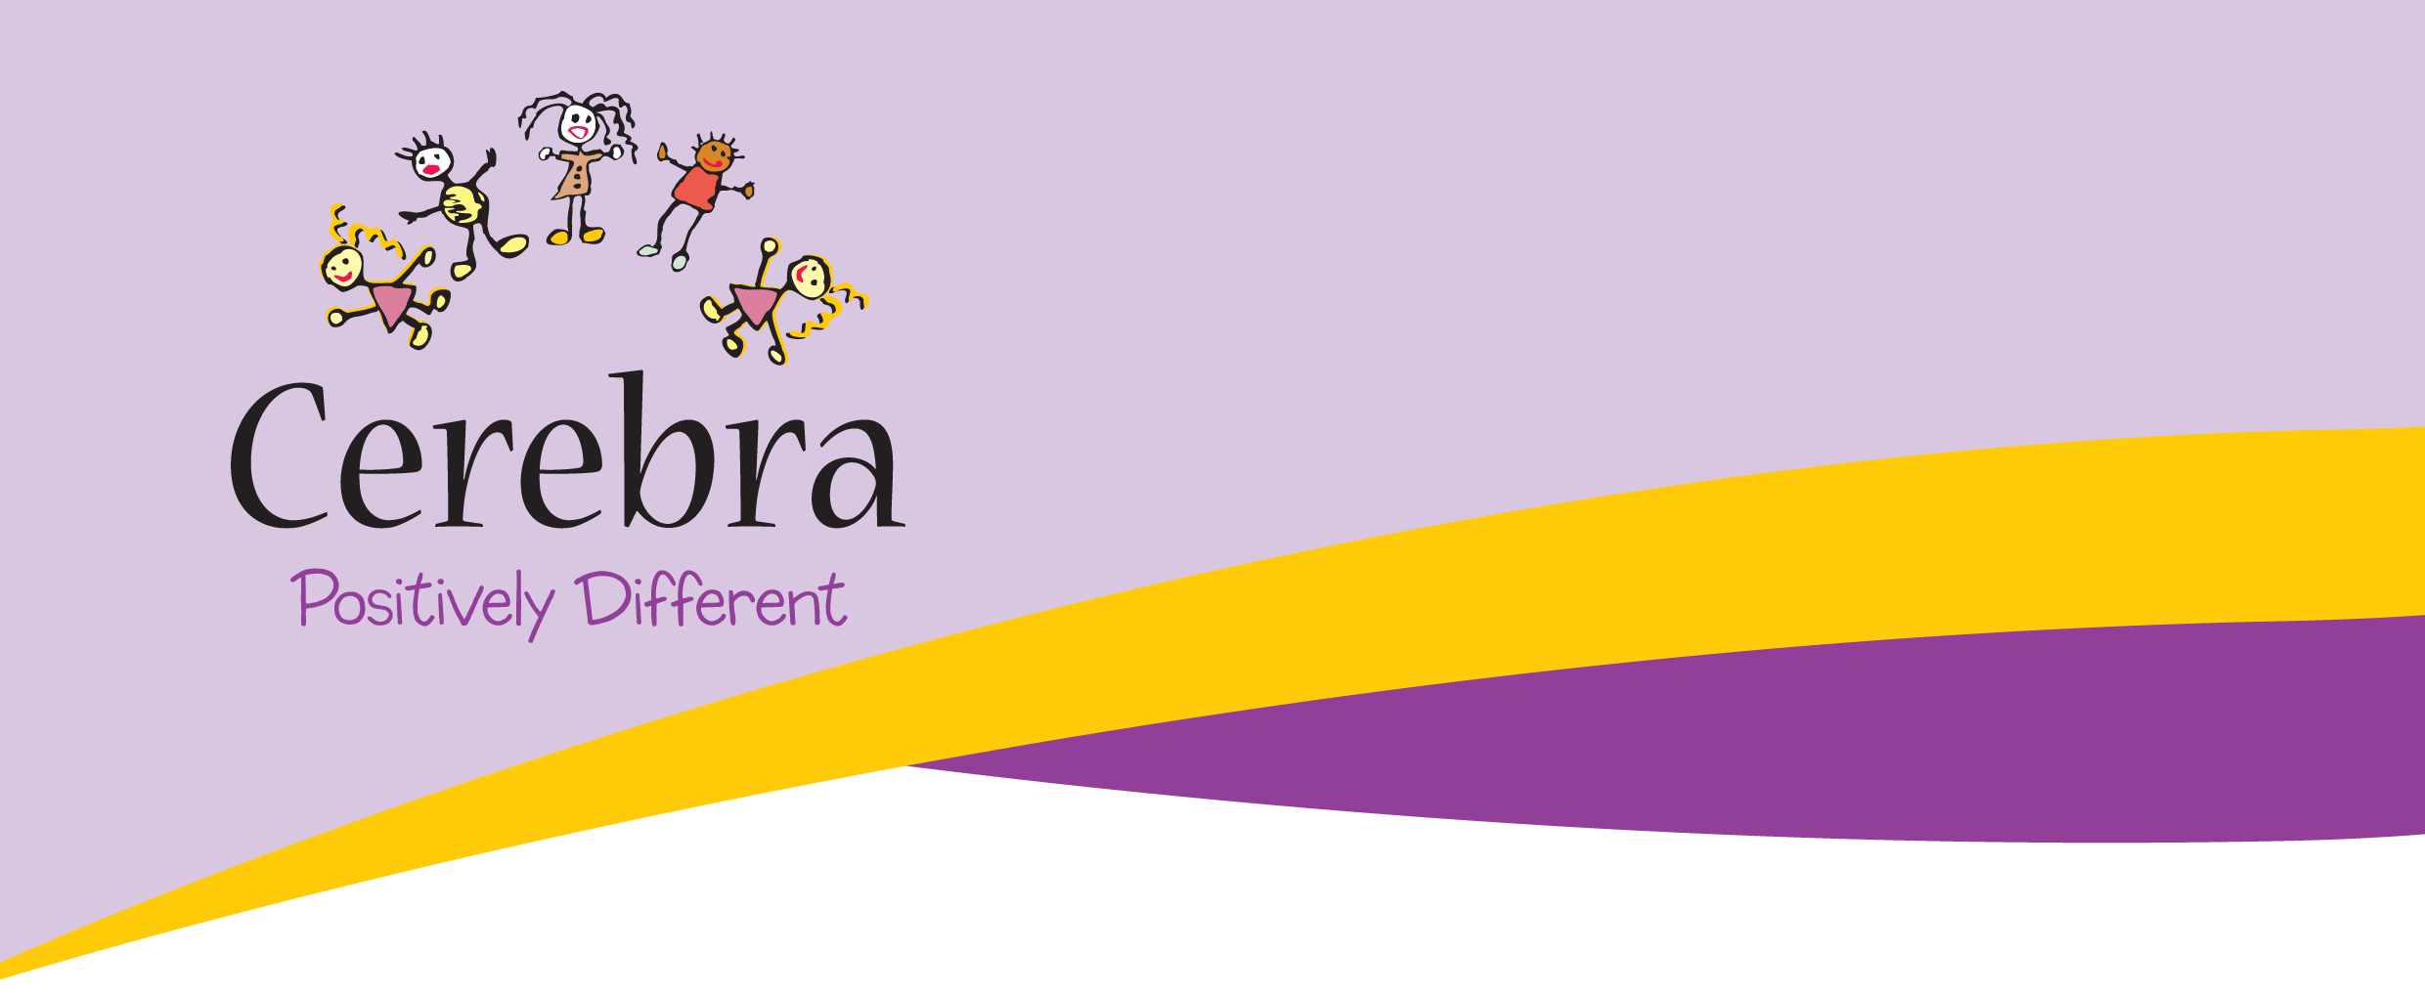

**Cerebra Family Forum Coventry**

**TEENAGE SLEEP**

**Are you the parent or carer of a child aged 13-16 years who has a neurological condition (e.g. autism, ADHD, Down syndrome, cerebral palsy) or acquired brain injury? Are you experiencing sleep deprivation?**

**A forum to help young people, parents and carers gain a basic awareness of teenage sleep and good sleep practice.**

**After the forum another session or 1:1 session can be offered at the sleep clinic in November. For parents and carers who are interested in following a personalised sleep plan for their child.**

 When: **Friday October 17th**

**C:\Program Files (x86)\Microsoft Office\MEDIA\CAGCAT10\j0234131.wmf** Time: **10.15 registration- Start at 10.30 finish 12.30**

**C:\Users\charlotteh\AppData\Local\Microsoft\Windows\Temporary Internet Files\Content.IE5\NP3LZ3BI\MC900237192[1].wmf** Where: **Tesco Community Space, Ricoh Arena, Coventry, CV6 6GE**

**Spaces are limited. If you would like to book a place contact Cerebra Regional Officer Charlotte Hobbs at** [**CharlotteH@cerebra.org**](mailto:CharlotteH@cerebra.org)**.uk**

# IIP-(white).pngOrganisational Member Logo png.pngAQS_logo-trans.png

Registered charity no. 1089812

Company no. 4336208

www.cerebra.org.uk

sleep@cerebra.org.uk

01267 244200