

**Lego Club**

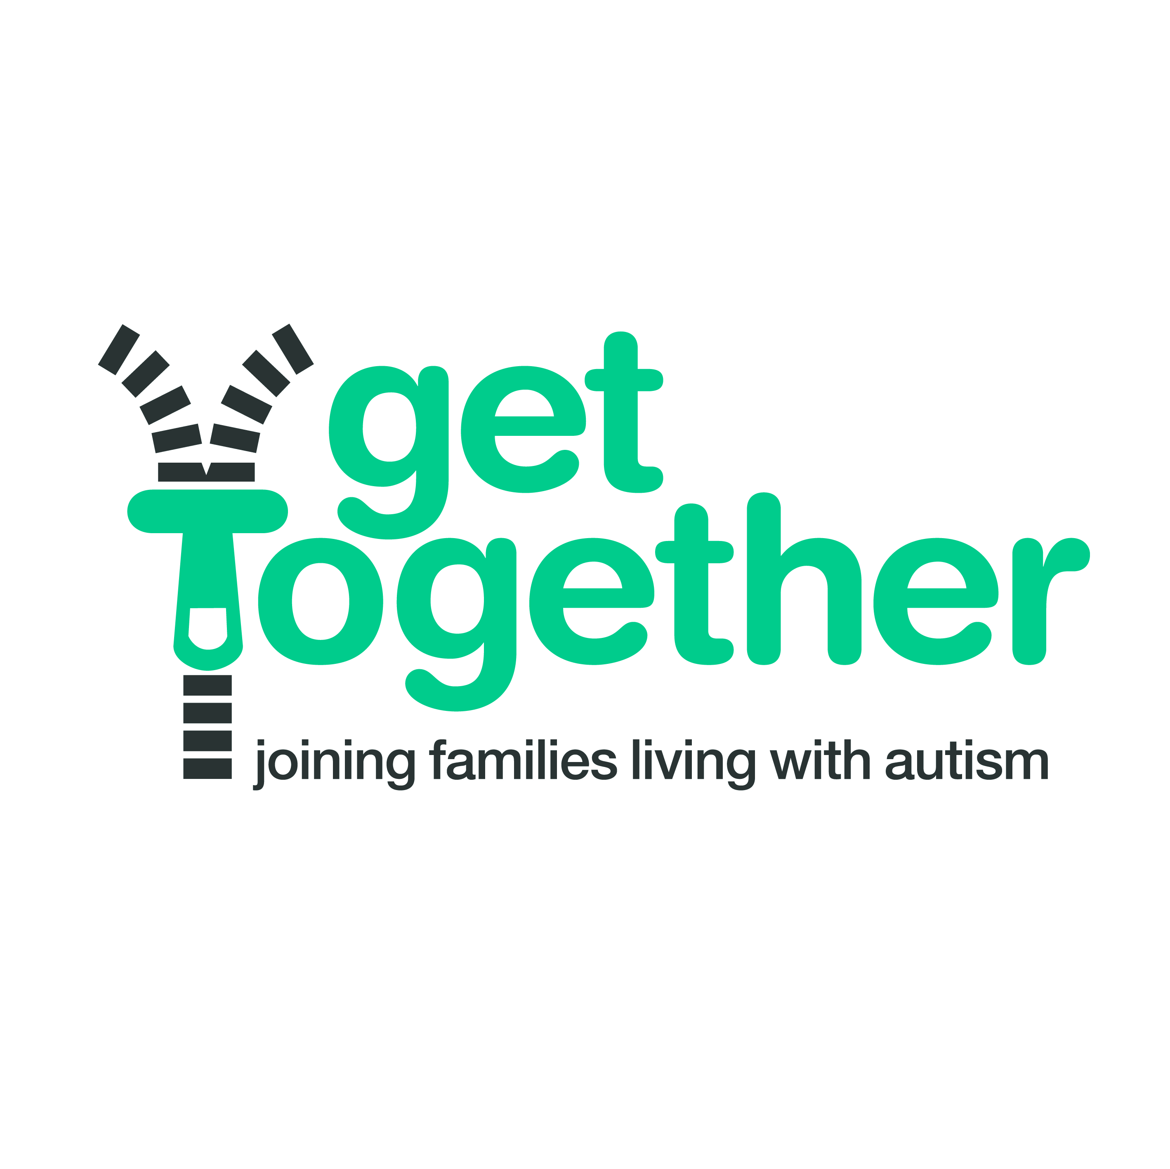

Registered Charity Number: 1154844

**Every Monday**

**(except bank holidays & school holidays)**

**Longford Baptist Church, Oban Road, Coventry**

**5pm -6.30pm**

**Admission: £2 per child**

**Come along and build with Lego.**

**An opportunity for children to socialise and make friends.**

**Bring your own Lego or build something from our selection.**

**We also have plenty of free build Lego and some building bricks for younger children**

**Children must be accompanied by an adult.**

**(This is an open club and can be joined by all children not just those with a diagnosis of autism)**

**Contact Kelly on 07943 556329**

**For dates**