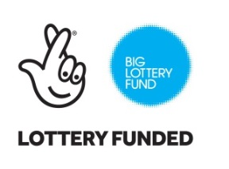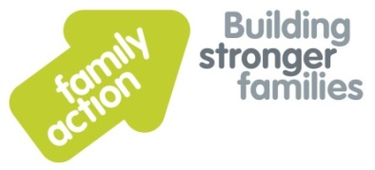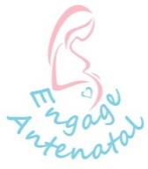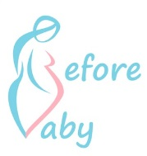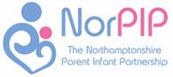

**Date: Tuesday 11 October**

**Lottery win for local mums, dads and babies**

It was announced this week that a new specialised programme to support new parents and their babies in Northampton and Daventry is to be launched thanks to an award of nearly £500,000 from the Big Lottery Fund.

The programme, ‘Flourishing Babies’, will be run in partnership by local family therapy charity NorPIP; family support charity, Family Action and Before Baby which is  run by social enterprise Engage Antenatal C.I.C.and aims to generate better outcomes for 300 vulnerable babies and families across the area over the next three years.

Being a parent should be a happy time, but the reality is that around 40% of parents struggle to form a loving bond with their child.  Sometimes this is because their childhood experiences can come flooding back and cause symptoms similar to post traumatic stress, like withdrawal from the world, not feeling like you love your baby or feeling like the baby doesn’t belong to you.  ‘Flourishing Babies’ will aid families to recover from these common issues and a key message to all parents is you’re not alone, and you can get help to feel better again.

The programme will offer a free antenatal programme for new parents across Northampton and Daventry, targeting new mums and dads who might need a bit of extra support with the emotional transition to parenting as a result of mental health issues or other complicated risk factors.  Parents experiencing postnatal depression often feel isolated, so the programme will also offer a perinatal peer support home visiting service where volunteer befrienders will provide families with support and advice. Additionally, intensive therapeutic support will be provided to parents when they are finding it difficult to bond with their babies or are finding parenting particularly tough.

NorPIP’s Executive Director, Anna Day said

*“We are tremendously grateful to the Big Lottery Fund for their award under the Reaching Communities grant stream.  We are delighted to be able to increase our scope to support vulnerable families and are very committed to helping parents and children get the most out of their lives together from the outset. We are delighted that the Big Lottery Fund has been able to share this vision with us”.*

Lucy Dolly, Director at Engage Antenatal C.I.C. and Before Baby programme lead said

*“We are very excited and thankful to the Big Lottery for providing us with the opportunity to educate and support pregnant vulnerable families alongside NorPIP and Family Action.”*

Julie Smith, National Perinatal Lead at Family Action added

*“The first 1001 days of a baby’s life is a critical time for his or her development and we are very grateful to the Big Lottery for funding this important programme. It will enable us to help families at this crucial time and give parents and their babies the support they need to flourish and thrive.  This will include peer support through our positively evaluated volunteer befrienders’ model. We are very much looking forward to working with our partners to help ensure parents and their babies get the best start possible to their new lives as a family “*

Being a parent isn’t always easy, and sometimes parents can go through a range of involuntary emotions about their babies. Many parents feel like it’s taboo to admit they are finding it hard to care for their babies, but we want them to know that not only is help at hand, but the help is the right support for them to stop feeling like this. This new service will help a hundred families a year with that specialist support to get their families off to the best start possible.

Parents to be or those with a child up to the age of two can self-refer to the programme by visiting [www.norpip.org.uk](http://www.norpip.org.uk) or by calling 01604 924735.

-   Ends  -