Embargoed until: 0001 hrs 15 October 2014

CHILD POVERTY FIGURES SHOW BIG VARIATIONS ACROSS UK AND WITHIN LOCAL AUTHORITIES

The Campaign to End Child Poverty has today published new figures that provide a child poverty map of the whole of the UK. The figures are broken down by parliamentary constituency, local authority and ward.

The figures reveal the wide disparity in poverty rates across the UK, between regions and striking variations even within regions. London scores badly - containing ten of the top 20 constituencies with the highest child poverty rates in the UK and 14 of the 20 highest-rate local authorities. However there is variation within regions. For example, in London, Bethnal Green and Bow has a child poverty rate of 49% compared to 15% in Richmond upon Thames.

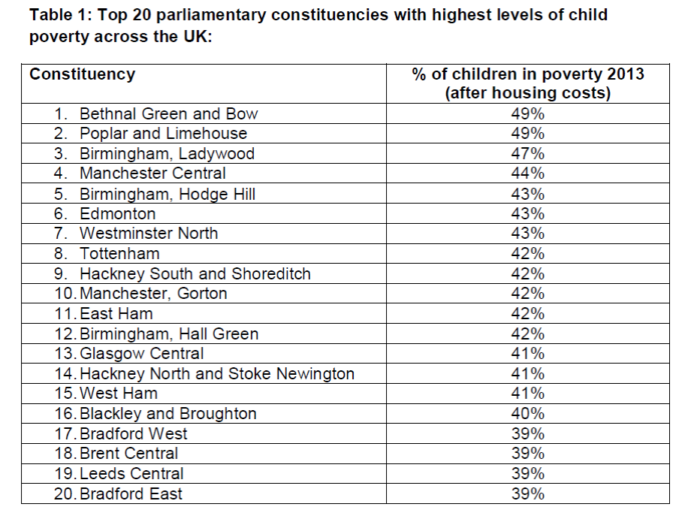
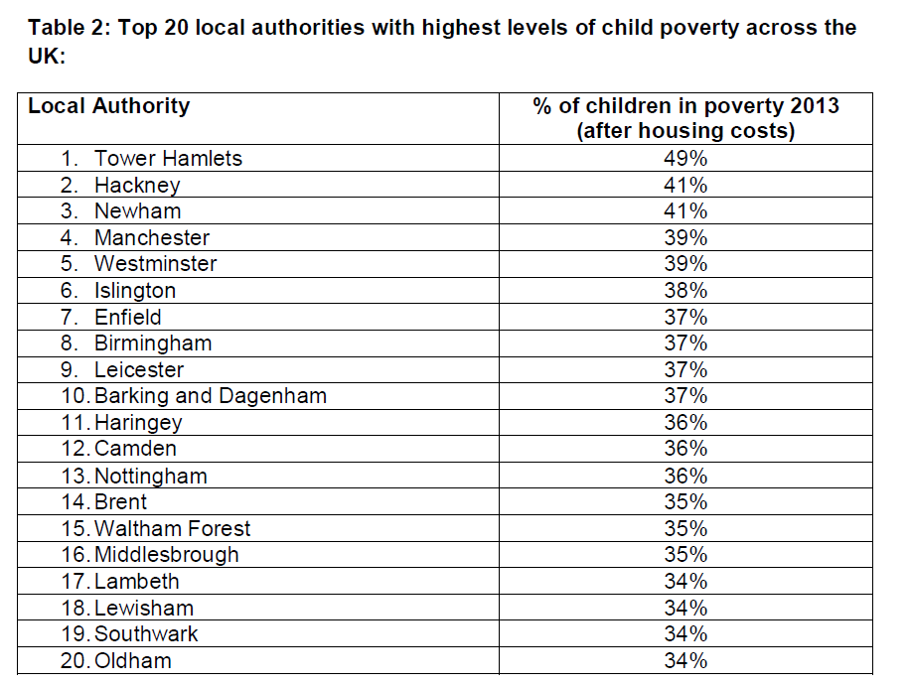
In the local authority with the worst child poverty rate – Tower Hamlets - the proportion of children in poverty is almost half (49%). Wokingham and Shetland Islands are the local authorities with the lowest rates (10%).

At a more local level, the map reveals more significant concentrations of child poverty: in 16 local wards, the majority of children are poor.

In 87 constituencies, the estimated child poverty level on the Government’s before housing costs measure is below 10%, the target set for 2020 in the Child Poverty Act. But in many of these better-off areas, housing costs are high. On an after housing costs measure, only two constituencies have rates below 10% - Sheffield Hallam and West Aberdeenshire and Kincardin

Chair of End Child Poverty David Holmes said:
“These figures reveal just how widely and deeply child poverty reaches into our communities, even those areas generally regarded as well off. Far too many children whose parents are struggling to make a living are suffering as a result and missing out on the essentials of a decent childhood that all young people should be entitled to. We can and must do better for our children.

“Poverty ruins childhoods and reduces life chances. Failing to invest properly in children is a false economy: already child poverty costs the country £29bn each year and in the long run taxpayers will foot an even higher bill for correcting the damage.

“We are calling on politicians of all parties to urgently set out a clear roadmap towards ending child poverty which includes the additional actions needed and the measures by which progress will be tracked."

ENDS
Notes to editors:

(1) In January 2014, the Institute for Fiscal Studies published projections showing that under current policies child poverty will rise from 2.3m (2011-12) to 3.2m by 2020 on the statutory Before Housing Costs measure. The Government says it is on course to end child poverty by 2020. On the After Housing Costs measure, the IFS projected child poverty would increase from 3.5m (2011-12) to 4.6m by 2020. IFS predictions for child and working-age poverty from 2010 to 2020 can be found here http://www.ifs.org.uk/bns/bn144.pdf

(2) Polling by You Gov last year uncovered strong public concern about poverty across the political spectrum http://www.endchildpoverty.org.uk/news/news/new-poll-shows-public-believe-government-action-on-child-poverty-falling-short-/23/197

(3) The full national report is attached with the email distribution of this release and can be obtained on request under embargo from the Campaign (see contact details below) and will be published on the campaign’s website on 15 October 2014.

(4) These estimates have been complied for End Child Poverty by Donald Hirsch and Laura Valadez, Centre for Research in Social Policy (CRSP), Loughborough University using a methodology introduced for this year’s figures to better reflect both out of work and in work child poverty levels. The estimates are based on official benefit and HMRC tax credit data and have been adjusted to reflect unemployment rates and the differing risks of child poverty for in and out of work families. A more detailed explanation is contained in the report.

(5) Ward level data sheets for UK regions can be provided on request during the embargo period (please see regional contact details below). The local data has been produced to correspond as closely as possible to the official definition of poverty used by the government in its regional and national data. However, direct comparisons between the two data sets should not be made (a full explanation of the methodology can be found in the report).

(6) A representative of the End Child Poverty Campaign will be available for comment in national media. There will also be regional spokespeople available – for details see the contacts section at the end of the notes.

(7) The Government has legal duties under the Child Poverty Act 2010 to reduce child poverty to a series of targets across a set of measures by 2020. Every three years the government must publish a child poverty strategy setting out how it will do this. The government’s current child poverty strategy, for 2014 to 2017, can be found here: https://www.gov.uk/government/uploads/system/uploads/attachment_data/file/324103/Child_poverty_strategy.pdf

(8) The Campaign to End Child Poverty (www.endchildpoverty.org.uk) is made up of more than 150 organisations from civic society including children’s charities, child welfare organisations, social justice groups, faith groups, trade unions and others, united in our vision of a UK free of child poverty.

Contacts:
UK national media only
End Child Poverty contact:
Jane Ahrends
020 7812 5216 or 07816 909302
jahrends@cpag.org.uk
Regional media requests: please use the table below to find the right End Child Poverty contact for requests for regional data and for regional spokespeople.

“

