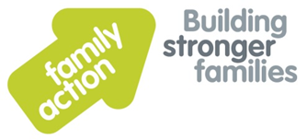
Support Worker (Temporary)
Birth Parents Support Service Medway
£19,194 to £21,703 per annum pro rata
15 hours per week
The Birth Parents Support Service offers support to parents who have lost a child through the adoption process. This support will be available through all the stages of adoption and will extend beyond the final court decision. We aim to help parents adjust to the loss of a child and move forward with the rest of their life.
The successful candidate will aid the Project Coordinator in offering a flexible service that meets the needs of the birth parents during the period when the adoption process is taking place. The support worker will be assigned specific tasks identified in an assessment to help the service users achieve their own objectives The person appointed will work closely with the volunteers appointed to the project.
You will need to have recent experience in health, social work or therapeutic work. You will ideally have had experience of working with parents who have a variety of complex needs and will be comfortable working with families in their own homes or community based venues. The successful candidate will show an aptitude in helping develop volunteers skills and knowledge in working with parents who have experienced a traumatic event.

We are forward looking, ambitious and with a commitment to continuous improvement. We are a people focused, can-do organisation, which strives for excellence in all we do and operate with mutual respect. If you share these values and behaviours and have the necessary skills then we look forward to hearing from you.
Appointments are subject to Family Action receiving an enhanced disclosure from the Disclosure and Barring Service that we consider acceptable.
For an application pack and further information, please visit www.family-action.org.uk/workingwithus
Please email completed applications to: completed.application1@family-action.org.uk
Closing date: 12th August 2016 Interview date: End of August 2016
Family Action offers good working conditions, a comprehensive training programme and a Group Personal Pension Scheme (GPPS). We welcome applications from all sections of the community.

