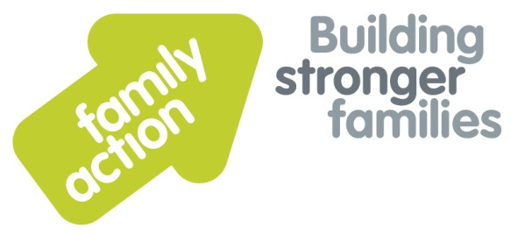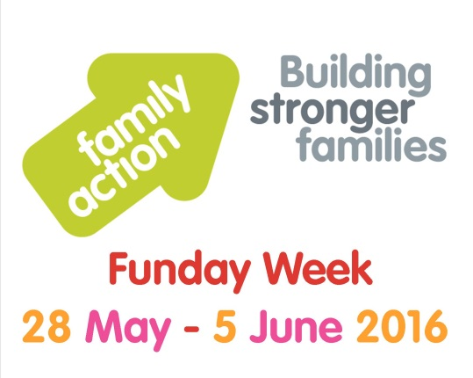

**Wooden Spoons at the Ready for the**

**Great Charity Bake Off**

**In support of Family Action**

Date:

Where:

To enter contact:

**Family Action builds stronger families across the UK, by providing practical, emotional and financial support to families facing complex and multiple disadvantage.**

Family Action, 24 Angel Gate, City Road, London, EC1V 2PT Registered Charity number 264713 www.family-action.org.uk