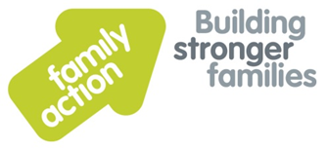
Sessional Worker East Midlands Adoption Support Service
East Midlands Adoption Support Service
£13.33per hour
As required on a sessional basis

Family Action has been awarded funding to develop and deliver a new adoption support service in the East Midlands in partnership with Lincolnshire County Council and the East Midlands Regional Adoption Agency (EMRAA). This is an exciting opportunity for committed individuals to join a new service for adoptive families.
Family Action is seeking to appoint to team of Sessional Adoption Support Workers who will work directly with Adoptive families as and when required. You will receive guidance, support and supervision from a designated Senior Adoption Support Worker. You will have experience of working with Adoptive families and/or vulnerable families in a professional capacity. You will have an understanding of attachment, child development and the impact of trauma. You will need excellent listening and communication skills. You will have an understanding, appropriate to the role, of the governments Adoption Agenda. You will need to be flexible and adaptable to meet the needs of adoptive families.
We are forward looking, ambitious and with a commitment to continuous improvement. We are a people focused, can-do organisation that strives for excellence in all we do and operates with mutual respect. If you share these values and behaviours and have the necessary skills then we look forward to hearing from you.
Appointments are subject to Family Action receiving an enhanced disclosure from the Disclosure and Barring Service that we consider acceptable.
For an application pack and further information, please visit www.family-action.org.uk/workingwithus
Please email completed applications to: completed.application16@family-action.org.uk
Application closing date: November 1st 2016
Interviews: Week Commencing November 7th 2016
Family Action offers good working conditions, a comprehensive training programme and a Group Personal Pension Scheme (GPPS). We welcome applications from all sections of the community.

