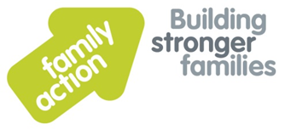
Family Support Worker
Service Cardiff with travel across South Wales
Salary £19, 386 pro rata per annum
Hours 25 hours per week

The Families Together project delivers specialist support to families with complex needs, such as domestic abuse, mental health, and substance misuse issues. We are looking to recruit a highly motivated and enthusiastic person who has experience of supporting families in their homes and group settings.
The successful candidate will hold a qualification in health & social care or equivalent. Have a minimum of two years experience in supporting families and working with statutory and voluntary services. Use of IT and have a full driving licence and access to a car for work purposes.
We are forward looking, ambitious and with a commitment to continuous improvement. We are a people focused, can-do organisation that strives for excellence in all we do and operates with mutual respect. If you share these values and behaviours and have the necessary skills then we look forward to hearing from you.
Appointments are subject to Family Action receiving an enhanced disclosure from the Disclosure and Barring Service that we consider acceptable.
For an application pack and further information, please visit www.family-action.org.uk/workingwithus
Please email completed applications to: completed.application22@family-action.org.uk
Closing date: 10th March 2017, 5pm
Interview date: 15th March 2017
Family Action offers good working conditions, a comprehensive training programme and a Group Personal Pension Scheme (GPPS). We welcome applications from all sections of the community.

