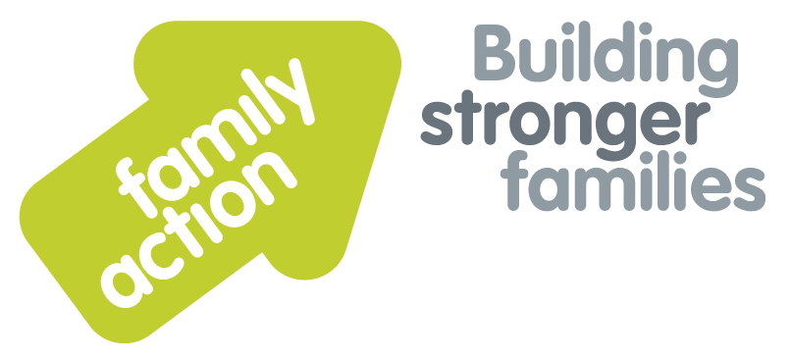

|  |  |  |  |
| --- | --- | --- | --- |
| **Placing children first** | **Two-Day Training Courses**  **In Birmingham** | |  |
| Introductory Offer  **Child Protection and Safeguarding for Designated Safeguarding Leads** | | | |
| 17 – 18 July 201719 – 20 September 2017 | | | |
| **Aim**  This training aims enable Designated Safeguarding Leads in Early Years settings, Out of School provisions and childminding arrangements, to fulfil their statutory obligations to recognise and act on any concerns about abuse, neglect or other forms of harm for children and young people in their care.  **Trainers**  Nicky Probert and Kanu Patel are both Training Managers for Family Action with over 60 years of social work experience between them. They are experienced trainers and have been delivering DSL/Refresher training for Local Authorities including Birmingham City Council for over 10 years.  **Target Group**  Designated Safeguarding Leads in Early Years settings, Out of School provisions and childminders. | | **DSL Statutory Requirements**  Designated Safeguarding leads need a comprehensive understanding of their roles and responsibilities, as set out in the Statutory framework for the Early Years foundation stage 2017. Ofsted inspections will focus on whether safeguarding requirements are met, and also on Early Help that is offered to children and their families when concerns about a child’s development are first raised. The training offered will enable DSLs to carry out their role confidently and effectively.  Areas of training covered encompass:-   * Legislation, policies and procedures * Early Help * Identifying abuse, neglect and forms of harm, such as FGM and radicalisation * Learning from Serious Case Reviews * Culture, diversity and personal values * Supporting and informing staff * Safer working practices: staff behaviour policies, recruitment and monitoring, POTS referrals * Information sharing, recording and reporting practice; whistleblowing   For a comprehensive list of Learning Outcomes please see [www.family-action.org.uk/training](http://www.family-action.org.uk/training) | |
| **Venue**    **The Saffron Centre**  256 Moseley Road  Highgate  Birmingham, B12 0BS  Tel: 0121 446 3029 | **Timing**  9.15 am Registration  9.30am Start  4.30pm Finish |
| Family Action, 55 Stevens Avenue, Bartley Green, Birmingham, B32 3SD  T: 07469 660 479 E: [joy.broadhurst@family-action.org.uk](mailto:joy.broadhurst@family-action.org.uk) [www.family-action.org.uk](http://www.family-action.org.uk)/training | | | |

|  |  |  |  |  |
| --- | --- | --- | --- | --- |
| **Registration Form**  **CP & Safeguarding for DSLs** | **17 – 18 July 2017**  **19 – 20 September 2017** | | | Please tick which event you wish  to attend |
| **Fee**    **£120.00** (+VAT £24.00) **=** **£144.00**  **£100.00** (+VAT £20.00) = **£120.00** (Early Bird Discount if booking at least one month prior to event)     * Remittance enclosed – cheque (including VAT) payable to *‘Family Action Enterprises Ltd.’* * Please invoice * To pay by credit/debit card please follow this link to our Eventbrite pages:-  |  |  | | --- | --- | | [*CP & Safeguarding for DSLs*](https://www.eventbrite.com/e/child-protection-and-safeguarding-for-designated-safeguarding-leads-two-day-course-birmingham-tickets-34820861133)  [*CP & Safeguarding for DSLs (E ARLY BIRD discoun*](https://www.eventbrite.com/e/child-protection-and-safeguarding-for-designated-safeguarding-leads-two-day-course-birmingham-early-tickets-34821315492)*t)*  [*CP & Safeguarding for DSLs*](https://www.eventbrite.com/e/child-protection-and-safeguarding-for-designated-safeguarding-leads-two-day-course-birmingham-tickets-34821391720)  [*CP & Safeguarding for DSLs*](https://www.eventbrite.com/e/child-protection-and-safeguarding-for-designated-safeguarding-leads-two-day-course-birmingham-early-tickets-34821442873) *(EARLY BIRD discount)* | 17-18 July 2017  17-18 July 2017 (EARLY BIRD discount)  19-20 September 2017  19-20 September 2017 (EARLY BIRD discount) |     In the event of cancellation, a cancellation fee is chargeable, as detailed below.   * We will store your details and may want to contact you in the future with more information about our services and   activities. Please tick here if you do **NOT** want us to do this. We will not pass your information on to a third party  without your permission. Data Protection Act 1998. | | | | |
| Name: | |  | Agency name & address: | |
| Position/Role: | |  |  | |
|  | |  |  | |
| Requirements  (eg: dietary, disability access): | |  |  | |
|  | |
| Telephone: | |  | Post code: | |
| E-mail: | |  | Billing e-mail *(if different):* | |
|  | |  |  | |
| **We will confirm your place and send joining**  **instructions via e-mail, so please write clearly** | |  | Your purchase order number: | |
| **Substitutions and cancellations**  Completion of this booking form is a binding agreement. Substitutions are welcome at any time. Family Action reserves the right to levy a fee in the event of your cancellation. More than 6 weeks prior to the event 25% of the fee; between 2 and 6 weeks 50%; less than 2 weeks 100%. In the event that you wish to transfer your booking to another workshop date, we reserve the right to levy a 25% administration fee, if you then cancel your place, the previous cancellation fee would also apply. | | | | |
| **Please e-mail/post completed form (indicating your method of payment) to:-**  **Joy Broadhurst**  **Family Action**  **55 Stevens Avenue, Bartley Green, Birmingham, B32 3SD**  E: [Joy.broadhurst@family-action.org.uk](mailto:Joy.broadhurst@family-action.org.uk)  T: 07469 660 479 www.family-action.org.uk/training  Registered Company Limited in England and Wales: 01514576 VAT Registration no. 355 1974 35  Family Action Enterprises Limited is a fully owned subsidiary of Family Action, Registered Charity no: 264713 | | | | |