**Placing children first**

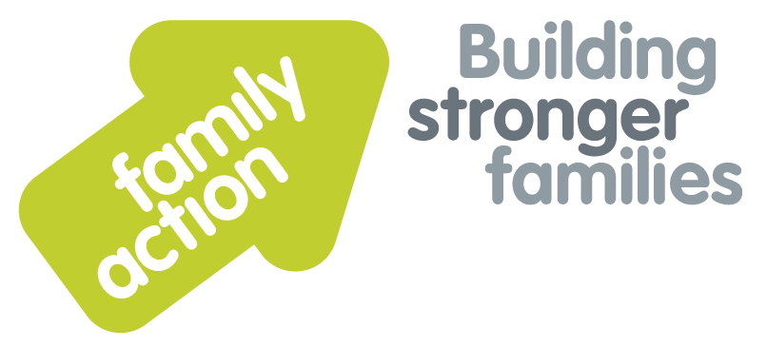

|  |  |  |  |  |
| --- | --- | --- | --- | --- |
|  | **One-Day Workshop** | | |  |
| **Direct Work with Children**  **and Young People** | | | | |
| Friday, 14 July 2017 | | | **London** | |
| **Focus**  This training aims to give workers the knowledge base and skills to communicate effectively during direct work with children and young people.  This is an experiential course that will enable participants to practise various techniques and use tools to develop their direct work skills.  **Trainer**  Nicky Probert is a Training Manager for Family Action with over 30 years of social work experience. She is an experienced trainer and manager, having worked for BAAF for over 12 years, and currently chairs a fostering panel. | | | **Target Group**  People working with children and young people in a wide variety of roles and settings, including social care, health, education and the courts and youth justice.  **Learning Outcomes**  By the end of the workshop participants will be able to:   * Apply their knowledge of child development to employ effective communication methods that reflect the child or young person’s stage of cognitive and emotional development; * Describe the impact that abuse and neglect may have on children’s development, their ability to form relationships and on their perceptions of people and events; * Establish a safe and therapeutic working relationship with children which will promote their emotional development; * Use a variety of techniques and tools to carry out direct work with children and young people who have been affected by abuse and neglect; * Produce plans for direct work which are appropriate for the individual child or young person, including preparatory and on-going work with family and/or carers to promote the child’s healthy development; * Identify sources of support including effective supervision to reflect on direct work; * Take appropriate action to deal with any disclosures or child protection issues that may arise in the course of direct work. | |
| **Venues**  **Family Action**  24 Angel Gate  City Road  **London, EC1V 2PT**  Tel: 0207 254 6251 | | **Timing**    9.30am Registration  9.45am Start  4.30pm Finish    Refreshments  & light lunch provided |
| Family Action, 55 Stevens Avenue, Bartley Green, Birmingham, B32 3SD  T: 07469 660 479 E: [joy.broadhurst@family-action.org.uk](mailto:joy.broadhurst@family-action.org.uk) [www.family-action.org.uk](http://www.family-action.org.uk)/training | | | | |  |

|  |  |  |  |  |
| --- | --- | --- | --- | --- |
| **Registration Form**  **One-Day Workshop**  **in London** | **Direct Work with Children**  **and Young People**  **Friday, 14 July 2017** | | |  |
| **Fee**    **£85.00** (+VAT £17.00) **=** **£102.00**     * Remittance enclosed – cheque (including VAT) payable to *‘Family Action Enterprises Ltd.’* * Please invoice * To pay by credit/debit card please follow this link to our Eventbrite page:-   [*https://www.eventbrite.com/e/direct-work-with-children-and-young-people-one-day-workshop-london-tickets-34720324425*](https://www.eventbrite.com/e/direct-work-with-children-and-young-people-one-day-workshop-london-tickets-34720324425)    In the event of cancellation, a cancellation fee is chargeable, as detailed below.   * We will store your details and may want to contact you in the future with more information about our services and   activities. Please tick here if you do **NOT** want us to do this. We will not pass your information on to a third party  without your permission. Data Protection Act 1998. | | | |
| Name: | |  | Agency name & address: |
| Position/Role: | |  |  |
|  | |  |  |
| Requirements  (eg: dietary, disability access): | |  |  |
|  |
| Telephone: | |  | Post code: |
| E-mail: | |  | Billing e-mail *(if different):* |
|  | |  |  |
| **We will confirm your place and send joining**  **instructions via e-mail, so please write clearly** | |  | Your purchase order number: |
| **Substitutions and cancellations**  Completion of this booking form is a binding agreement. Substitutions are welcome at any time. Family Action reserves the right to levy a fee in the event of your cancellation. More than 6 weeks prior to the event 25% of the fee; between 2 and 6 weeks 50%; less than 2 weeks 100%. In the event that you wish to transfer your booking to another workshop date, we reserve the right to levy a 25% administration fee, if you then cancel your place, the previous cancellation fee would also apply. | | | |
| **Please e-mail/post completed form (indicating your method of payment) to:-**  **Joy Broadhurst**  **Family Action**  **55 Stevens Avenue, Bartley Green, Birmingham, B32 3SD**  E-mail: [Joy.broadhurst@family-action.org.uk](mailto:Joy.broadhurst@family-action.org.uk)  Tel: 07469 660 479 www.family-action.org.uk/training  Registered Company Limited in England and Wales: 01514576 VAT Registration no. 227 3222 34  Family Action Enterprises Limited is a fully owned subsidiary of Family Action, a Registered Charity no: 264713 | | | |