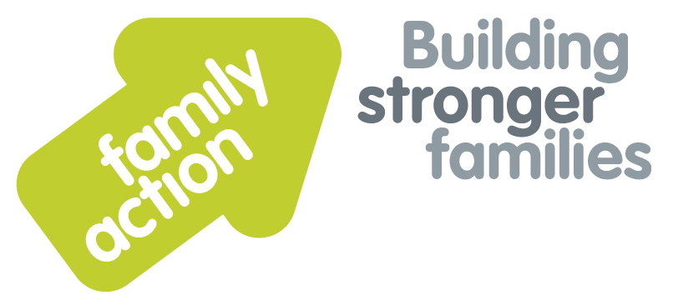

|  |  |  |  |
| --- | --- | --- | --- |
| **Placing children first** | **One-Day Workshops** | |  |
| **Agency Decision Makers** | | | |
| Friday, 22 September 2017 London **Monday, 30 October 2017 Birmingham** | | | |
| **Focus**  Decision Makers in fostering and adoption agencies have a vital role in making life changing decisions for children and families. For many Decision Makers, there are few opportunities to prepare for the role, or to share practice dilemmas with others. This workshop will allow participants to share best practice and consider some issues associated with the role:   * How can you ensure your decisions are ‘Hofstetter’ compliant? * What processes are in place to convey decisions effectively and in a timely manner? * How can the ADM ensure that Panel processes are fair and transparent? * What is your role in relation to quality assurance of assessments and panel functions?   Legislation, regulations and guidance are clear about the importance of the ADM role and the decision making process. Based also on the latest case law and research, this workshop will explore issues and dilemmas, providing participants with useful audits and templates to assist future decision making. | | **Target Group**  Current Agency Decision Makers or those anticipating taking on this role. This workshop is aimed at the PCF Strategic Social Work Manager level.  **Trainer**  Nicky Probert is a Training Manager for Family Action with over 30 years of social work experience. She is an experienced trainer, having worked for BAAF for over 12 years and currently chairs a fostering panel.  **Learning Outcomes**  By the end of the day participants will be able to:   * Identify the implications of some of the most recent judgements related to agency decision making; * Describe the process of decision making in the context of legislation regulations and guidance; * Demonstrate ways to ensure that the basis of the decision making is sound, and decisions are communicated effectively; * Review their agency’s process in conducting appraisals of panel chairs; * Apply principles of quality assurance to the process of panel and the decision making process. | |
| **Venues**    **Family Action**  24 Angel Gate  City Road  **London**, EC1V 2PT  T: 0207 254 6251  **The Saffron Centre**  256 Moseley Road  Highgate  **Birmingham**, B12 0BS  T: 0121 446 3029 | **Timing**  9.30am Registration  9.45am Start  4.30pm Finish    Refreshments  & light lunch provided |
| Family Action, 55 Stevens Avenue, Bartley Green, Birmingham, B32 3SD  T: 07469 660 479 E: [joy.broadhurst@family-action.org.uk](mailto:joy.broadhurst@family-action.org.uk) [www.family-action.org.uk](http://www.family-action.org.uk)/training | | | |

|  |  |  |  |  |
| --- | --- | --- | --- | --- |
| **Registration Form**  One-Day Workshop Agency Decision Makers | Friday, 22 September 2017  London    Monday, 30 October 2017  Birmingham | | | **Please tick which location**  **you wish to attend** |
| **Fee**    **£85.00** (+VAT £17.00) **=** **£102.00**     * Remittance enclosed – cheque (including VAT) payable to *‘Family Action Enterprises Ltd.’* * Please invoice * To pay by credit/debit card please follow these links to our Eventbrite pages:   [*https://www.eventbrite.com/e/agency-decision-makers-one-day-workshop-london-tickets-34722313374*](https://www.eventbrite.com/e/agency-decision-makers-one-day-workshop-london-tickets-34722313374)***London***  [*https://www.eventbrite.com/e/agency-decision-makers-one-day-workshop-birmingham-tickets-37029556400*](https://www.eventbrite.com/e/agency-decision-makers-one-day-workshop-birmingham-tickets-37029556400)***Birmingham***  In the event of cancellation, a cancellation fee is chargeable, as detailed below.   * We will store your details and may want to contact you in the future with more information about our services and   activities. Please tick here if you do **NOT** want us to do this. We will not pass your information on to a third party  without your permission. Data Protection Act 1998. | | | | |
| Name: | |  | Agency name & address: | |
| Position/Role: | |  |  | |
|  | |  |  | |
| Requirements  (eg: dietary, disability access): | |  |  | |
|  | |
| Telephone: | |  | Post code: | |
| E-mail: | |  | Billing e-mail *(if different):* | |
|  | |  |  | |
| **We will confirm your place and send joining**  **instructions via e-mail, so please write clearly** | |  | Your purchase order number: | |
| **Substitutions and cancellations**  Completion of this booking form is a binding agreement. Substitutions are welcome at any time. Family Action reserves the right to levy a fee in the event of your cancellation. More than 6 weeks prior to the event 25% of the fee; between 2 and 6 weeks 50%; less than 2 weeks 100%. In the event that you wish to transfer your booking to another workshop date, we reserve the right to levy a 25% administration fee, if you then cancel your place, the previous cancellation fee would also apply. | | | | |
| **Please e-mail/post completed form (indicating your method of payment) to:-**  **Joy Broadhurst**  **Family Action**  **55 Stevens Avenue, Bartley Green, Birmingham, B32 3SD**  E: [Joy.broadhurst@family-action.org.uk](mailto:Joy.broadhurst@family-action.org.uk)  T: 07469 660 479 www.family-action.org.uk/training  Registered Company Limited in England and Wales: 01514576 VAT Registration no. 227 3222 34  Family Action Enterprises Limited is a fully owned subsidiary of Family Action, a Registered Charity no: 264713 | | | | |