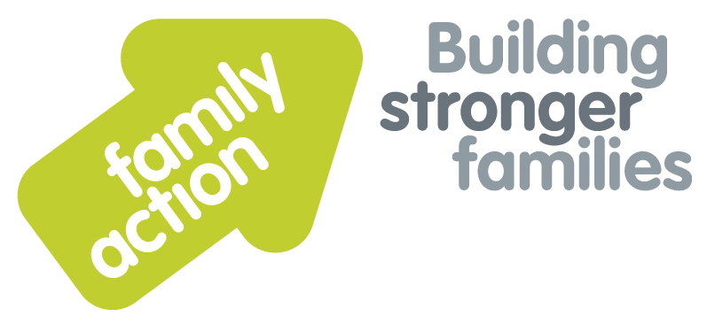

|  |  |  |  |
| --- | --- | --- | --- |
| **Placing children first** | **Two-Day Training Course**  **In Birmingham** | |  |
| **Child Protection and Safeguarding for Designated Safeguarding Leads** | | | |
| 11 - 12 January 2018 | | | |
| **Aim**  This training aims to enable Designated Safeguarding Leads in Early Years settings, Out of School provisions and childminding arrangements, to fulfil their statutory obligations to recognise and act on any concerns about abuse, neglect or other forms of harm for children and young people in their care.  **Trainer**  Pravin Patel has over 35 years’ experience of youth and community work, including senior management, and delivery of education and training at degree and masters levels. He has trained multi-agency staff in Safeguarding and Equalities, including DSL training delivered to Birmingham Early Years for the past 5 years.  **Target Group**  Designated Safeguarding Leads in Early Years settings, Out of School provisions and childminders. | | **DSL Statutory Requirements**  Designated Safeguarding leads need a comprehensive understanding of their roles and responsibilities, as set out in the Statutory framework for the Early Years foundation stage 2017. Ofsted inspections will focus on whether safeguarding requirements are met, and also on Early Help that is offered to children and their families when concerns about a child’s development are first raised. The training offered will enable DSLs to carry out their role confidently and effectively.  Areas of training covered encompass:-   * Legislation, policies and procedures * Early help * Identifying abuse, neglect and forms of harm, such as FGM and radicalisation * Learning from Serious Case Reviews * Culture, diversity and personal values * Supporting and informing staff * Safer working practices: staff behaviour policies, recruitment and monitoring, POTS referrals * Information sharing, recording and reporting practice; whistleblowing   For a comprehensive list of Learning Outcomes please see [www.family-action.org.uk/training](http://www.family-action.org.uk/training) | |
| **Venue**    **The Saffron Centre**  256 Moseley Road  Highgate  Birmingham, B12 0BS  Tel: 0121 446 3029 | **Timing**  9.15 am Registration  9.30am Start  4.30pm Finish |
| Family Action, 55 Stevens Avenue, Bartley Green, Birmingham, B32 3SD  T: 07469 660 479 E: [joy.broadhurst@family-action.org.uk](mailto:joy.broadhurst@family-action.org.uk) [www.family-action.org.uk](http://www.family-action.org.uk)/training | | | |

|  |  |  |  |
| --- | --- | --- | --- |
| **Registration Form** | **CP & Safeguarding for DSLs**  **Two Day Training Course in Birmingham**  **11 – 12 January 2018** | | |
| **Fee**    **£150.00 (+VAT £30.00) = £180.00**  **£130.00 (+VAT £26.00) = £156.00 (Early Bird Discount if booking at least one month prior to event)**     * **Remittance enclosed – cheque (including VAT) payable to *‘Family Action Enterprises Ltd.’*** * **Please invoice** * **To pay by credit/debit card please follow these links to our Eventbrite pages:-**  |  | | --- | | [*https://cpsafeguardingtwo-daycourse11-12january2018.eventbrite.com*](https://cpsafeguardingtwo-daycourse11-12january2018.eventbrite.com)  [*https://cpsafeguardingfordsls11-12january2018earlybird.eventbrite.com*](https://cpsafeguardingfordsls11-12january2018earlybird.eventbrite.com) *Early Bird Discount (at least one month prior to event)* |     **In the event of cancellation, a cancellation fee is chargeable, as detailed below.**   * We will store your details and may want to contact you in the future with more information about our services and   activities. Please tick here if you do NOT want us to do this. We will not pass your information on to a third party  without your permission. Data Protection Act 1998. | | | |
| Name: | |  | Agency name & address: |
| Position/Role: | |  |  |
|  | |  |  |
| Requirements  (eg: dietary, disability access): | |  |  |
|  |
| Telephone: | |  | Post code: |
| E-mail: | |  | Billing e-mail *(if different):* |
|  | |  |  |
| **We will confirm your place and send joining**  **instructions via e-mail, so please write clearly** | |  | Your purchase order number: |
| **Substitutions and cancellations**  Completion of this booking form is a binding agreement. Substitutions are welcome at any time. Family Action reserves the right to levy a fee in the event of your cancellation. More than 6 weeks prior to the event 25% of the fee; between 2 and 6 weeks 50%; less than 2 weeks 100%. In the event that you wish to transfer your booking to another workshop date, we reserve the right to levy a 25% administration fee, if you then cancel your place, the previous cancellation fee would also apply. | | | |
| **Please e-mail/post completed form (indicating your method of payment) to:-**  **Joy Broadhurst**  **Family Action**  **55 Stevens Avenue, Bartley Green, Birmingham, B32 3SD**  E: [Joy.broadhurst@family-action.org.uk](mailto:Joy.broadhurst@family-action.org.uk)  T: 07469 660 479 www.family-action.org.uk/training  Registered Company Limited in England and Wales: 01514576 VAT Registration no. 227 3222 34  Family Action Enterprises Limited is a fully owned subsidiary of Family Action, Registered Charity no: 264713 | | | |