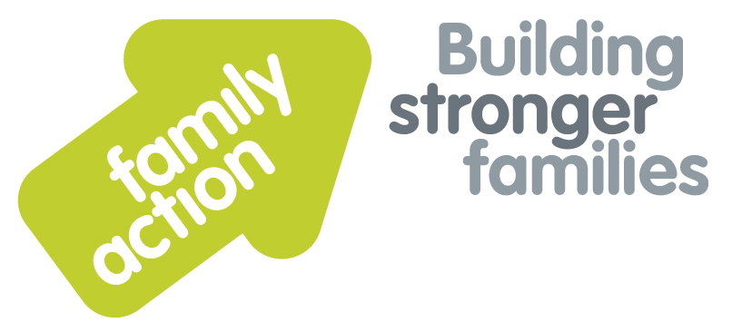

|  |  |  |  |
| --- | --- | --- | --- |
| **Placing children first** | **One-Day Refresher Training**  In Birmingham | |  |
| **Child Protection and Safeguarding for Designated Safeguarding Leads** | | | |
| Friday, 10 November 2017 | | | |
| **Aim**  This training aims to enable Designated Safeguarding Leads in Early Years settings, Out of School provisions and childminding arrangements to fulfil their statutory obligations to recognise and act on any concerns about abuse, neglect or other forms of harm for children and young people in their care. Participants are expected to have already attended a two day DSL course. This one day course is designed to update safeguarding requirements and should be repeated on a two year cycle.  **Trainer**  Pravin Patel has over 35 years’ experience of youth and community work, including senior management, and delivery of education and training at degree and masters levels. He has trained multi-agency staff in Safeguarding and Equalities, including DSL training delivered to Birmingham Early Years for the past 5 years. | | **Learning Outcomes**  By the end of the day participants  will be able to:   * Review their own role and responsibilities as a Designated Safeguarding Lead in fulfilling statutory duties, and identifying the need for Early Help or concerns regarding abuse and neglect; * Audit their practice in relation to organisational policies and procedures in line with national legislation, regulations and guidance; * Ensure there are robust recruitment strategies in place and that induction monitoring and review processes for staff include safeguarding and child protection; * Implement policies and procedures in their organisations to keep children and young people safe; * Apply best practice in recording and information sharing.   **Target Group**   * Designated Safeguarding Leads in Early Years settings, Out of School provisions and childminders. | |
| **Venue**    **The Saffron Centre**  256 Moseley Road  Highgate  Birmingham, B12 0BS  Tel: 0121 446 3029 | **Timing**  9.15 am Registration  9.30am Start  4.30pm Finish |
| Family Action, 55 Stevens Avenue, Bartley Green, Birmingham, B32 3SD  T: 07469 660 479 E: [joy.broadhurst@family-action.org.uk](mailto:joy.broadhurst@family-action.org.uk) [www.family-action.org.uk](http://www.family-action.org.uk)/training | | | |

|  |  |  |  |
| --- | --- | --- | --- |
| **Registration Form** | **CP & Safeguarding for DSLs** One-Day Refresher TrainingFriday, 10 November 2017 | | |
| **Fee**    **£75.00** (+VAT £15.00) **=** **£90.00**  **Please note that for the first ten bookings we are offering a discount of £10.00**  This discount can not be processed through Eventbrite. Please therefore use the other methods of payment.     * Remittance enclosed – cheque (including VAT) payable to *‘Family Action Enterprises Ltd.’* * Please invoice * To pay by credit/debit card please follow this link to our Eventbrite pages:-   [*https://cpandsafeguardingfordslsbirmingham10november2107.eventbrite.com*](https://cpandsafeguardingfordslsbirmingham10november2107.eventbrite.com)   |  |  | | --- | --- | |  |  |   In the event of cancellation, a cancellation fee is chargeable, as detailed below.   * We will store your details and may want to contact you in the future with more information about our services and   activities. Please tick here if you do **NOT** want us to do this. We will not pass your information on to a third party  without your permission. Data Protection Act 1998. | | | |
| Name: | |  | Agency name & address: |
| Position/Role: | |  |  |
|  | |  |  |
| Requirements  (eg: dietary, disability access): | |  |  |
|  |
| Telephone: | |  | Post code: |
| E-mail: | |  | Billing e-mail *(if different):* |
|  | |  |  |
| **We will confirm your place and send joining**  **instructions via e-mail, so please write clearly** | |  | Your purchase order number: |
| **Substitutions and cancellations**  Completion of this booking form is a binding agreement. Substitutions are welcome at any time. Family Action reserves the right to levy a fee in the event of your cancellation. More than 6 weeks prior to the event 25% of the fee; between 2 and 6 weeks 50%; less than 2 weeks 100%. In the event that you wish to transfer your booking to another workshop date, we reserve the right to levy a 25% administration fee, if you then cancel your place, the previous cancellation fee would also apply. | | | |
| **Please e-mail/post completed form (indicating your method of payment) to:-**  **Joy Broadhurst**  **Family Action**  **55 Stevens Avenue, Bartley Green, Birmingham, B32 3SD**  E: [Joy.broadhurst@family-action.org.uk](mailto:Joy.broadhurst@family-action.org.uk)  T: 07469 660 479 www.family-action.org.uk/training  Registered Company Limited in England and Wales: 01514576 VAT Registration no. 227 3222 34  Family Action Enterprises Limited is a fully owned subsidiary of Family Action, Registered Charity no: 264713 | | | |