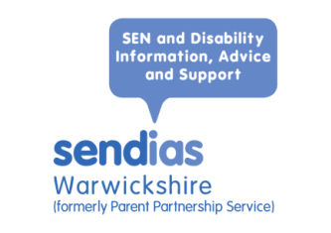
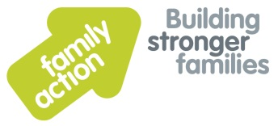
The Local Offer

What is the Local Offer?

Every local authority must publish a Local Offer. The Local Offer tells you what support is available for children and young people with special educational needs (SEN) and/or disabilities, and their families. It should include information about education, health and care provision. It should also tell you about training, employment and independent living for young people with special educational needs and/or disabilities. You can find the Local Offer for Warwickshire Local Authority at www.warwickshire.gov.uk/SEND

Who is it for?

The Local Offer is for:
- children and young people with SEN and/or disabilities from birth to 25
- their parents and carers
- practitioners and professionals.

What is the idea?

The Local Offer should:
- make it easier to find out what you need to know
- give you information about what is available
- tell you where you can get further information.

The Local Offer should also make services more responsive to local needs.

The SEND Code of Practice says that the Local Offer should:

- provide clear, comprehensive, accessible and up-to-date information about the available provision and how to access it
- make provision more responsive to local needs and aspirations by directly involving disabled children and those with SEN and their parents, and disabled young people and those with SEN, and service providers in its development and review (4.2)

What does it include?

The Local Offer includes information on:
- how children and young people’s needs are identified
- how their needs are assessed
- the special educational, health and social care provision for children and young people with SEN or disabilities
- opportunities for training and employment
- support for independent living
- how provision is funded
- leisure activities and support groups
- where you can find more information, advice and support
- arrangements for travel
- the help available to resolve disagreements.

The Local Offer must also tell you about services provided outside your area which local people are likely to use. You can find the full list of what must be included in the SEND Code of Practice section 4.30.

How can I get involved?

The local authority must involve children and young people with SEN and disabilities, and parents and carers in preparing and reviewing the Local Offer. If you would like to be involved, or make some comments, you can find out more on the Local Offer website.

Parents who want to be more involved in developing and reviewing the Local Offer can contact their local Parent Carer Forum (ask Warwickshire Sendias for details). Children and young people who want to be more involved in developing and reviewing the Local Offer can contact Warwickshire Sendias for details.

The local authority must publish what children, young people and parents tell them about the Local Offer. It must also say clearly what it will do about the comments it has received.

Where can I get further information, advice or support?

Chapter 4 of the SEND Code of Practice tells you more about the Local Offer.

You can find the Local Offer for Warwickshire Local Authority at www.warwickshire.gov.uk/SEND

Warwickshire SEND (Information, Advice and Support Service) can also give you:
- information and advice about SEN and disability support and provision
- more information about local services, organisations, and resources which might help
- advice and support to get more involved.

Contact us

Family Action has been commissioned by Warwickshire Local Authority to deliver an independent SENDIAS Service.

Phone the Warwickshire SENDIAS team on 024 7636 6054 or email wias@family-action.org.uk

Visit our SENDIAS website to find information about local and national support services: www.family-action.org.uk/wias

Find out more about national charity Family Action: www.family-action.org.uk

Next review date for this document: 31 March 2018

