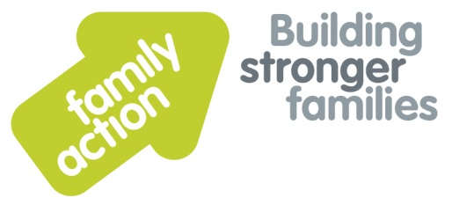
Section 9: EMASS Toolkit

Managing Challenging Behaviour: Anger and Aggression
A guide for schools
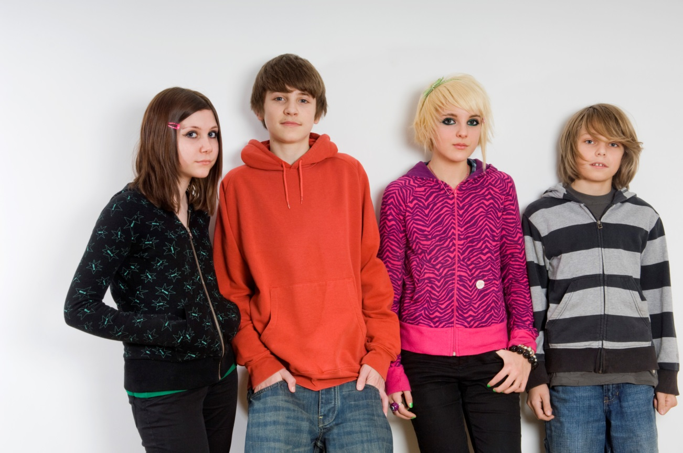
Produced by Family Action’s East Midlands Adoption Support Service (EMASS)

Contents
What is challenging behaviour and why is it relevant to Page 3
children who are adopted or living with Special Guardians?
What is the meaning behind the behaviour? Page 4
How staff in school settings can help Page 5
Where to go for further information and support Page 7

What is challenging behaviour and why is it relevant to children who are adopted or living with Special Guardians?
Most children will at sometime in their lives display behaviour that challenges their parents, siblings, teachers, other adults or peers.
While this section of the EMASS Toolkit concentrates on behaviour such as anger and aggression, we should also acknowledge that children may also be challenging through passivity or withdrawal. In these cases, if the behaviour does not pose an immediate problem it might simply be ignored, but these children and young people may also be very vulnerable and just as much in need of our help and support as those showing more overt distress.
From toddlers to teens and even into adulthood, some of the most challenging behaviour comes from people who present as ‘out of control’ and potentially dangerous to those around them. We know that children who have not had positive role models and good attachments to well regulated (calm), caring adults may struggle to know how to contain their own strong emotions such as fear, anger or rage.
Many young people who have been adopted or who are living with Special Guardians may struggle with their emotions and find it hard to express them appropriately due to their own past experiences.
A large study of disruptions in adoption noted that there was a high level of child to parent violence in some adoptive families and that parents found it both hard to admit what was happening and also hard to get appropriate help. (Selwyn et al., 2014, Beyond the Adoption Order: challenges, interventions and adoption disruption, research report).

What is the meaning behind the behaviour?
Anger and aggressive behaviour are hard wired into us all as survival mechanisms. While we tend to look at them as negative emotions, without them we would arguably lack the motivation to fight injustice or push for positive change in society.
To understand what is behind these emotions, we need to understand that we all have a range of defensive reactions when feeling threatened or afraid. Most people are familiar with the idea that if we are alarmed by something we may fight, take flight (run away) or freeze (shut down).
There are also another two responses:
- Flop: where a person may faint and literally flop involuntarily
- Friend: where the person under threat tries to make friends with their aggressor (like the Stockholm syndrome sometimes referred to in hostage situations).
These responses rely on mechanisms in the brain that are wired to respond immediately to alarming situations so that we are kept as safe as possible. They are not easily accessible to our conscious control. This means that it is almost impossible (and often not helpful) to try to reason with someone who is in one of these states. The thinking part of their brain is shut down at this time and responses are more instinctual.
Children and young people who have experienced trauma may be particularly sensitive to triggers in the external school environment – loud noises, the way someone looks at them, a smell or internal feelings of rejection or shame. Teachers and school staff need to be aware that this is not a child being controlling, defiant or naughty but an inevitable reaction which gets the child ready to deal with danger, even if that danger is no longer really there.
If we respond to children in this state by getting angry ourselves, then the child will in turn respond to this increased threat by becoming more agitated and the alarm can become terror. The chemical messengers like adrenaline that prepare our bodies for fight or flight will also persist in the child’s system, leading them to be less able to calm and settle themselves even after the ‘trigger’ has gone.

How staff in schools settings can help
It is always easier to prevent a child or young person’s ‘meltdown’ before it happens than to deal with the aftermath.
School staff can begin by recognising the tell-tale signs that a child is getting stressed or anxious and then agreeing with the child and their parents what would help calm them down. Children may also need help to recognise the bodily sensations associated with feelings of stress themselves and then can then also be helped to develop techniques such as slow breathing to create a thinking space before any impulse takes over.
If teachers and other adults are helped to understand why traumatised children may be behaving this way, they themselves are more likely to remain calm and regulated and offer more helpful responses to the child or young person.
Ways to help
- Stay regulated and calm yourself.
- Identify a key person who can stay with the child if they are in a state of alarm. (It is often more practical to have a few key members of staff to be ‘safe’ people so that there is always one ‘safe’ person available.)
- Provide children with a safe space within the classroom that they can use if they need to. This allows the pupil to have proximity to adults while learning to self-regulate.
- Tune in to their feelings by matching the intensity of your response to make sure they know they are understood, but ensure that you are responding with empathy and acceptance of their feelings, not your own anger, frustration or fear.
- Teach children techniques like slow ‘belly breathing’ to calm their anxiety (breathe in for 3, hold for 1, out for 4).
- Encourage physical movement to dispel some of the child’s pent-up tension – go for a walk with them or send them on an errand (if they are still calm enough) for instance.
- Remember, it takes two to enter into a power struggle; there does not have to be a ‘win’.
- Do not try to argue or convince the child.
- Enforce reasonable limits to keep everyone safe, for instance, the removal of the student or of other students.
- Avoid any verbal or non-verbal threats.
- Don’t over or underreact.
- Explain limits and rules in an authoritative firm but respectful way.
- Give safe choices where possible.
When to seek help
You will know within a few minutes whether de-escalation is going to work. If a child or young person becomes so enraged that they may threaten to cause harm to themselves or others, then suggest they leave the room. If they will not come with you then remove yourself and others and call for help. Children should not be made to feel ‘trapped’ – always give them a route by which they can leave the situation.

Where to go for further information and support
Inside I’m Hurting: Practical Strategies for supporting children with attachment difficulties in schools, Louise Bomber (Worth Publishing)
What about me? Inclusive strategies to support pupils with attachment difficulties make it through the school day, Louise Bomber (Worth Publishing)
Happy Families: A Parents' Guide to the Non-Violent Resistance Approach, Carmelite Avraham-Krehwinkel and David Aldridge (Jessica Kingsley Publishers 2010
Helping Children locked in rage or hate: A guidebook (Helping Children with Feelings), Margot Sunderland 2003
The Yellow Kite (This is set up to advocate for children and young people who have been misunderstood and misinterpreted in our schools and communities for too long.)
www.theyellowkite.co.uk
Useful articles and books on anxiety, for instance, explaining anxiety to children ‘Hey Warrior’ by Karen Young
www.heysigmund.com
Akamas (For publications and training to support vulnerable children in education)
www.akamas.co.uk
Child Trauma (downloadable papers)
www.childtrauma.org
Scholastic
www.scholastic.co.uk
Early Childhood Today Emotional Development: Creating an Emotionally Safe Classroom, Bruce D. Perry MD, PhD

About us

Family Action is a charity committed to building stronger families and brighter lives by delivering innovative and effective services and support that reaches out to many of the UK’s most vulnerable people. We seek to empower people and communities to address their issues and challenges through practical, financial and emotional help.

Our East Midlands Adoption Support Service (EMASS) was funded by the Department for Education (DfE) until March 2018. This document forms part of the EMASS Toolkit, a set of resources produced to support schools that have taken part in the project.

Training and consultancy

Family Action’s Training and Consultancy Service can offer a wide range of training workshops for schools and educational establishments, including all the issues covered in the EMASS Toolkit. To book a workshop or inset training day contact:

Family Action, Training and Consultancy
55 Stevens Avenue
Bartley Green
Birmingham B32 3SD
Email: TandC@family-action.org.uk or Joy.broadhurst@family-action.org.uk
Tel: 020 3640 2303
Visit: www.family-action.org.uk/training

Disclaimer: This document includes links to websites and resources used by those involved in the EMASS project. External links were reviewed in February 2018 when this document was produced; however, we are not responsible for the changing content of external websites over time.

Last updated 28.3.18

