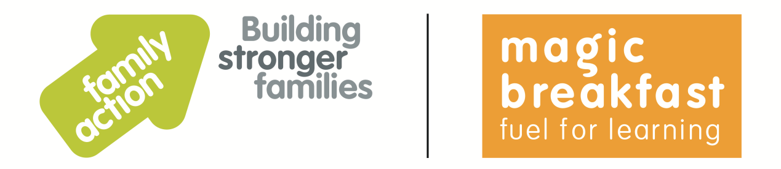

**Fun activities for the whole family**

Below are some tips for free or low-cost activities for children and families to do together during the school holidays. Thank you to families and staff taking part in Family Action’s Holiday Food and Activities programmes this summer for providing these tips.

**Decorate a plant pot**

Ask each member of the family to put the palm of their hand in some paint and then press their hand onto the plant pot. Perhaps use a different colour for each person in the family.

**Do the daily mile**

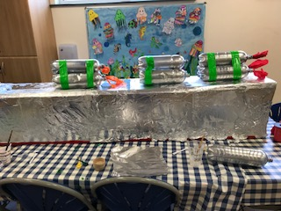Stop what you are all doing at the same time each day – and go for a walk together. You could aim to build up to doing a ‘daily mile’.

**Junk modelling**

A great way to spend some time together as a family is to do some junk modelling. Save all your empty boxes, bottles, foil, coloured paper etc and make a fantastic family creation … like this rocket!

**A trip to the park**

The local park is a fun day out, especially when you have children of different ages. Take along some games (eg football, frisbee) and a healthy picnic to make it a great day out for the whole family.

**Family tree boards**

Make a family tree board or poster together. Include photos or drawing showing the history of your family, festivities you celebrate together, family traditions, songs you listen to, bedtime stories etc. Display your piece of work prominently in your home.

**Acting up**

Get out some old clothes and dress up as a character in a book or film you all enjoy.

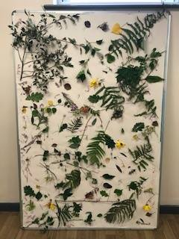**Nature hunt**

Go for a walk together in the local area and collect different leaves, etc. When you get home, make a display together, like this ‘sensory display’.

**Make a den**

Make a tent or a den using old sheets, table, chairs etc. Perhaps play some board games or listen to a story together in your tent/den.

**Cooking**

Make pizzas from scratch together as family. You can use wholemeal pitta bread pockets as a base, add your favourite healthy toppings, pop under the grill – and enjoy your creations together for lunch.

**Papier-mâché**

Cut up your old newspaper into strips. Then mix together 3 cups of flour, 1 cup of water and a teaspoon of salt. Dip the newspaper into the mixture; then put them onto a blown up balloon; when the paper has dried you can paint or decorate it. Warning – it can get messy!

**Get out and about**

Find out what’s on in your local museum, art gallery or library. Many have free entrance and also free activities during school holidays (eg reading challenge, arts and crafts, trails). Some towns and cities offer free swimming in the holidays for children.

**Find out more about our holiday food and activity programmes at**[**www.family-action.org.uk/holidayhub**](http://www.family-action.org.uk/holidayhub)