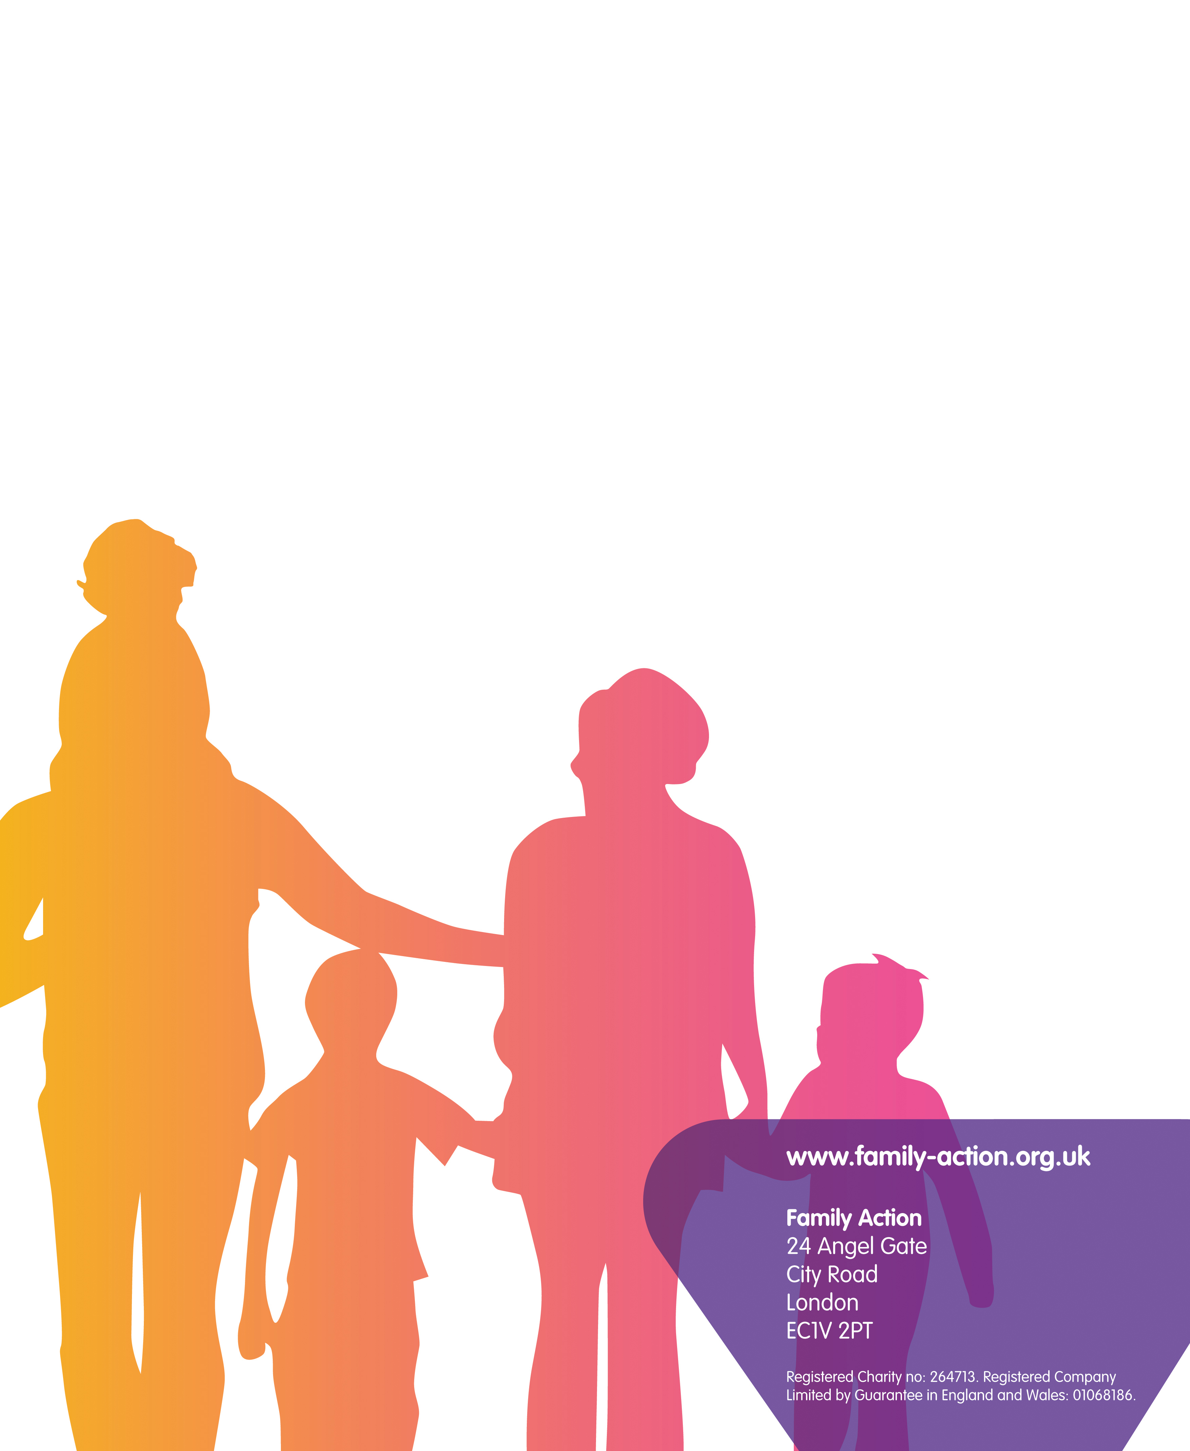
Lambeth Participation and
Engagement Service (PES)
We support parents and carers of children and young people with special educational needs and disabilities (SEND) in Lambeth.
Information and Advice:
We offer support with issues such as:
- understanding your child’s condition and circumstances
- navigating the SEND system
- workshops, coffee mornings and signposting to forums and Local Authority events
- drop-ins
- regular communication bulletins.

Family Support and Outreach:
- We offer additional support and empower parents and carers who require emotional and practical support via face-to-face, individual and group sessions, telephone, email and regular communication bulletins.
- This will ensure families with children and young people with SEND are aware of their rights and entitlements and how to access support services available in Lambeth.

For further information contact us:
Email: LambethPES@family-action.org.uk
Phone: 07976 201 031
www.family-action.org.uk

.

