Placing children first

Attachment and Brain Development

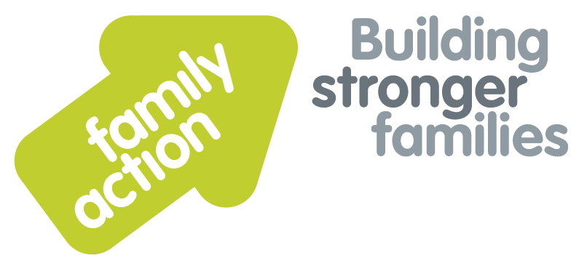

|  |  |  |  |
| --- | --- | --- | --- |
| **Placing children first** | One-Day Workshops  **In London** | |  |
|  | | | |
| Friday, 11 October 2019 Wednesday, 22 January 2020 | | | |
| **Focus**  Recent research into Adverse Childhood Experiences (ACES) has illustrated the long lasting physical and psychological impact of maltreatment, adverse caregiving environments and trauma in childhood. This workshop will enable practitioners to understand the importance of early relationships and the impact that attachment has on the developing brain.  **Target Group**  All professionals working with infants, babies, children, young people and their parents or carers whose work involves identifying strategies to strengthen parent/child attachments in the context of local early help, family support and safeguarding procedures. | | **Trainer**  Kanu Patel is a social worker and highly skilled trainer, with over 30 years’ experience of working with children and families, and in adoption and fostering. He is passionate about sharing his knowledge and understanding of early development, so that professionals can help children to get the best start in life.  **Learning Outcomes**  By the end of the day participants will be able to:   * Define what is meant by attachment and describe different attachment strategies that children may develop; * Identify aspects of early brain development that are essential for emotional and physical development and promote positive attachment; * Explain the impact of abuse and neglect on children’s development and attachments; * Demonstrate techniques which help children build attachment and trust; * Describe how attachment is used to socialise children and how it contributes to conscience development; * Help and support parents to understand their children’s development and what they can do to promote good attachment. | |
| **Venue**    **Family Action**  34 Wharf Road  **London**, N1 7GR  T: 0207 254 6251 | **Timing**  9.30am Registration  9.45am Start  4.30pm Finish    Refreshments  & light lunch provided |
| Family Action, 55 Stevens Avenue, Bartley Green, Birmingham, B32 3SD  T: 07469 660 479 E: [joy.broadhurst@family-action.org.uk](mailto:joy.broadhurst@family-action.org.uk) [www.family-action.org.uk](http://www.family-action.org.uk)/training | | | |

|  |  |  |  |
| --- | --- | --- | --- |
| **Registration Form**  One-Day Workshop  Attachment &  Brain Development | **Please tick which date**  **you wish to attend**  11 October 2019  22 January 2020 | | |
| **Fee**    **£95.00** (+VAT £19.00) **=** **£114.00**     * Remittance enclosed – cheque (including VAT) payable to *‘Family Action’* * Please invoice * To pay by credit/debit card please follow this link to our Eventbrite page:   [*https://attachmentandbraindevelopment-london-11october2019.eventbrite.com*](https://attachmentandbraindevelopment-london-11october2019.eventbrite.com)  [*https://attachmentandbraindevelopment-london-22january2020.eventbrite.com*](https://attachmentandbraindevelopment-london-22january2020.eventbrite.com)    In the event of cancellation, a cancellation fee is chargeable, as detailed below.   * If you **WOULD** like us to contact you by e-mail in the future, with more information about our courses, services and activities, please **TICK** this box. You can see our privacy policy by following this link:[*Privacy Policy*](https://www.family-action.org.uk/content/uploads/2018/07/Family-Action-Privacy-Notice-TC.docx) | | | |
| Name: | |  | Agency name & address: |
| Position/Role: | |  |  |
|  | |  |  |
| Requirements  (eg: dietary, disability access): | |  |  |
|  |
| Telephone: | |  | Post code: |
| E-mail: | |  | Billing e-mail *(if different):* |
|  | |  |  |
| **We will confirm your place and send joining**  **instructions via e-mail, so please write clearly** | |  | Your purchase order number: |
| **Substitutions and cancellations**  Completion of this booking form is a binding agreement. Substitutions are welcome at any time. Family Action reserves the right to levy a fee in the event of your cancellation. More than 6 weeks prior to the event 25% of the fee; between 2 and 6 weeks 50%; less than 2 weeks 100%. In the event that you wish to transfer your booking to another workshop date, we reserve the right to levy a 25% administration fee, if you then cancel your place, the previous cancellation fee would also apply. | | | |
| **Please e-mail/post completed form (indicating your method of payment) to:-**  **Joy Broadhurst**  **Family Action**  **55 Stevens Avenue, Bartley Green, Birmingham, B32 3SD**  E: [Joy.broadhurst@family-action.org.uk](mailto:Joy.broadhurst@family-action.org.uk)  T: 07469 660 479 www.family-action.org.uk/training  Registered Charity no: 264713. Registered Company Limited in England and Wales: 01068186 | | | |