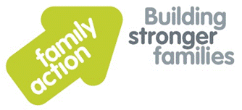
SOLIHULL SENDIAS
Referral and Exit Criteria

What is Solihull SENDIAS?
Solihull SENDIAS is a statutory service that provides information, advice and support to children and young people with Special Educational Needs and Disabilities (SEND) and their parents/carers.

- Statutory means the local authority HAVE to do something. It’s the law!
- A young person is anyone aged 25 years old or younger

How do I get help or advice from Solihull SENDIAS?
If you think you might like help from Solihull SENDIAS there are three different things you can choose to do:
- You can get in touch yourself
- Your parent or carer can get in touch with us
- You can ask someone else who supports you to help you get in touch with us (this could be a social worker, a support worker, a teacher or someone different)

Sometimes it might be ok for other organisations to contact us for you but only if they have your permission
Other services can also contact Solihull SENDIAS for general advice around SEND (special educational needs and disabilities)

Asking Solihull SENDIAS for help or advice is easy!
You can get in touch by:
- Email - solihullsendias@family-action.org.uk
- Telephone - 0121 516 5173

- In person at any event that we are attending.

Please be aware, if you come to see us and don’t have an appointment, we won’t be able to see you on that day.

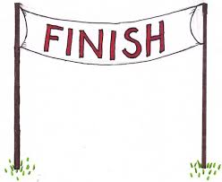
When will Solihull SENDIAS stop working with me?
We will stop working with young people or their families when:

- You, (the young person) or your parent/ carer does not want any more help or advice
- You are happy with the help and advice we have given you and don’t need anything else
- If the case has gone to SENDIST appeal & the outcome has been agreed.
- If another service are giving you information, advice & support about the same issues.
When we have finished working with you we will probably contact you and ask for your feedback on the help or advice we gave you.
What if I need more help and advice?
You can contact us at any time up until your 26th birthday. You might want help or advice about the same issue or about something different. These are both ok.

