Placing children first

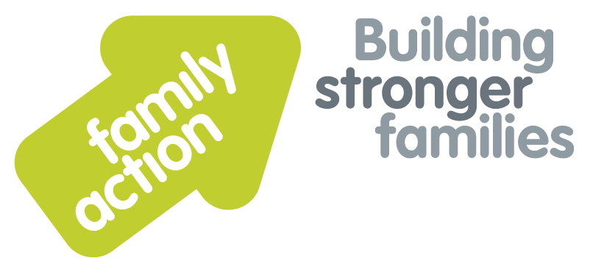

|  |  |  |  |
| --- | --- | --- | --- |
| **Placing children first** |  | |  |
| One-Day Workshop  **In London**  Becoming an Effective Panel Member  **Adoption and Fostering** | | | |
| Wednesday, 4 September 2019 | | | |
| **Focus**  Fostering and adoption panels play a key role in decision making for children, prospective carers and carers who have already been approved. If you have been, or are thinking about being appointed to a panel, this workshop will prepare you and give you the opportunity to develop the knowledge required to fulfil your role.  The workshop will enable you to gain an understanding of the legislative and regulatory requirements of panel, your responsibilities as a panel member and the responsibilities of others in the panel team and the wider service.  **Target Group**  New panel members in fostering or adoption panels, individuals considering undertaking a role on panel, and panel administrators wanting to know more about panel members’ roles.  This training can be offered as part of the induction that agencies are required to offer to all new panel members. (Fostering NMS 2011 23.9 and Adoption NMS 2014 23.24). | | **Trainer**  Nicky Probert is a Training Manager for Family Action, with over 30 years of social work experience including acting as a Panel Chair for 7 years. She is an experienced trainer, having previously worked for BAAF for over 12 years. Nicky has a consultancy role as an ADM for an independent agency.  **Learning Outcomes**  By the end of the day participants will be able to:   * Name current legislation, regulations, guidance, National Minimum Standards and recent case law that impact on panel business; * Apply learning from serious case reviews; * Name requirements in terms of panel constitution and function for adoption and fostering panels according to legislation, regulations and guidance; * Develop strategies to keep a focus on the child when considering all reports presented to panel; * Apply frameworks for analysis in relation to assessments and reviews; * Apply critical reading methods to reports presented. | |
| **Venue**    **Family Action**  34 Wharf Road  **London**, N1 7GR  T: 0207 254 6251 | **Timing**  9.30am Registration  9.45am Start  4.30pm Finish    Refreshments  & light lunch provided |
| Family Action, 55 Stevens Avenue, Bartley Green, Birmingham, B32 3SD  T: 07469 660 479 E: [joy.broadhurst@family-action.org.uk](mailto:joy.broadhurst@family-action.org.uk) [www.family-action.org.uk](http://www.family-action.org.uk)/training | | | |

|  |  |  |  |
| --- | --- | --- | --- |
| **Registration Form**  One-Day Workshop | Becoming an Effective Panel Member  4 September 2019 | | |
| **Fee**    **£95.00** (+VAT £19.00) **=** **£114.00**     * Remittance enclosed – cheque (including VAT) payable to *‘Family Action’* * Please invoice * To pay by credit/debit card please follow this link to our Eventbrite page:   [*https://panelmembers-london-4september2019.eventbrite.com*](https://panelmembers-london-4september2019.eventbrite.com)  In the event of cancellation, a cancellation fee is chargeable, as detailed below.   * If you **WOULD** like us to contact you by e-mail in the future, with more information about our courses, services and activities, please **TICK** this box. You can see our privacy policy by following this link:[*Privacy Policy*](https://www.family-action.org.uk/content/uploads/2018/07/Family-Action-Privacy-Notice-TC.docx) | | | |
| Name: | |  | Agency name & address: |
| Position/Role: | |  |  |
|  | |  |  |
| Requirements  (eg: dietary, disability access): | |  |  |
|  |
| Telephone: | |  | Post code: |
| E-mail: | |  | Billing e-mail *(if different):* |
|  | |  |  |
| **We will confirm your place and send joining**  **instructions via e-mail, so please write clearly** | |  | Your purchase order number: |
| **Substitutions and cancellations**  Completion of this booking form is a binding agreement. Substitutions are welcome at any time. Family Action reserves the right to levy a fee in the event of your cancellation. More than 6 weeks prior to the event 25% of the fee; between 2 and 6 weeks 50%; less than 2 weeks 100%. In the event that you wish to transfer your booking to another workshop date, we reserve the right to levy a 25% administration fee, if you then cancel your place, the previous cancellation fee would also apply. | | | |
| **Please e-mail/post completed form (indicating your method of payment) to:-**  **Joy Broadhurst**  **Family Action**  **55 Stevens Avenue, Bartley Green, Birmingham, B32 3SD**  E: [Joy.broadhurst@family-action.org.uk](mailto:Joy.broadhurst@family-action.org.uk)  T: 07469 660 479 www.family-action.org.uk/training  Registered Charity no: 264713. Registered Company Limited in England and Wales: 01068186 | | | |