Placing children first

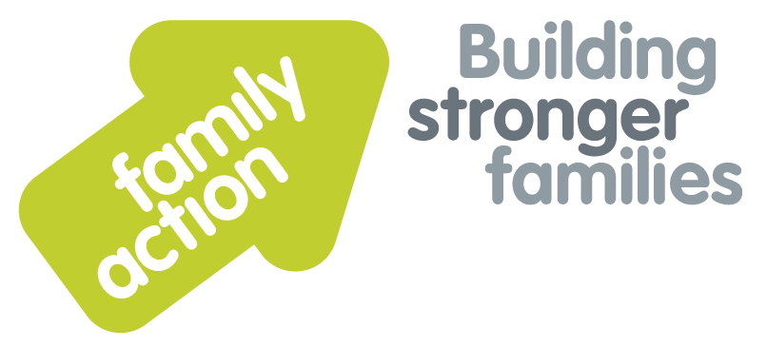

|  |  |  |  |
| --- | --- | --- | --- |
| **Placing children first** |  | |  |
| One-Day Workshop  **In London**  Safeguarding & Child Protection  for Family Placement Services  **Adoption and Fostering** | | | |
| Wednesday, 5 February 2020 | | | |
| **Target Group**  **Fostering, Adoption, Kinship Care and Special Guardianship Services.** Social workers, support staff, administrators, managers, panel members, advisers and chairs in fostering or adoption agencies, and kinship/special guardianship teams.  **Focus**  Ensuring the safety of vulnerable children is a priority for all fostering and adoption agencies, but Ofsted inspection reports, serious case reviews and child practice reviews have shown that at times children in placement have been left vulnerable to further abuse and neglect.  This workshop emphasises the need for continued vigilance from all those involved in family placement services. It helps agencies to ensure that staff and panel members have safeguarding and child protection at the heart of all they do, and raises awareness of the vulnerability of children and the steps necessary to ensure that robust processes are in place to protect children from harm.  **Trainers**  Nicky Probert and Kanu Patel are Training & Consultancy Managers for Family Action, both with over 30 years’ of social work experience in the fields of child care, child protection and adoption & fostering. | | **Learning Outcomes**  By the end of the day participants will be able to:   * Identify child protection and safeguarding issues that may affect children placed in substitute family care throughout their lifetime; * Recognise the vulnerabilities of particular groups including children with a disability, children who have previously experienced trauma, sexual exploitation, asylum seeking children and those who have been trafficked; * Describe the responsibilities of carers and the agency when children and young people go missing from care; * Identify the risks posed by child sexual exploitation in the context of poly-victimisation and children who have experienced betrayal trauma; * Describe the short and long term consequences of female genital mutilation; * Identify risks in relation to the radicalisation of children and young people; * Apply a framework to identify risks and vulnerabilities when considering contact arrangements for children with their birth family members; * Recognise potential risks for carers and their families; * Apply learning from serious case reviews; * Identify how to make child protection or position of trust referrals to statutory services, and raising any safeguarding concerns with the agency using the whistleblowing procedure when necessary; * Describe the impact of secondary post traumatic stress on carers and workers.   This course is also available to commission in-house for 8–25 participants where a daily delivery rate is charged. Please call us for enquiries regarding costings and availability. | |
| **Venue**    **Family Action**  34 Wharf Road  **London**, N1 7GR  T: 0207 254 6251 | **Timing**  9.30am Registration  9.45am Start  4.30pm Finish    Refreshments  & light lunch provided |
| Family Action, 55 Stevens Avenue, Bartley Green, Birmingham, B32 3SD  T: 07469 660 479 E: [joy.broadhurst@family-action.org.uk](mailto:joy.broadhurst@family-action.org.uk) [www.family-action.org.uk](http://www.family-action.org.uk)/training | | | |

|  |  |  |  |
| --- | --- | --- | --- |
| **Registration Form**  One-Day Workshop | Safeguarding & Child Protection  for Family Placement Services  5 February 2020 | | |
| **Fee**    **£95.00** (+VAT £19.00) **=** **£114.00**     * Remittance enclosed – cheque (including VAT) payable to *‘Family Action’* * Please invoice * To pay by credit/debit card please follow this link to our Eventbrite page:   [*https://safeguardingandcp-london-5february2020.eventbrite.com*](https://safeguardingandcp-london-5february2020.eventbrite.com)  In the event of cancellation, a cancellation fee is chargeable, as detailed below.   * If you **WOULD** like us to contact you by e-mail in the future, with more information about our courses, services and activities, please **TICK** this box. You can see our privacy policy by following this link:[*Privacy Policy*](https://www.family-action.org.uk/content/uploads/2018/07/Family-Action-Privacy-Notice-TC.docx) | | | |
| Name: | |  | Agency name & address: |
| Position/Role: | |  |  |
|  | |  |  |
| Requirements  (eg: dietary, disability access): | |  |  |
|  |
| Telephone: | |  | Post code: |
| E-mail: | |  | Billing e-mail *(if different):* |
|  | |  |  |
| **We will confirm your place and send joining**  **instructions via e-mail, so please write clearly** | |  | Your purchase order number: |
| **Substitutions and cancellations**  Completion of this booking form is a binding agreement. Substitutions are welcome at any time. Family Action reserves the right to levy a fee in the event of your cancellation. More than 6 weeks prior to the event 25% of the fee; between 2 and 6 weeks 50%; less than 2 weeks 100%. In the event that you wish to transfer your booking to another workshop date, we reserve the right to levy a 25% administration fee, if you then cancel your place, the previous cancellation fee would also apply. | | | |
| **Please e-mail/post completed form (indicating your method of payment) to:-**  **Joy Broadhurst**  **Family Action**  **55 Stevens Avenue, Bartley Green, Birmingham, B32 3SD**  E: [Joy.broadhurst@family-action.org.uk](mailto:Joy.broadhurst@family-action.org.uk)  T: 07469 660 479 www.family-action.org.uk/training  Registered Charity no: 264713. Registered Company Limited in England and Wales: 01068186 | | | |