**Two-Day Workshop**

**In London**

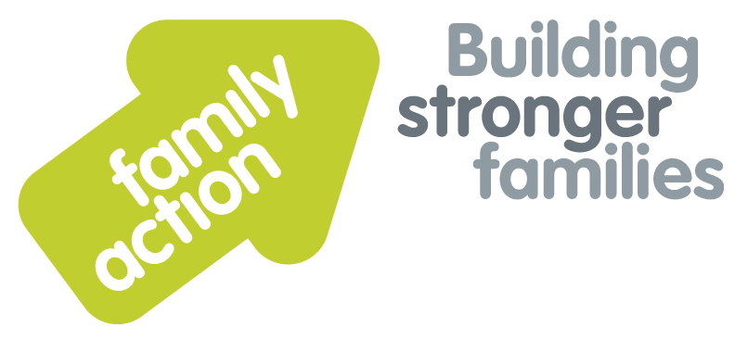

|  |  |  |  |
| --- | --- | --- | --- |
| **Placing children first** |  | |  |
| Strengthening Fostering Assessments | | | |
| 22 - 23 January 2020 | | | |
| **Focus**  Rigorous, evidence based and analytic fostering assessments are essential to ensure that prospective foster carers can meet the complex needs of children placed in their care. This workshop is suitable for new and experienced assessors, and will develop participants’ skills by introducing frameworks for analysis and assessment tools to engage fostering households in the assessment process. This training is equally applicable when using any assessment template, such as the Form F or the Skills to Foster assessment materials.  **Trainer**  Nicky Probert is a Training Manager for Family Action, with over 30 years of social work experience including acting as a Panel Chair for 7 years. She is an experienced trainer, having previously worked for BAAF for over 12 years. Nicky has a consultancy role as an ADM for an independent fostering agency. | | **Target Group**  New and experienced assessors and their managers, and panel members, panel administrators or chairs who wish to understand the assessment process more fully.  **Learning Outcomes**   * Name the key legislation, regulations and guidance relating to the assessment and approval process; * Plan and manage the assessment process; * Develop robust methods to review and analyse checks and references based on learning from serious case reviews; * Define the skills, knowledge and values required by foster carers to fulfil their role; * Name sources of evidence which can be used to support applications; * Identify tools to engage all family members in the assessment process; * Apply frameworks for analysis which identify risk and protective factors; * Develop recommendations regarding training/development plans for carers; * Present robust and well-evidenced recommendations to panel.   This course is also available to commission in-house for 8–25 participants where a daily delivery rate is charged. Please call us for enquiries regarding costings and availability. | |
| **Venue**    **Family Action**  34 Wharf Road  London, N1 7GR  T: 0207 254 6251 | **Timing**  9.30am Registration  9.45am Start  4.30pm Finish    Refreshments  & light lunch provided |
| Family Action, 55 Stevens Avenue, Bartley Green, Birmingham, B32 3SD  T: 07469 660 479 E: [joy.broadhurst@family-action.org.uk](mailto:joy.broadhurst@family-action.org.uk) [www.family-action.org.uk](http://www.family-action.org.uk)/training | | | |

|  |  |  |  |
| --- | --- | --- | --- |
| **Registration Form**  Two-Day Workshop | Strengthening Fostering Assessments  22 – 23 January 2020 | | |
| **Fee**    **£190.00** (+VAT £38.00) **=** **£228.00**     * Remittance enclosed – cheque (including VAT) payable to *‘Family Action’* * Please invoice * To pay by credit/debit card please follow this link to our Eventbrite page:   [*https://strengtheningassessments-london-22-23january2020.eventbrite.com*](https://strengtheningassessments-london-22-23january2020.eventbrite.com)  In the event of cancellation, a cancellation fee is chargeable, as detailed below.   * If you **WOULD** like us to contact you by e-mail in the future, with more information about our courses, services and activities, please **TICK** this box. You can see our privacy policy by following this link:[*Privacy Policy*](https://www.family-action.org.uk/content/uploads/2018/07/Family-Action-Privacy-Notice-TC.docx) | | | |
| Name: | |  | Agency name & address: |
| Position/Role: | |  |  |
|  | |  |  |
| Requirements  (eg: dietary, disability access): | |  |  |
|  |
| Telephone: | |  | Post code: |
| E-mail: | |  | Billing e-mail *(if different):* |
|  | |  |  |
| **We will confirm your place and send joining**  **instructions via e-mail, so please write clearly** | |  | Your purchase order number: |
| **Substitutions and cancellations**  Completion of this booking form is a binding agreement. Substitutions are welcome at any time. Family Action reserves the right to levy a fee in the event of your cancellation. More than 6 weeks prior to the event 25% of the fee; between 2 and 6 weeks 50%; less than 2 weeks 100%. In the event that you wish to transfer your booking to another workshop date, we reserve the right to levy a 25% administration fee, if you then cancel your place, the previous cancellation fee would also apply. | | | |
| **Please e-mail/post completed form (indicating your method of payment) to:-**  **Joy Broadhurst**  **Family Action**  **55 Stevens Avenue, Bartley Green, Birmingham, B32 3SD**  E: [Joy.broadhurst@family-action.org.uk](mailto:Joy.broadhurst@family-action.org.uk)  T: 07469 660 479 www.family-action.org.uk/training  Registered Charity no: 264713. Registered Company Limited in England and Wales: 01068186 | | | |