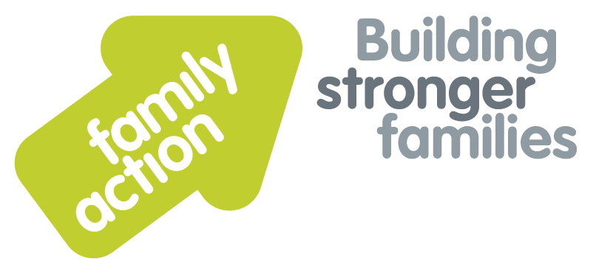

One-Day Workshop **in London**

|  |  |  |  |
| --- | --- | --- | --- |
| **Placing children first**  Strengthening Special Guardianship Assessments |  | |  |
|  | | | |
| Thursday, 6 February 2020 | | | |
| **Focus**  Special Guardianship Orders were first introduced in 2005 as a private law application which would offer an alternative route to permanence for children outside the care system. Whilst originally intended to ensure children could be offered stability and security by living with existing foster carers or family members, eleven years on, we have seen a huge increase in the numbers of children leaving care through SGO’s and an increasing concern amongst practitioners that at times these orders may not provide the safe, positive and permanent family experience that is intended.  Recent research and regulatory changes have led to an increased awareness of the importance of producing robust and analytic special guardianship assessments. Drawing on important messages from two reports published by the DfE: ‘The impact of Family Justice Reforms on Front Line Practice Phase 2: Special Guardianship Orders’ (2015) and ‘Guardianship: experiences, challenges and outcomes research report’ (2014) the course will highlight areas which require particular attention during the assessment process.  The workshop aims to enable new and existing practitioners to strengthen their assessments and at the same time to highlight any vulnerabilities and extra support needs that families may have. This will include consideration of the use of therapeutic support which is now available through the adoption support fund. | | **Target Group**  Social workers conducting special guardianship assessments, their managers and children’s team social workers.  **Trainer**  Nicky Probert is a Training Manager for Family Action with over 30 years of social work experience. She has worked as an assessor and manager in the field of adoption, and is an experienced trainer, having worked for BAAF for over 12 years. Nicky offers consultancy to Family Action’s national  **Special Guardianship Support Service**.  **Learning Outcomes**  By the end of the workshop participants will be able to:   * Describe the legislative and regulatory framework and current context for SGO assessments; * Identify messages from recent research and learning from Serious case reviews that inform best practice in SGO assessments; * Identify the factors involved in successful placements and in those which might lead to disruptions; * Define the secure base model and its application to the assessment of special guardians; * Identify tools to assess family dynamics, conflicts and loyalty issues in the assessment; * Apply frameworks for analysis which identify risk and protective factors; * Present robust and well evidenced assessment reports which highlight strengths and vulnerabilities and identify support needs. | |
| **Venue**  **Family Action**  34 Wharf Road  London, N1 7GR  Tel: 0207 254 6251 | **Timing**  9.30am Registration  9.45am Start  4.30pm Finish    Refreshments  & light lunch provided |
| Family Action, 55 Stevens Avenue, Bartley Green, Birmingham, B32 3SD  T: 07469 660 479 E: [joy.broadhurst@family-action.org.uk](mailto:joy.broadhurst@family-action.org.uk) [www.family-action.org.uk](http://www.family-action.org.uk)/training | | | |

|  |  |  |  |
| --- | --- | --- | --- |
| **Registration Form**  One-Day Workshop | Strengthening Special  Guardianship Assessments  6 February 2020 | | |
| **Fee**    **£95.00** (+VAT £19.00) **=** **£114.00**     * Remittance enclosed – cheque (including VAT) payable to *‘Family Action’* * Please invoice * To pay by credit/debit card please follow this link to our Eventbrite page:-   <https://strengtheningsgassessments-london-6february2020.eventbrite.com>      In the event of cancellation, a cancellation fee is chargeable, as detailed below.   * If you **WOULD** like us to contact you by e-mail in the future, with more information about our courses, services and activities, please **TICK** this box. You can see our privacy policy by following this link:[*Privacy Policy*](https://www.family-action.org.uk/content/uploads/2018/07/Family-Action-Privacy-Notice-TC.docx) | | | |
| Name: | |  | Agency name & address: |
| Position/Role: | |  |  |
|  | |  |  |
| Requirements  (eg: dietary, disability access): | |  |  |
|  |
| Telephone: | |  | Post code: |
| E-mail: | |  | Billing e-mail *(if different):* |
|  | |  |  |
| **We will confirm your place and send joining**  **instructions via e-mail, so please write clearly** | |  | Your purchase order number: |
| **Substitutions and cancellations**  Completion of this booking form is a binding agreement. Substitutions are welcome at any time. Family Action reserves the right to levy a fee in the event of your cancellation. More than 6 weeks prior to the event 25% of the fee; between 2 and 6 weeks 50%; less than 2 weeks 100%. In the event that you wish to transfer your booking to another workshop date, we reserve the right to levy a 25% administration fee, if you then cancel your place, the previous cancellation fee would also apply. | | | |
| **Please e-mail/post completed form (indicating your method of payment) to:-**  **Joy Broadhurst**  **Family Action**  **55 Stevens Avenue, Bartley Green, Birmingham, B32 3SD**  E: [Joy.broadhurst@family-action.org.uk](mailto:Joy.broadhurst@family-action.org.uk)  T: 07469 660 479 www.family-action.org.uk/training  Registered Charity no: 264713. Registered Company Limited in England and Wales: 01068186 | | | |