**Two-Day Workshop**

**In London**

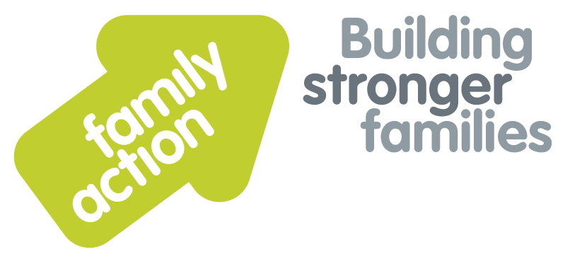

|  |  |  |  |
| --- | --- | --- | --- |
| **Placing children first** |  | |  |
| Supervising Social Workers  in Fostering Services | | | |
| 18 – 19 December 2019 | | | |
| **Focus**  The role of the Supervising Social Worker is key in enabling Fostering Services to ensure that vulnerable looked after children are safe, nurtured and that their resilience is being promoted. Yet there is often little opportunity to prepare new workers for this role or for experienced staff to reflect on their practice.  This two-day workshop enables Social Workers to apply robust frameworks to their supervisory practice, taking into account what we know from research and lessons from serious case reviews. We will also examine the role of emotional intelligence and adult learning in relation to enable reflective practice in foster carers and examine how to tackle difficult conversations and performance issues.  **Trainer**  Nicky Probert is a Training Manager for Family Action, with over 30 years of social work experience including acting as a Panel Chair for 7 years. She is an experienced trainer, having previously worked for BAAF for over 12 years. Nicky has a consultancy role as an ADM for an independent fostering agency. | | **Target Group**  Experienced and new Supervising Social Workers or those considering this role, managers in fostering services and panel members or chairs who wish to gain more knowledge and understanding of the role.  **Workshop Outline**  This workshop will examine the supervisory task in relation to the 4x4x4 model, which highlights the key functions of supervision, and relates these directly to foster carers’ tasks:   * Management * Support * Development * Mediation   The workshop will use group discussions, case studies and small group exercises to achieve the learning outcomes.  A full list of learning outcomes is available on request from [joy.broadhurst@family-action.org.uk](mailto:joy.broadhurst@family-action.org.uk)  This course is also available to commission in-house for 8–25 participants where a daily delivery rate is charged. Please call us for enquiries regarding costings and availability. | |
| **Venue**    **Family Action**  34 Wharf Road  London, N1 7GR  T: 0207 254 6251 | **Timing**  9.30am Registration  9.45am Start  4.30pm Finish    Refreshments  & light lunch provided |
| Family Action, 55 Stevens Avenue, Bartley Green, Birmingham, B32 3SD  T: 07469 660 479 E: [joy.broadhurst@family-action.org.uk](mailto:joy.broadhurst@family-action.org.uk) [www.family-action.org.uk](http://www.family-action.org.uk)/training | | | |

|  |  |  |  |
| --- | --- | --- | --- |
| **Registration Form**  Two-Day Workshop | Supervising Social Workers  in Fostering Services  18 -19 December 2019 | | |
| **Fee**    **£190.00** (+VAT £38.00) **=** **£228.00**     * Remittance enclosed – cheque (including VAT) payable to *‘Family Action’* * Please invoice * To pay by credit/debit card please follow this link to our Eventbrite page:   [*https://supervisingsocialworkers-london-18-19december2019.eventbrite.com*](https://supervisingsocialworkers-london-18-19december2019.eventbrite.com)  In the event of cancellation, a cancellation fee is chargeable, as detailed below.   * If you **WOULD** like us to contact you by e-mail in the future, with more information about our courses, services and activities, please **TICK** this box. You can see our privacy policy by following this link:[*Privacy Policy*](https://www.family-action.org.uk/content/uploads/2018/07/Family-Action-Privacy-Notice-TC.docx) | | | |
| Name: | |  | Agency name & address: |
| Position/Role: | |  |  |
|  | |  |  |
| Requirements  (eg: dietary, disability access): | |  |  |
|  |
| Telephone: | |  | Post code: |
| E-mail: | |  | Billing e-mail *(if different):* |
|  | |  |  |
| **We will confirm your place and send joining**  **instructions via e-mail, so please write clearly** | |  | Your purchase order number: |
| **Substitutions and cancellations**  Completion of this booking form is a binding agreement. Substitutions are welcome at any time. Family Action reserves the right to levy a fee in the event of your cancellation. More than 6 weeks prior to the event 25% of the fee; between 2 and 6 weeks 50%; less than 2 weeks 100%. In the event that you wish to transfer your booking to another workshop date, we reserve the right to levy a 25% administration fee, if you then cancel your place, the previous cancellation fee would also apply. | | | |
| **Please e-mail/post completed form (indicating your method of payment) to:-**  **Joy Broadhurst**  **Family Action**  **55 Stevens Avenue, Bartley Green, Birmingham, B32 3SD**  E: [Joy.broadhurst@family-action.org.uk](mailto:Joy.broadhurst@family-action.org.uk)  T: 07469 660 479 www.family-action.org.uk/training  Registered Charity no: 264713. Registered Company Limited in England and Wales: 01068186 | | | |