Placing children first

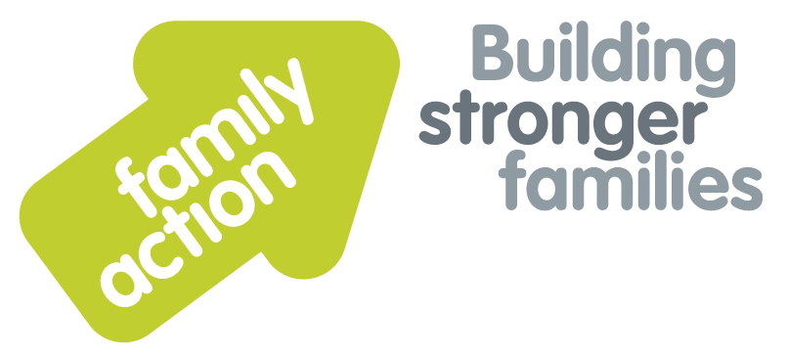

|  |  |  |  |
| --- | --- | --- | --- |
|  |  | |  |
| One-Day Workshop  **In London**  Understanding Mental Health Issues in Fostering and Adoption Assessments  **Adoption and Fostering** | | | |
| Friday, 11 October 2019 | | | |
| **Focus**  Fostering and adoption services need an awareness of the impact of mental health issues for carers, both within the assessment process, and to support carers looking after vulnerable children. There is a need to balance an accurate risk assessment with a positive and anti-discriminatory attitude towards mental ill health and recovery. This workshop enables professionals and panel members to explore the concept of the mental health continuum, to familiarise themselves with some mental health conditions and their prognoses, and to explore some of the dilemmas they may encounter in the assessment, review and support of carers.  **Target Group**  Those involved in assessing and supporting adopters and foster carers, including supervising social workers and their managers, medical advisers, agency decision makers, panel chairs and vice chairs, and panel members and advisers.  **Trainer**  Nicky Probert is a Training & Consultancy Manager for Family Action, with over 30 years of social work experience including acting as a Panel Chair for 7 years. She is an experienced trainer, having previously worked for the British Association for Adoption & Fostering for over 12 years. Nicky has a consultancy role as an ADM for an independent fostering agency. | | **Learning Outcomes**  This training aims to enable panel members and assessors to understand how mental health conditions may impact on applicants wishing to foster or adopt.  By the end of the day participants will be able to:   * Identify the impact of participants’ own values and beliefs on perceptions of mental ill health; * Describe how people with mental health difficulties may experience stigma and discrimination; * Identify the legislation that prevents discrimination on the grounds of disability; * Describe the Mental Health Continuum and consider the implications for applicants with mental health conditions; * Identify the signs, symptoms, indicators and impact of common mental health conditions; * Identify sources of stress and pre-disposing factors that may impact on mental health, including the issues of loss; * Use the recent life events questionnaire to assess the impact of stress on applicants; * Use the Resilience Vulnerability Matrix to assess protective factors, adversity and applicant/s’ resilience and vulnerabilities; * Use the Strengthening Families Framework to analyse information and apply critical reading methods to reports presented. | |
| **Venue**    **Family Action**  34 Wharf Road  **London**, N1 7GR  T: 0207 254 6251 | **Timing**  9.30am Registration  9.45am Start  4.30pm Finish    Refreshments  & light lunch provided |
| Family Action, 55 Stevens Avenue, Bartley Green, Birmingham, B32 3SD  T: 07469 660 479 E: [joy.broadhurst@family-action.org.uk](mailto:joy.broadhurst@family-action.org.uk) [www.family-action.org.uk](http://www.family-action.org.uk)/training | | | |

|  |  |  |  |
| --- | --- | --- | --- |
| **Registration Form**  One-Day Workshop | Understanding Mental Health Issues in Fostering and Adoption Assessments  11 October 2019 | | |
| **Fee**    **£95.00** (+VAT £19.00) **=** **£114.00**     * Remittance enclosed – cheque (including VAT) payable to *‘Family Action’* * Please invoice * To pay by credit/debit card please follow this link to our Eventbrite page:   [*https://mentalhealthinassessment-london-11october2019.eventbrite.com*](https://mentalhealthinassessment-london-11october2019.eventbrite.com)  In the event of cancellation, a cancellation fee is chargeable, as detailed below.   * If you **WOULD** like us to contact you by e-mail in the future, with more information about our courses, services and activities, please **TICK** this box. You can see our privacy policy by following this link:[*Privacy Policy*](https://www.family-action.org.uk/content/uploads/2018/07/Family-Action-Privacy-Notice-TC.docx) | | | |
| Name: | |  | Agency name & address: |
| Position/Role: | |  |  |
|  | |  |  |
| Requirements  (eg: dietary, disability access): | |  |  |
|  |
| Telephone: | |  | Post code: |
| E-mail: | |  | Billing e-mail *(if different):* |
|  | |  |  |
| **We will confirm your place and send joining**  **instructions via e-mail, so please write clearly** | |  | Your purchase order number: |
| **Substitutions and cancellations**  Completion of this booking form is a binding agreement. Substitutions are welcome at any time. Family Action reserves the right to levy a fee in the event of your cancellation. More than 6 weeks prior to the event 25% of the fee; between 2 and 6 weeks 50%; less than 2 weeks 100%. In the event that you wish to transfer your booking to another workshop date, we reserve the right to levy a 25% administration fee, if you then cancel your place, the previous cancellation fee would also apply. | | | |
| **Please e-mail/post completed form (indicating your method of payment) to:-**  **Joy Broadhurst**  **Family Action**  **55 Stevens Avenue, Bartley Green, Birmingham, B32 3SD**  E: [Joy.broadhurst@family-action.org.uk](mailto:Joy.broadhurst@family-action.org.uk)  T: 07469 660 479 www.family-action.org.uk/training  Registered Charity no: 264713. Registered Company Limited in England and Wales: 01068186 | | | |