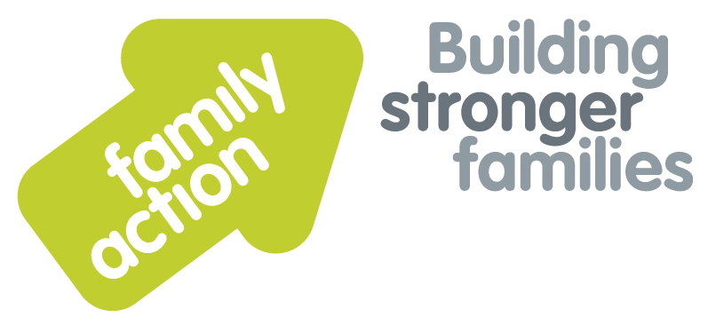

|  |  |  |  |
| --- | --- | --- | --- |
| **Placing children first**  **Two-Day Training Course**  In Birmingham |  | |  |
| Child Protection and Safeguarding for Designated Safeguarding Leads | | | |
| 17 & 18 September 2019 | | | |
| **Aim**  This training aims to enable Designated Safeguarding Leads in Early Years settings, out of school provisions and childminding arrangements, to fulfil their statutory obligations to recognise and act on any concerns about abuse, neglect or other forms of harm for children and young people in their care.  All our trainers are qualified and highly experienced in the delivery of safeguarding and child protection training to designated safeguarding leads, and multi-agency professionals.  **Target Group**  Designated Safeguarding Leads in Early Years settings, Out of School provisions and childminders. | | **DSL Statutory Requirements**  Designated Safeguarding Leads need a comprehensive understanding of their roles and responsibilities, as set out in the statutory framework for the Early Years Foundation Stage 2017. Ofsted inspections will focus on whether safeguarding requirements are met, and also on Early Help that is offered to children and their families when concerns about a child’s development are first raised. The training offered will enable DSLs to carry out their role confidently and effectively.  Areas of training covered encompass:-   * Legislation, policies and procedures * Early help * Identifying abuse, neglect and forms of harm, such as FGM and radicalisation * Learning from Serious Case Reviews * Culture, diversity and personal values * Supporting and informing staff * Safer working practices: staff behaviour policies, recruitment and monitoring, POTS referrals * Information sharing, recording and reporting practice; whistleblowing   For a comprehensive list of Learning Outcomes please see  [www.family-action.org.uk/training](http://www.family-action.org.uk/training) | |
| **Venue**      **The Hub, Hazelwell**  318 Vicarage Road Kings Heath **Birmingham B14 7NH**  Tel: 0121 441 5500 | **Timing**    9.15 am Registration  9.30am Start  4.30pm Finish |
| Family Action, 55 Stevens Avenue, Bartley Green, Birmingham, B32 3SD  T: 07469 660 479 E: [joy.broadhurst@family-action.org.uk](mailto:joy.broadhurst@family-action.org.uk) [www.family-action.org.uk](http://www.family-action.org.uk)/training | | | |

|  |  |  |  |
| --- | --- | --- | --- |
| **Registration Form**  **CP & Safeguarding**  **for DSLs** | **Two-Day Training Course**  17 & 18 September 2019 | | |
| **Fee**    **£160.00** (+VAT £32.00) **=** **£192.00**  **£140.00 (+VAT £28.00) = £168.00** (Early Bird Discount if booked prior to 18 August 2019)     * Remittance enclosed – cheque (including VAT) payable to *‘Family Action’* * Please invoice * To pay by credit/debit card please follow this link to our Eventbrite page:-   [*https://cpandsafeguardingfordsls2day17and18september2019.eventbrite.com*](https://cpandsafeguardingfordsls2day17and18september2019.eventbrite.com)  In the event of cancellation, a cancellation fee is chargeable, as detailed below.   * If you **WOULD** like us to contact you by e-mail in the future, with more information about our courses, services and activities, please **TICK** this box. You can see our privacy policy by following this link:[*Privacy Policy*](https://www.family-action.org.uk/content/uploads/2018/07/Family-Action-Privacy-Notice-TC.docx) | | | |
| Name: | |  | Agency name & address: |
| Position/Role: | |  |  |
|  | |  |  |
| Requirements  (eg: dietary, disability access): | |  |  |
|  |
| Telephone: | |  | Post code: |
| E-mail: | |  | Billing e-mail *(if different):* |
|  | |  |  |
| **We will confirm your place and send joining**  **instructions via e-mail, so please write clearly** | |  | Your purchase order number: |
| **Substitutions and cancellations**  Completion of this booking form is a binding agreement. Substitutions are welcome at any time. Family Action reserves the right to levy a fee in the event of your cancellation. More than 6 weeks prior to the event 25% of the fee; between 2 and 6 weeks 50%; less than 2 weeks 100%. | | | |
| **Please e-mail/post completed form (indicating your method of payment) to:-**  **Joy Broadhurst**  **Family Action**  **55 Stevens Avenue, Bartley Green, Birmingham, B32 3SD**  E: [Joy.broadhurst@family-action.org.uk](mailto:Joy.broadhurst@family-action.org.uk)  T: 07469 660 479 www.family-action.org.uk/training  Registered Company Limited in England and Wales: 01514576 VAT Registration no. 227 3222 34  Family Action Enterprises Limited is a fully owned subsidiary of Family Action, Registered Charity no: 264713 | | | |