Holiday Hub in Stapleford, Summer 2019

Our Holiday Hub sessions took place this summer at the Haven Centre in Stapleford, Notts.

- 28 families attended across the 8 sessions
- 48 participants were children
- 30 were adults

The rooms were set up for all age groups and abilities. For example, we had an under 1s area, as well as construction, small world, role play, home corner and creative areas. We also had an outdoor physical area and an under 1s area set up outside.

We offered a variety of healthy meals, and did a range of price comparison activities so that families could see the benefits of homemade food compared to shop bought or takeaway items.
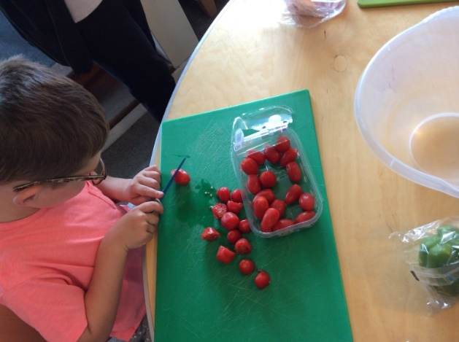
We had a board on display clearly showing the day’s menu and what allergens were contained in each of the food items. We also made sure we had a gluten free, vegetarian and vegan option.

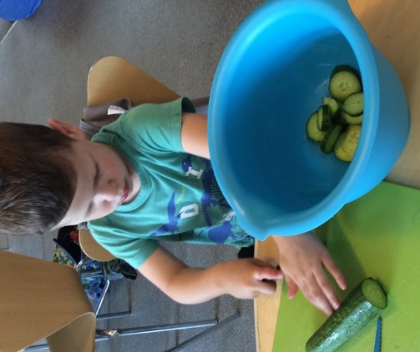
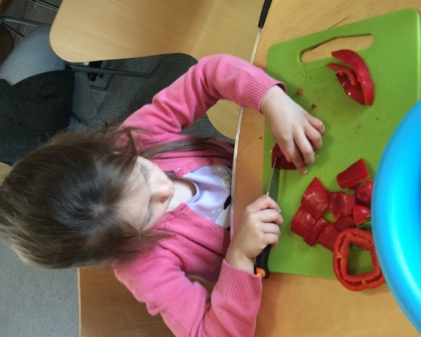
Children’s feedback

‘I have enjoyed making my own food.’ – K aged 8
‘I liked making a lion face on my pizza.’ – J age 5

Our meals included:

- Pizza top cobs and salad: We invited children to chop and prepare their own toppings and salad, including peppers, mushrooms, cucumber, tomatoes and lettuce. We did a price comparison exercise, comparing their meals with Dominos and Pizza Hut, and showed families they could save up to £30 by making their own pizza. We also showed families they could use wraps to make calzone or pitta breads as well as cobs.
- Pasta bar: We provided different pastas such as wheat and ‘coloured pasta’, which contained tomatoes and spinach. This was very appealing to the children. The most popular filling was tuna mayo, with children asking for seconds. Parents commented that they enjoyed the pesto and would not have thought to use that at home.
- Fruit and custard/yogurt: The children enjoyed preparing the fruit, and also trying fruits they had not tried before, such as mango and blueberries. We had a variety of tinned, fresh and frozen fruit to show the families. Children enjoyed the option of warm and cold custard.
- Jacket potatoes: We provided white potatoes, red potatoes and sweet potatoes. The families had a selection of hot and cold fillings to select from such as beans, tuna and cheese. One family suggested that we could offer chilli as another hot option in future.
- Healthy party food: This session aimed to show families how to make a healthy party buffet. The children were, for instance, invited to cut up celery, carrots and cucumbers into sticks.
- Fruity flapjack: This went down very well with families, and some families asked for the recipe so they could make it at home. We added grated apple into the flapjack and showed the families alternative fruit they could add.
Each week was themed and the activities would match the theme.

- Week 1: Animals – Families made animal masks and we spoke about different animals. We set up a farm and also a ‘Dinosaur World’. We read animal books such as The Hungry Caterpillar and The Gruffalo. After reading the The Hungry Caterpillar this got the children talking about different insects, and J and the children went outside to extend the children’s learning by going on our very own bug hunt.
- Week 2: Musical instruments – Families enjoyed making shakers with bottles and rice. M from the children’s centre brought her drums in and did a small drumming workshop, and each child had their own small drum to join in. G from ‘Broxtowe Everybody Health’ also joined us to do sports activities. The children enjoyed the cone game and the football games.
- Week 3: All the fun of the fair – Children were able to join in with ‘tin can alley’ and ‘hook a duck’. This got parents and some of the older children discussing Goose Fair and Ilkeston fair and all the fun memories they had there when they were younger and the food they had. A Zumba instructor came in to do a 45-minute Zumba session. She spoke to the families about the importance of exercise and showed them some simple moves they could dance along to at home.
- Week 4: Magic – The children enjoyed making their own wands and casting spells. One child said he felt like Harry Potter, so we changed the table place cards to Harry Potter themed ones. We also had ‘Alex-cadabra’, the magician, come to entertain the children and adults. The children were WOWed by his magic and enjoyed having the chance to help be his magician’s assistant.
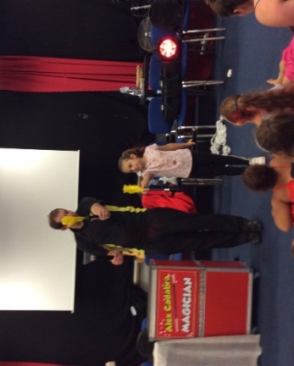
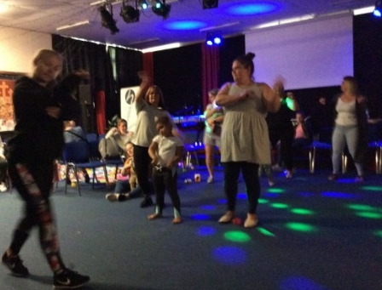

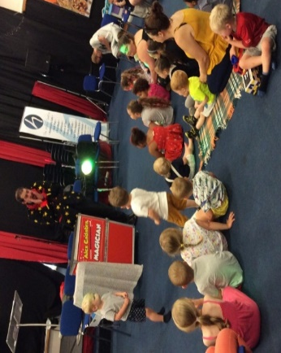

Children’s feedback

‘I liked having my face painted.’ – L aged 4
‘Oh wow play dough, my favourite.’ – L aged 4
‘ I liked helping the magician and I liked the balloon.’ I aged 4
‘I liked the dancing.’

Positive feedback was received from parents as well as the young people:

‘The staff at holiday hub are fantastic and fun to be around. We have loved every minute of it’
‘We have enjoyed making the musical instruments.’
‘We enjoyed helping make the food.’
‘Very well organised, lots for children and parents to do, staff are very welcoming, we enjoyed painting with T, loved outside, bubbles and games, really lovely to be given cooking books to enjoy with the families. J is amazing with babies and caters for all children’s needs. C the Zumba teacher was fantastic at dancing with the children.’
‘My children really enjoyed their sessions at Holiday Hub, especially the entertainer. I would like more activities in Beeston as there was only the beach but no activities near to me and I had friends that also couldn’t come to the Holiday Hub because of this.’
‘We really enjoyed it and would like this to run more regular, I have benefitted from the advice given and I am now trying my son on less more milk and more solid food.’
‘Holiday hub is a great way of making different foods for families to try.’
‘Today’s event has been fab, plenty of activities for the children to do. It is brilliant for families that are watching their pennies too.’
‘Felt so included, such a valuable group when you struggle to get out the house, wide variety for all ages. The staff are so important to me – they’ve helped me with my confidence, they have given wonderful advice and much needed support’
‘The team go above and beyond to make sure everyone has the ‘Best’ time. It is nonstop well organised and my son had a fantastic morning.’
‘Please keep funding this wonderful project ’
‘We have had a lovely day. Very welcoming, my boys have loved it. We enjoyed making pizzas, everyone is lovely thank you ’
‘I really enjoyed the little side activities in place for the children and the variety of lunch. I also love how helpful all the staff are when I needed help juggling my children! Thank you! X.’
‘All staff members are very interactive and happy to be around plus the kids love them all.’
‘Really enjoyed today, thank you. The children’s centre staff are amazing and very helpful.’
‘Holiday Hub has been a very good experience for families to get to know other people and for kids to play with other kids.’

