**Monsters in the rain!**

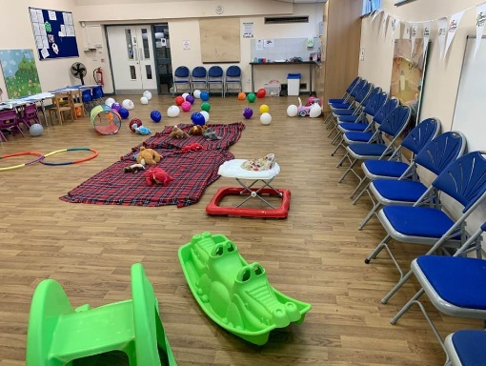Children and families at four of our Holiday Hub settings (in Coventry, Wigan, Leigh and Surrey) enjoyed their very own Family Monsters picnics this summer.

Higher Folds Community Centre in Leigh had so much rain that the bouncy castle had to be cancelled, and all the Family Monster balloons and bunting quickly moved indoors.

*‘My kids had a ball’*

*‘Thank you so much for organising’*

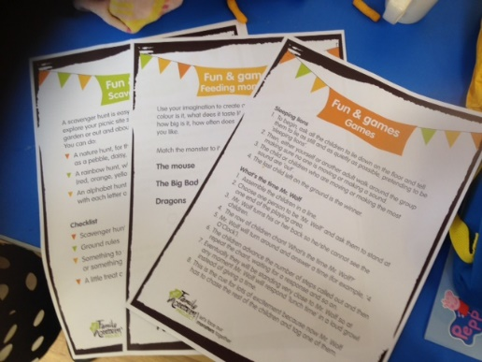*‘We loved it all’*

But the weather didn’t dampen the spirits of the families arriving, some in their homemade monster outfits, or the determination of the Holiday Hub team to make it a great day for everyone.

Using some of the Family Monster activity ideas, staff and volunteers arranged a wide variety of fun activities (games, dance, singing etc), as well as preparing a tasty free lunch. <https://www.facebook.com/HigherFoldsCommunityCentre/>

Find out more about Holiday Hub: [www.family-action.org.uk/holidayhub](http://www.family-action.org.uk/holidayhub)

**About our Family Monsters campaign**

For 150 years, Family Action have been working to relieve the everyday struggles, big and small, faced by every family. But we’ve noticed that, like monsters, these pressures sometimes hide in the dark and grow when we don’t talk about them.

That is why, to mark our 150th anniversary, we are launching the Family Monsters Project, to start a national conversation about the pressures on every family and how we can face them together.

[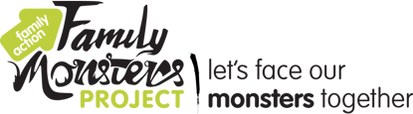](https://www.family-action.org.uk/family-monsters/)We want to encourage people to get involved, join the conversation and share their own family monsters, as well as our short film, to help others talk about and deal with the challenges all families face.

Learn more about our Family Monsters campaign:  
[www.family-action.org.uk/family-monsters/](http://www.family-action.org.uk/family-monsters/)