Fun with food in Nottinghamshire!

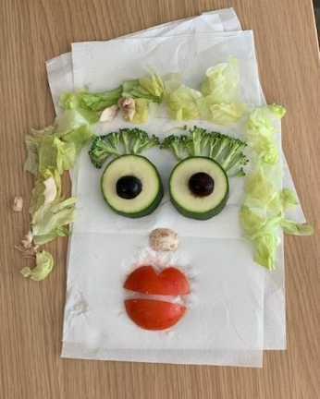
As part of our support offer for settings, the Holiday Hub team arranged a training session for Holiday Hub teams in Nottinghamshire. Staff from the different children’s centres came together over the summer to have fun with food and to learn:

- more about School Food Standards
- some healthy recipes to use in their Summer Holiday Hub sessions
- ideas for fun food-related activities (e.g. games) to use with families.

We asked nutritionist and experienced community trainer Gill Kelsall from the NSBP team to plan and deliver the interactive session, supported by Andy White, Training and Learning Facilitator, NCFP.
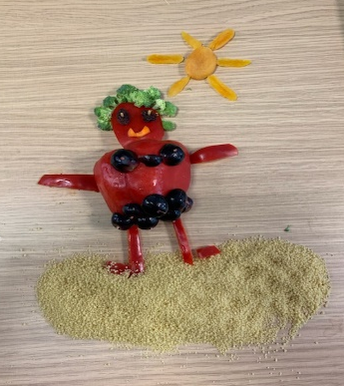
Gill put forward a wide range of healthy recipe ideas for use in
Holiday Hub clubs, such as:

- watermelon/melon ice lollies
- hummus and vegetables
- banana and yoghurt lollies
- guacamole/tzatziki and other dips with vegetables
- adding fruit to salads e.g. raisins, dried apricots, peaches, plums, grapes (sliced), kiwi, orange
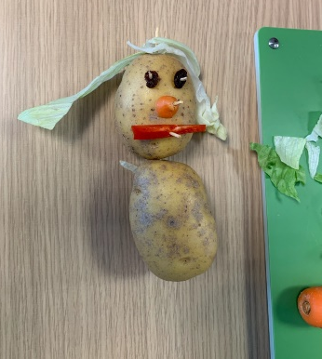
- vegetable kebab
- homemade pizzas using naan pizza, flat bread pizza, muffin pizza, tortilla pizza, or cauliflower base pizza.

She also presented some fun activities, such as:

- fruit/vegetable bingo
- making fruit/vegetable faces ,
- fruit and vegetable printing/place mat printing
- parachute games with plastic fruit on the parachute
- happy face/sad face – shout out a food and families to run to
the happy or sad face.

No food was wasted as it was all used for cooking after this activity. Participants thoroughly enjoyed trying out all the ideas together and commented:

‘Really great to update knowledge on the latest evidence based information as it’s been years since I’ve had any such training.’

‘Some really great tips particularly around the salt and sugar guidance, which I
will use for families.’

Find out more about Holiday Hub at www.family-action.org.uk/holidayhub

