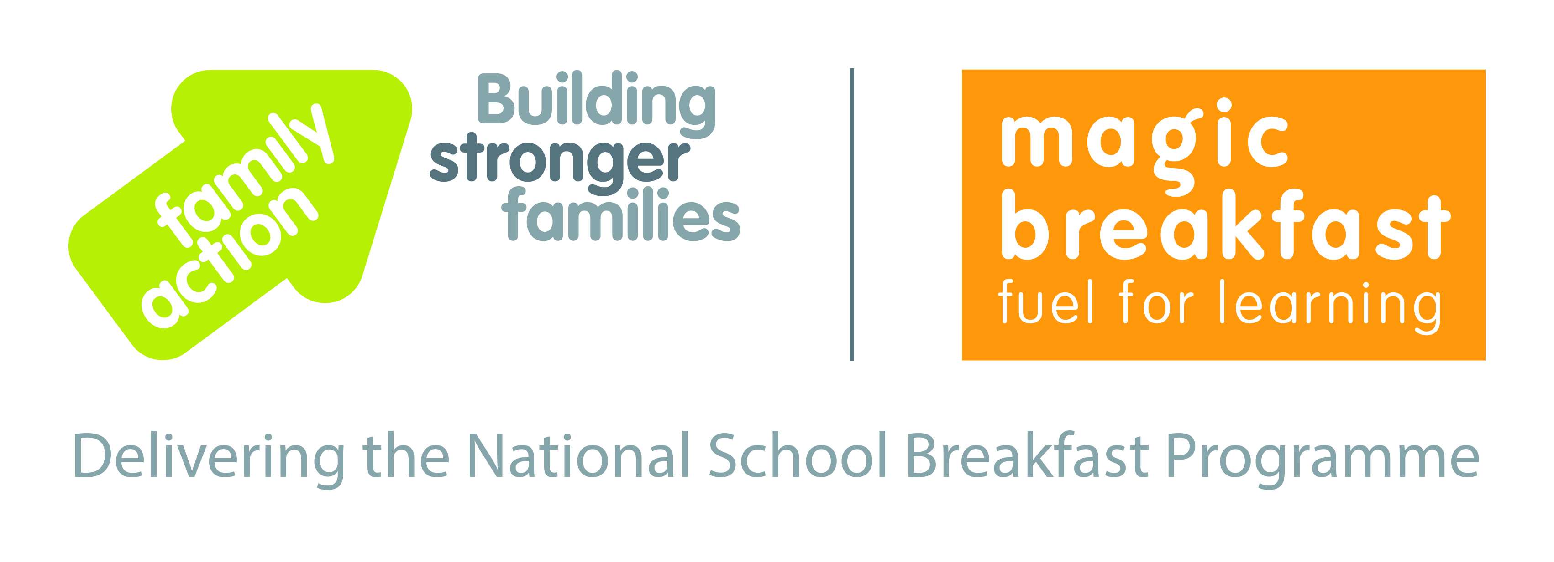

Expression of Interest in

National School Breakfast Programme

Family Action, in partnership with Magic Breakfast, has secured funding from the Department for Education to support an additional 650 schools in disadvantaged areas to start or expand breakfast provision, starting in April 2020. The offer involves bespoke support and a combination of grants and food aid for eligible schools.

The aim of the National School Breakfast Programme is to ensure no child starts the school day too hungry to learn. We bring our experience working with disadvantaged communities and providing schools with food aid and support to reach children at risk of hunger at the start of the school day. To date, more than 1,800 schools across England have benefitted from this programme of support.

If your school would like to explore the benefit of removing the hunger barrier to learning for all your pupils, please complete the form below. We will check your eligibility for the DfE funded programme, and follow up with you as soon as possible.

Please email the completed form to: nsbp@family-action.org.uk

Name of School
School URN
Local Authority
Date completed
Head Teacher | Name:  Email:
Breakfast provision leader  (if applicable) | Name:  Email:
Address
Postcode
Phone
School Type  (please tick all that apply) | Primary Secondary Through School  Mainstream SEN PRU  Maintained Academy Church School Free School  If Academy - name of chain or MAT:
Number of pupils on roll (excl. nursery)*
Number of nursery on roll
(if applicable)*
% Free School Meals (eligibility)*
% Ever6 (%eligible for FSM in the last 6 years)*
% Pupil Premium*

*NB Please use/supply figures from your most recent census.

Next page >

Are there any particular challenges you are currently facing as a school?  (Please tick all that apply and add as necessary) | Ofsted  Academy conversion  Budget deficit  Major staffing changes  Other:
Does a breakfast provision exist currently? | Yes  No
If yes, please provide a bit of detail: | Time (from/to):  Charge:  No. of free places currently:  No. of staff:  Use of catering staff/kitchen facilities?:  How is it currently funded?  Other:
What food and drink is on offer daily at your breakfast provision?
How many children attend on a typical day?  How many of those are eligible for Pupil Premium (please estimate if not sure)? | Typical attendance:  No of those who are PP:
Is that number capped? | Yes  No
Are there more children you would like to reach with breakfast? (Please comment.)
Are there particular challenges you are facing in delivering breakfast to those who most need it?  Please tick all that apply and add as necessary. | Bringing in difficult to reach children  Engaging some families  Space or staffing for breakfast  Other:
Is there anything else you think it would be useful for us to know?
Form completed by | Name:  Role:

Thank you for taking the time to fill in this form.
Please email back to: nsbp@family-action.org.uk

