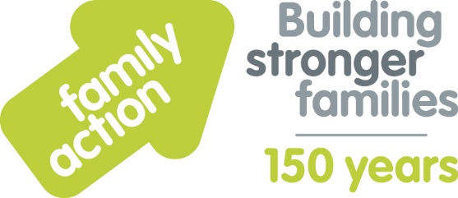

Case Study: A2ndvoice CIC
(support group run by parents/carers living and caring for a child or adult on the Autistic Spectrum)
Holiday Food and Fun
The London Borough of Croydon and Family Action received funding from the Department for Education (DfE) to co-ordinate free holiday activities and food provision during the 2019 summer holidays. The Holiday Food and Fun programme aimed to help children and, where appropriate, their parents:
- to eat more healthily over the summer holidays
- to be more active over the summer holidays
- to take part in engaging and enriching activities which support the development of resilience, character and wellbeing and other skills
- to be safe and not to be socially isolated
- to have greater knowledge of health and nutrition
- to be more engaged with school and other local services and to have greater knowledge and awareness of local free holiday provision.
A wide range of local organisations delivered Holiday Food and Fun, including A2ndvoice CIC. Venessa from the support group comments:
“We wanted to take part in the Holiday Food and Fun programme due to the lack of such services for autistic children, especially those with behavioural problems, or for home schooled children. Challenges for providers can include: finding a venue that is accessible; healthy eating for autistic children, due to their sensory needs; recognising parents/carers who have hidden disabilities (e.g. autism, ADHD, specific language difficulties).
Children we supported this summer benefitted in many ways – through us offering regular sessions over four days a week, and a safe place to be for children with special educational needs and disabilities (SEND) and their siblings. Families stayed for sessions so we were also able to offer parent support (e.g. parents of newly diagnosed children and young people needing advice). We have developed our knowledge of how to run a summer scheme – for example, how to manage and plan effectively and the legal side of things.”
Learn more about Holiday Food and Fun by visiting www.holidayfoodandfun.org
Find out more about holiday activities and food provision in Croydon by emailing Sanum.Ghafoor@croydon.gov.uk

