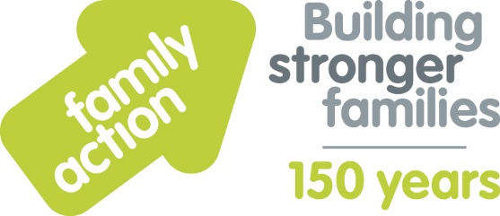

Case Study: CC Coaching (sports coaching provider)
Holiday Food and Fun
The London Borough of Croydon and Family Action received funding from the Department for Education (DfE) to co-ordinate free holiday activities and food provision during the 2019 summer holidays. The Holiday Food and Fun programme aimed to help children and, where appropriate, their parents:
- to eat more healthily over the summer holidays
- to be more active over the summer holidays
- to take part in engaging and enriching activities which support the development of resilience, character and wellbeing and other skills
- to be safe and not to be socially isolated
- to have greater knowledge of health and nutrition
- to be more engaged with school and other local services and to have greater knowledge and awareness of local free holiday provision.
A wide range of local organisations delivered Holiday Food and Fun, including CC Coaching. Clarry from the organisation comments:
“The main reason I wanted to take part in Holiday Food and Fun was to provide
sports activities for children aged 5 to 12 and to provide food for children who would usually get free school meals.
Children made friends with children from other schools while actively taking part in
activities such as arts and crafts. Parents benefited from us providing free food
during the summer holidays. We have developed our own knowledge
(e.g. around providing food, data collection).”

Learn more about Holiday Food and Fun by visiting www.holidayfoodandfun.org
Find out more about holiday activities and food provision in Croydon by emailing Sanum.Ghafoor@croydon.gov.uk

