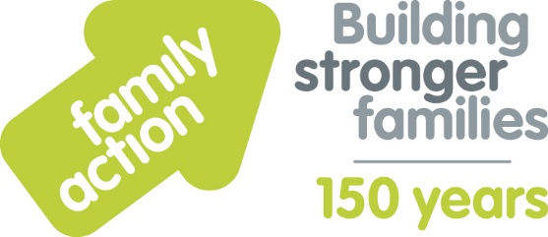

Case Study: Good Food Matters
(community food learning centre)
Holiday Food and Fun
The London Borough of Croydon and Family Action received funding from the Department for Education (DfE) to co-ordinate free holiday activities and food provision during the 2019 summer holidays. The Holiday Food and Fun programme aimed to help children and, where appropriate, their parents:
- to eat more healthily over the summer holidays
- to be more active over the summer holidays
- to take part in engaging and enriching activities which support the development of resilience, character and wellbeing and other skills
- to be safe and not to be socially isolated
- to have greater knowledge of health and nutrition
- to be more engaged with school and other local services and to have greater knowledge and awareness of local free holiday provision.
A wide range of local organisations delivered Holiday Food and Fun, including Good Food Matters. Amanda from the centre comments:
“We wanted to take part in the programme as we saw first hand the need for quality food and enrichment activities here in the most deprived ward in Croydon.
Children on the Holiday Food and Fun programme this summer ate well, were stimulated socially, tried new food, news sports and lots of nature-based activities.
We also supported parents, for example, by ensuring those in food poverty received a free healthy meal. We are now applying for funding from the local community fund to enable us to take our work forward next summer.”
Learn more about Holiday Food and Fun by visiting www.holidayfoodandfun.org
Find out more about holiday activities and food provision in Croydon by emailing Sanum.Ghafoor@croydon.gov.uk

