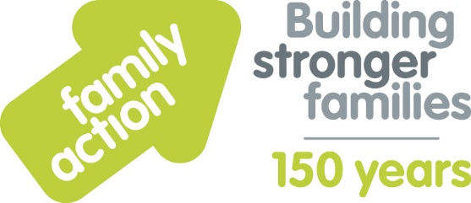

Case Study: Totstars (sports coaching company)
Holiday Food and Fun
The London Borough of Croydon and Family Action received funding from the Department for Education (DfE) to co-ordinate free holiday activities and food provision during the 2019 summer holidays. The Holiday Food and Fun programme aimed to help children and, where appropriate, their parents:
- to eat more healthily over the summer holidays
- to be more active over the summer holidays
- to take part in engaging and enriching activities which support the development of resilience, character and wellbeing and other skills
- to be safe and not to be socially isolated
- to have greater knowledge of health and nutrition
- to be more engaged with school and other local services and to have greater knowledge and awareness of local free holiday provision.
A wide range of local organisations delivered Holiday Food and Fun, including Totstars. Kelly from Totstars comments:
“We wanted to take part in the programme to show support in the community – and to reach out to more children through our passion for sport. Children this summer benefitted in many ways, for example, by doing lots of sporting and other activities – outdoors when possible (archery, high jump, football, camp fires, woodland walks etc).
Feedback was that children were happy and it took pressure off families. Parents were exceptionally grateful that their children were fed – and Holiday Food and Fun was free!
We feel we reached more disadvantaged families, and showed children some
healthy food options that they hadn’t seen before. As a company it opened up our eyes even more to the areas of need in Croydon. We would like to be able to support families in the future whenever we can.”
Learn more about Holiday Food and Fun by visiting www.holidayfoodandfun.org
Find out more about holiday activities and food provision in Croydon by emailing Sanum.Ghafoor@croydon.gov.uk

