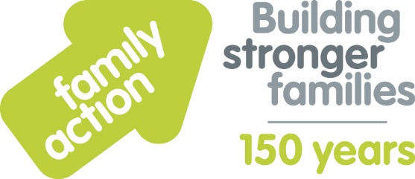

Case Study: Reaching Higher (youth charity)
Holiday Food and Fun
The London Borough of Croydon and Family Action received funding from the Department for Education (DfE) to co-ordinate free holiday activities and food provision during the 2019 summer holidays. The Holiday Food and Fun programme aimed to help children and, where appropriate, their parents:
- to eat more healthily over the summer holidays
- to be more active over the summer holidays
- to take part in engaging and enriching activities which support the development of resilience, character and wellbeing and other skills
- to be safe and not to be socially isolated
- to have greater knowledge of health and nutrition
- to be more engaged with school and other local services and to have greater knowledge and awareness of local free holiday provision.
A wide range of local organisations delivered Holiday Food and Fun, including Reaching Higher. Khalifa from the charity comments:
“We wanted to provide an alternative to cheap food, which lacks nutrition, and to provide hot meals to individuals from low income households.
Children supported this summer benefitted in many ways, for example, by learning transferable skills (e.g. around independent living) and the importance of fitness and physical activity. Parents benefited from having a safe and stimulating environment for their child to come to, where they received free healthy food, fruit, snacks and water throughout the programme.
We have also developed our knowledge around how to manage dietary requirements and supporting those with eating disorders. We plan to build on our experiences this summer by including a variety of food within a programme, and also to look at budgeting effectively.”
Learn more about Holiday Food and Fun by visiting www.holidayfoodandfun.org
Find out more about holiday activities and food provision in Croydon by emailing Sanum.Ghafoor@croydon.gov.uk

