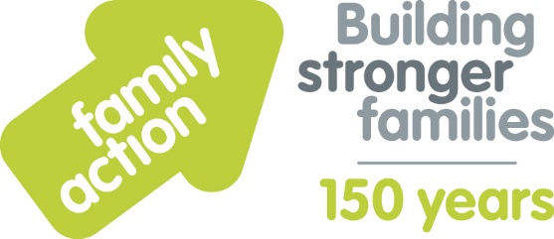

Case Study: Purley Oaks Children’s Centre
Holiday Food and Fun
The London Borough of Croydon and Family Action received funding from the Department for Education (DfE) to co-ordinate free holiday activities and food provision during the 2019 summer holidays. The Holiday Food and Fun programme aimed to help children and, where appropriate, their parents:
- to eat more healthily over the summer holidays
- to be more active over the summer holidays
- to take part in engaging and enriching activities which support the development of resilience, character and wellbeing and other skills
- to be safe and not to be socially isolated
- to have greater knowledge of health and nutrition
- to be more engaged with school and other local services and to have greater knowledge and awareness of local free holiday provision.
A wide range of local organisations delivered Holiday Food and Fun, including Purley Oaks Children’s Centre. Jackie from the centre comments:
“The main reason I wanted to take part in Holiday Food and Fun was to help to alleviate child poverty, to provide families with opportunities that they might not usually have access to, and to provide a supportive network for parents.
Children we supported during the summer benefitted in many ways, for example, gaining confidence in small group work, taking part in physical activities, cooking and preparing food, and trying new food they don’t usually have at home. The main benefit for parents was feeling supported and not so isolated during the summer break. Parents felt that staff had more understanding of their situations.
Staff gained confidence, for example, in assisting to deliver music and dance sessions.
Staff-parent relationships also became stronger. We plan to maintain and build on the relationships we have built over the summer, and we are looking forward to next year, when we plan to deliver workshop sessions for parents.”
Learn more about Holiday Food and Fun by visiting www.holidayfoodandfun.org
Find out more about holiday activities and food provision in Croydon by emailing Sanum.Ghafoor@croydon.gov.uk

