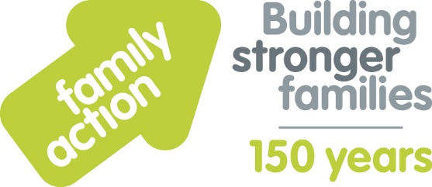

Eco Explorers – example activities

Recycled robot
Make recycled robots from waste packaging. Which is the biggest? Most intricate?
Which materials used are recyclable? What harm does the different types of waste have on the environment?

Barking up the wrong tree
What different trees can you see in your garden / outside the setting / in a park? Look for some interesting tree bark.
Hold a sheet of paper against the tree park and rub the side of a crayon up and down slowly. You will soon see the bark pattern showing through.
Experiment! Try different trees, different coloured crayons etc.

Eye spy
Lie on the ground and look into the air – perhaps on a nice blanket.
Call out what you can see – e.g. seagull, butterfly, bee, cloud.
Keep a count of what you can see in 5 mins.

How much rain?
- Using an old plastic bottle without the lid, cut off the top 1/3. Put something heavy in the base like a stone. Then fill with water until covered – draw a line on the bottle.
Use a ruler and mark up from there in cm. Put the 1/3 of the bottle you cut off into the bottom bit upside down as a kind of funnel – you might need to put tape in to keep it together.
- Pop your bottle outside – check it every day – how much rain have you collected? Which was the rainiest day of the week? What can you use the rainwater for?

