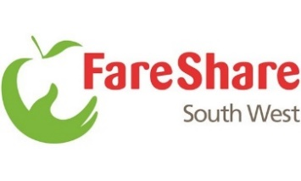
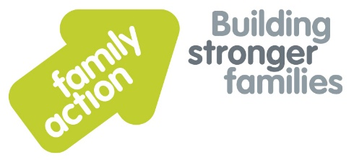
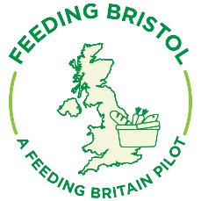

FOOD Clubs (Food on Our Doorstep)
Bristol April 2020
FOOD Clubs were established in Bristol 2019 by the national charity Family Action, in close partnership with Fareshare, Feeding Bristol and Bristol City Council Early Years, following a successful launch in Manchester. Pete Godden is the FOOD Club Co-ordinator and Simon Green is the Support Worker.
The clubs are open in Children’s Centres and community venues across Bristol. They offer a means for eligible families to access good quality ingredients which come straight from the manufacture that may otherwise end up in landfill. The food comprises of a mix of fresh fruit and vegetables, dried goods, fresh meat and dairy products. For just £3.50 per week each member receives a weekly bag of food worth up to £15-£20.
The clubs are currently providing food for up to 300 local families per week across 12 sites in the city. The project will be expanding over the next few weeks to increase the capacity of existing clubs and to open new clubs in Priority 1 wards.
The first Bristol FOOD clubs opened in Southmead and Hartcliffe in summer 2019. The second phase of club openings was in Lockleaze, Inns Court and St Pauls. Over the last two weeks, due to the current COVID-19 pandemic, the project has seen a rapid expansion to open 7 more clubs, including Knowle West, Redcliffe, Oldbury Court, Broomhill, Speedwell and a second club in Hartcliffe and Lockleaze. This expansion will continue at pace.
Before the crisis, the ‘club’ element offered crucial support to its members centred on food and cookery lessons, demos and nutritional information. These elements are fundamental to the project’s ethos and will be re-prioritised following the COVID-19 crisis.

For more information please contact Pete.godden@family-action.org.uk

