Christmas session feedback

All young people circled more than one.

What did you enjoy the most?

* Doing games
* Art and crafts
* Picture game
* Arts and crafts
* The hot chocolate
* I don’t know

Is there anything you would like us to do differently?

* Maybe make some softer paper for arts and crafts
* Yes healthy eating

What else would you like to do in these sessions?

* Chill time
* More arts and crafts
* I don’t know
* Same things

Anything else you would like to say?

* 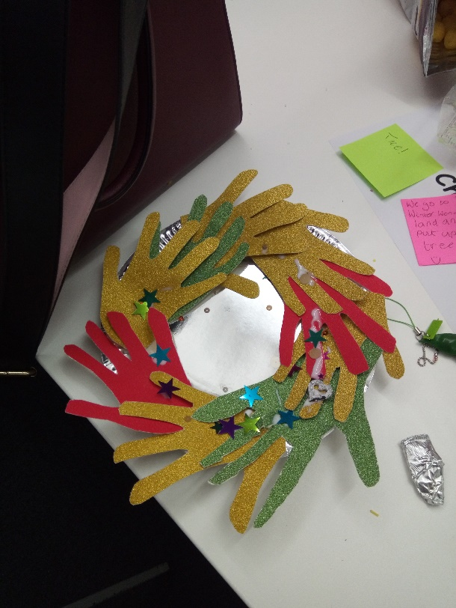I liked the little hut things, they were comfy.

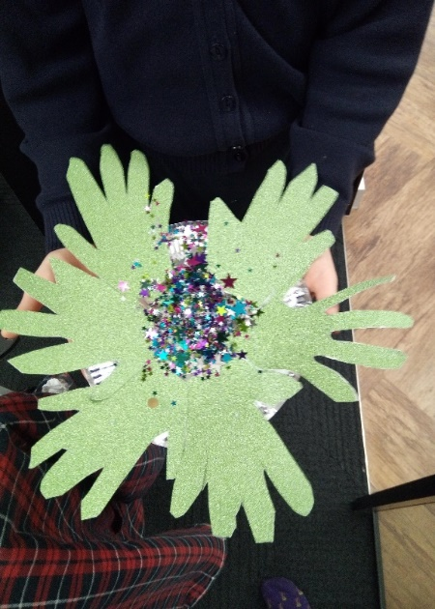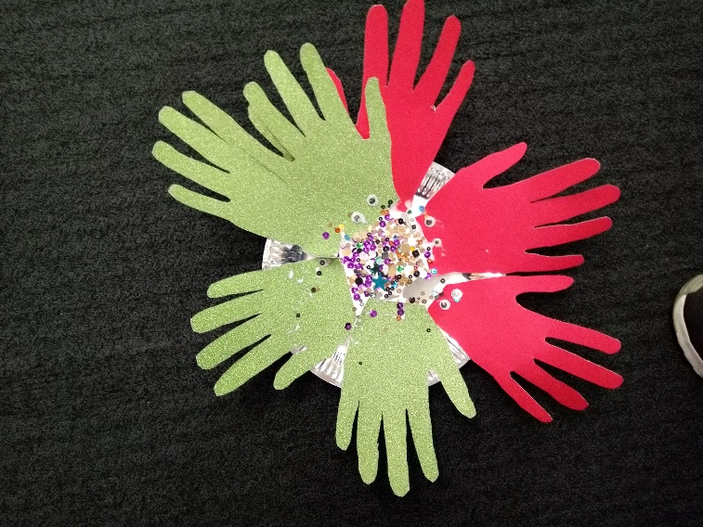

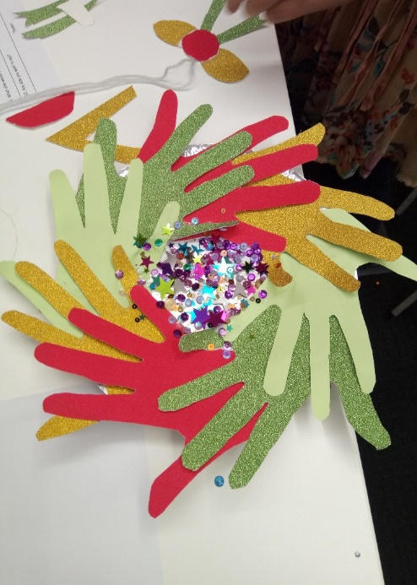

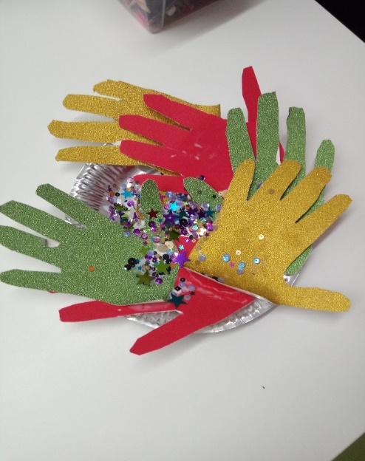

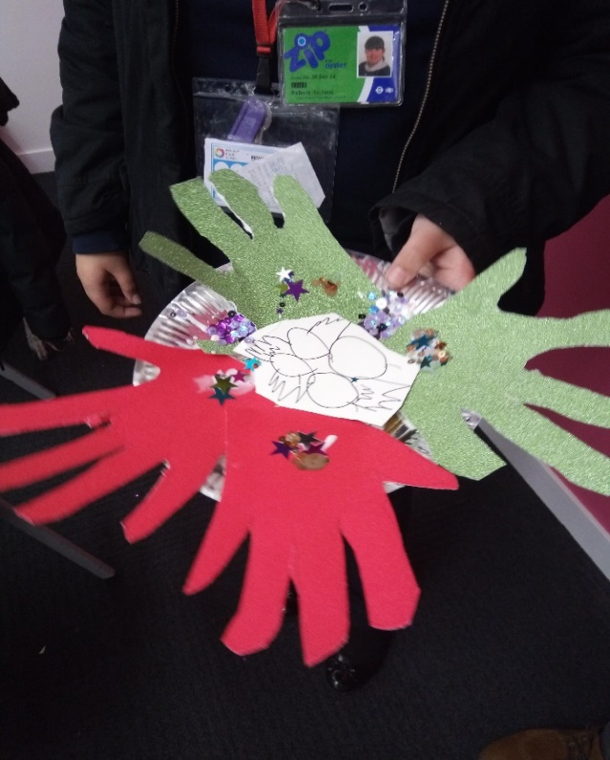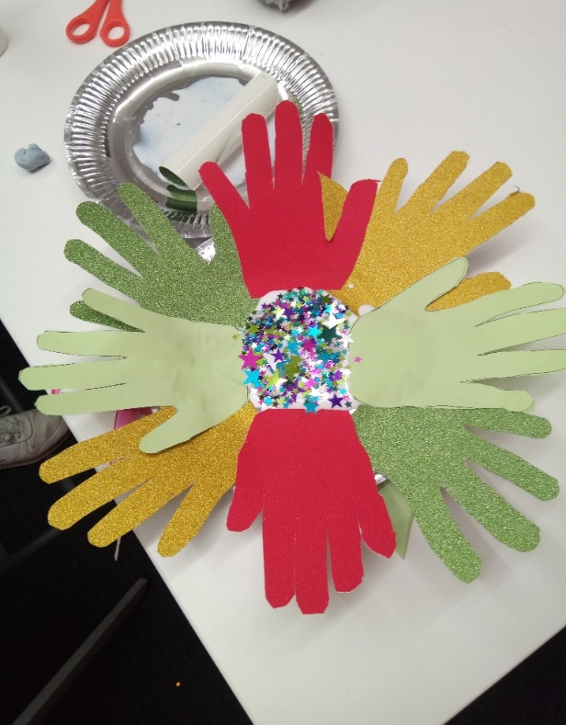

The young people wreathes that they made.

Parent feedback

Please let us know what part of the sessions you most enjoyed / found most useful?

* Talking to other parents.
* Sharing information with other parents.
* Both of them
* Meeting other parents of children with ASC and talking.

Please let us know what else could be helpful for you/ your child in these sessions?

* Work on what is appropriate and inappropriate when communicating socially.
* Nothing, excellent

Other comments

* Unable to make a valid conclusion as my children have only been to a couple of these sessions so far.