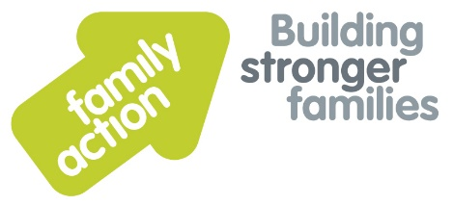

Weekly FOOD Club report, Greater Manchester
Co-ordinator - Gemma Mcardle 07971 755 865

Overview of clubs
Clubs | Address/Telephone | Times open
Newton Heath Sure start centre | Great Newton st, Newton Heath,  Manchester, M40 1GX  Tel: 0161 413 5790 | Mondays 12-2
Colly Hurst Primary School | Collyhurst Nursery School and Children's Centre  Teignmouth Avenue  Collyhurst  Manchester  M40 7QD  Tel: 0161 205 1744  Mob: 07483 103 325 | Monday 12-2
St Francis Church | St Francis of Assisi Church  Textile Street  Gorton  Manchester  M12 5DJ  Tel : 0161 223 3457  07958 793 083 | Tuesday 12-2
Gorton Sure start centre, | Gorton Sure Start Centre,  mount road,  Mancheste,  M18 7BG  Tel- 0161 219 2580 | Wednesday 11-1
Whalley Range sure start centre | Whalley Range Sure start Centre,  Burford Road,  Manchester,  M16 8HE  Tel:0161 245 7007 | Wednesday 1.15-3.15
Miles Platting sure start centre | Miles platting sure start centre,  Holland st,  Manchester,  M40 7DA  Tel : 0161 277 6970 | Thursday 1-3
Miles Platting sure start centre | Miles platting sure start centre,  Holland st,  Manchester,  M40 7DA  Tel : 0161 277 6970 | Friday 1-3

