Children’s Trauma Therapy Service, Bradford

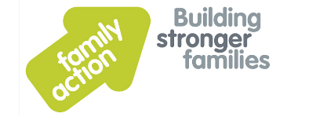

**About us**

The **Children’s Trauma Therapy Service**, at Bradford Family Action, is a specialist therapy service providing trauma and attachment focussed therapy for children and their families. We currently have two streams of therapy:

1. Specialist recovery-focussed therapy for children / young people aged 5-18 who have experienced **sexual abuse** or a **traumatic bereavement**. Our offer of therapy usually includes work with the whole family, though we also welcome self-referrals from individual young people.
2. Children aged 4-11 who have experienced one or more **Adverse Childhood Experiences** (ACEs) and who are experiencing trauma symptoms or family difficulties. These families can now receive therapy through **CALM**; a new therapy service jointly funded by the Department of Health and Bradford CCG. This service is led by the **Children’s Trauma Therapy Service** team and delivered in partnership with **Step2** and **Relate Bradford**.

We welcome self-referrals from families and referrals from professionals. If you /your family, or a family you work with, live in the Bradford District CCG area (i.e. have a Bradford GP) and fall under either of the above criteria, please do get in touch with us.

Just call **01274 651652** and ask for a member of the Children’s Trauma Therapy Service or email [**CTTS@family-action.org.uk**](mailto:CTTS@family-action.org.uk)

More information on what to expect from each therapy stream is detailed below.

Please use this form to clearly identify which service you are requesting.

**Please send completed referral forms:**

**By secure email to** [**CTTS@family-action.org.uk**](mailto:CTTS@family-action.org.uk)

Secure emails can be received through at this address through GalaxyKey, Egress Switch & by encrypted email.

**Or by post to** Children’s Trauma Therapy Service

Kenburgh House

28 Manor Row

Bradford, BD1 4QU

Therapy Stream 1: Referral to the

Children’s Trauma Therapy Service,

delivered by Family Action

Criteria for Childhood Sexual Abuse (CSA) or Traumatic Bereavement Referrals

* The referred child or children (sibling groups) should be aged 5 to 18 years old at the time the referral is made and live within the Bradford District CCG areas
* Referred child(ren) should be safe from sexual abuse, sexual exploitation and other forms of abuse or harm.

For cases of sexual abuse:they should be supported by a trusted adult who believes their disclosure

* For cases of traumatic or complicated griefThe referred child(ren) could be considered to have experienced a traumatic bereavement if they have experienced any one or more of the following: loss through suicide, homicide or other traumatic /violent event; if they have been involved in the care of a severely ill close family member who passed away from their illness; if the death was sudden or unexpected and they are now presenting with trauma symptoms as a result of this loss; if there were existing difficulties in attachment or a history of trauma in the family which are now compounded by the bereavement.

Following acceptance of a referral, we offer an initial clinical assessment to the referred family. Following assessment, we may make an offer of direct therapy to the family (with their agreement) and/ or offer specialist consultation to the professional system supporting the child.

The Children’s Trauma Therapy Service is comprised of a highly skilled team of psychotherapists and counsellors. Our therapy team is currently comprised of: a Child and Adolescent Psychotherapist, an Art Psychotherapist, Dramatherapists, a Dance and Movement Psychotherapist, Child and Adult Counsellors and Family and Systemic Psychotherapists. In addition, many of our clinicians have additional training in dyadic (parent-child) or trauma focussed approaches to therapy. As a team, we are able to offer some of the following therapies to referred families:

* Individual Child Therapy is normally a creative therapeutic approach, using a range of techniques to support children and young people.
* Dyadic (Parent-child) therapy aims to build on positive interactions to strengthen attachment relationships.
* Family Therapy to address the impact of trauma and difficulties in family relationships.
* Trauma-focussed therapy involves using additional therapies to help us process traumatic memories as part of the overall work. In our service, this is normally additional therapies such as EMDR or CATT.
* Therapeutic Parenting: either with individuals or groups of parents. Therapeutic parenting aims to help support and equip parents of children who have experienced trauma. Therapeutic parenting works with an understanding of attachment and trauma in mind.
* Specialist consultation to support key professionals and the system around the child as they plan for the child’s care

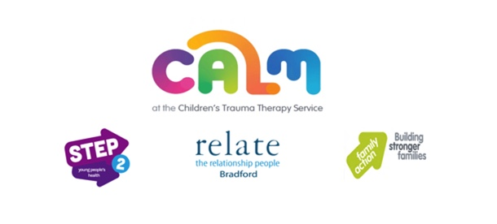

**Therapy Stream 2: Referrals to**

**CALM at the Children’s Trauma Therapy Service,**

**delivered by Family Action, Step2 and Relate Bradford**

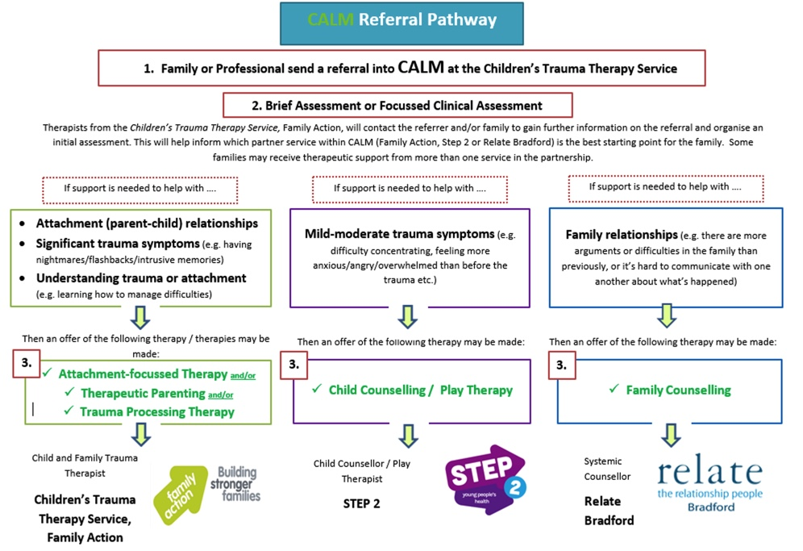

CALM is a new, Department of Health and Bradford CCG joint-funded therapy service for Children aged 4-11 who have experienced one or more Adverse Childhood Experiences (ACEs).  CALM is led by the **Children’s Trauma Therapy Service** (part of Family Action in Bradford). Families referred to CALM will receive therapy through one (or more) of 3 partner organisations: **Family Action**, **Step 2** and **Relate Bradford**.

**Criteria for CALM Referrals**

1. The referred child(ren) must be aged between 4-11 at the time of referral and have experienced one or more of the following ACEs:

* Domestic abuse
* Parental abandonment through separation/divorce
* A parent with a mental health condition
* Abuse (physical, emotional)
* Neglect (physical, emotional)
* Household member in prison
* Household adults with alcohol or drug abuse problems.

1. The referred child /children must be presenting with symptoms of trauma or impaired family functioning
2. All children referred must be safe from harm, living with a trusted adult who is capable of supporting them and live within the Bradford District CCG area