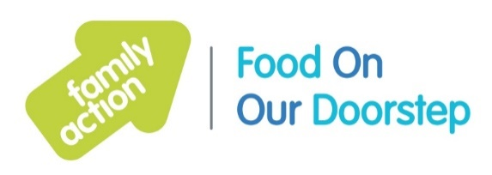

Greater Manchester Food On Our Doorstep (FOOD)
Overview of clubs and contact details

Coordinator: Susan AstburySusan.Astbury@family-action.org.uk
Email: manchesterfoodclubs@family-action.org.uk
Support Workers: Kin and Paula
- Kin.Yip@family-action.org.uk
- Paula.Marsland@family-action.org.uk

Day | Club | Club time | Contact
Monday | Newton Heath Sure Start Centre, Great Newton Street, Newton Heath, Manchester M40 1GX | 1-3pm | manchesterfoodclubs@family-action.org.uk  Tel: 0161 413 5790
Wednesday | Gorton Sure Start Centre,  Mount Road, Manchester M18 7BG | 9.30am-12.30pm | manchesterfoodclubs@family-action.org.uk  Tel: 0161 219 2580
Thursday | Littleborough Sure Start Centre,  Denhurst Road, Littleborough OL15 9LD | 1-3.30pm | manchesterfoodclubs@family-action.org.uk  Tel: 01706 378 166  littleboroughcc@rochdale.gov.uk
Friday | Whalley Range Sure Start Centre,  Burford Road, Manchester M16 8HE | 1-3pm | manchesterfoodclubs@family-action.org.uk  Tel:0161 245 7007
Friday | Miles Platting Sure Start Centre, Holland Street, Manchester M40 7DA | 1.15-3.15pm | manchesterfoodclubs@family-action.org.uk  0161 694 6544
Friday | Fitton Hill community Hub (next to the Brew), Fir Tree Avenue, Oldham OL8 2SR | 11am-1pm | manchesterfoodclubs@family-action.org.uk  Mob: 07551 357 202  enquire.reel@gmail.com
Friday | Derby Street Children’s Centre, Derby Street, Heywood OL10 4QJ | 9.30-11.30am | manchesterfoodclubs@family-action.org.uk
Friday | Newbold Sure Start Children’s Centre  Moss Street, Rochdale OL16 5NL | 9.30-11.30am | manchesterfoodclubs@family-action.org.uk  Tel: 01706 649729
Friday  Opening TBC | Coldhurst Children’s Centre, Winterbottom Street, Oldham OL9 6HY | TBC | manchesterfoodclubs@family-action.org.uk  Tel: 0161 470 4200
Friday  Opening TBC | Hollinwood Children Centre, St Chad’s Centre, Oldham OL8 3HH | TBC | manchesterfoodclubs@family-action.org.uk  Tel: 0161 770 8417

