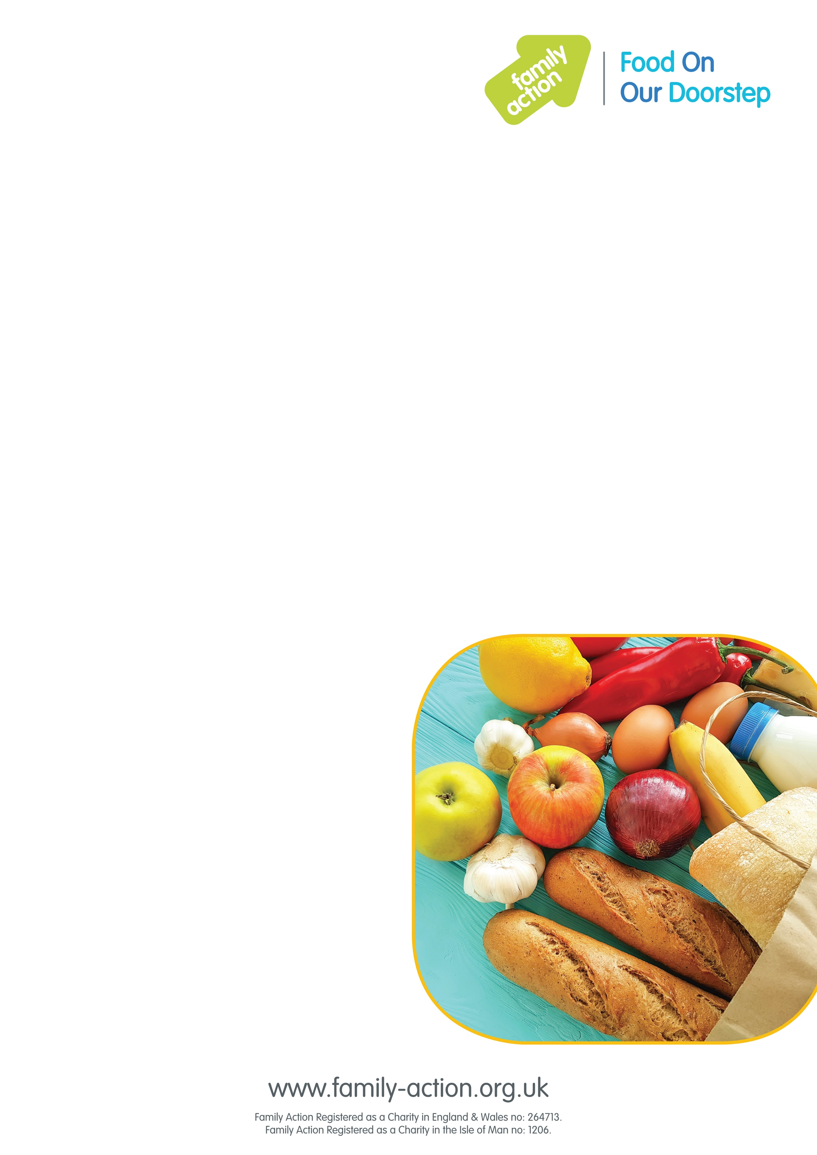

### Find out more

To find out more, please email [manchesterfoodclubs@family-action.org.uk](mailto:manchesterfoodclubs@family-action.org.uk), phone 01706 378 166 or email [littleboroughcc@rochdale.gov.uk](mailto:littleboroughcc@rochdale.gov.uk)

### Where and when

#### Littleborough Sure Start Centre, Denhurst Road, Littleborough OL15 9LD

#### Thursdays, 1 – 3.30pm

# Greater Manchester

## Food On Our Doorstep

### Good-quality food at a low price

Family Action has launched Food On Our Doorstep (FOOD) clubs in Greater Manchester to provide families with good-quality food at a low cost, while also reducing food waste.

It costs just £1 a year for your family to become a member. Once you’ve joined, you can purchase a bag of tasty food items every week worth approx. £15 for just £3.50!

To become a member you must live or work within 15 minutes of the club.