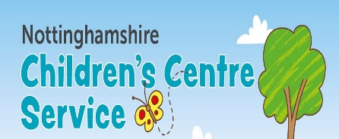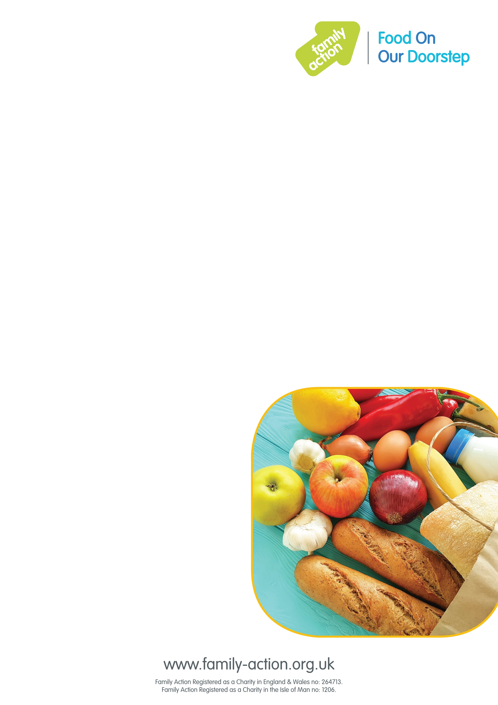

### Where and when

#### Every Thursday, 1 – 3pm

#### Lifespring Centre, Sherwood Drive,

#### New Ollerton, NG22 9PP

# Nottinghamshire FOOD Club

## Food On Our Doorstep

Good-quality food at a low price

Our new FOOD On Our Doorstep (FOOD) club in Ollerton will provide families with good-quality food at a low cost, while also reducing food waste.

It costs just £1 a year for your family to become a member. Once you’ve joined, you can purchase a bag of tasty food items every week worth approx. £15 for just £3.50!

To become a member you must live or work within 15 minutes of the club.

### More information

To find out more:

#### Call 07549925299

#### Email l.hill@attfe.org.uk