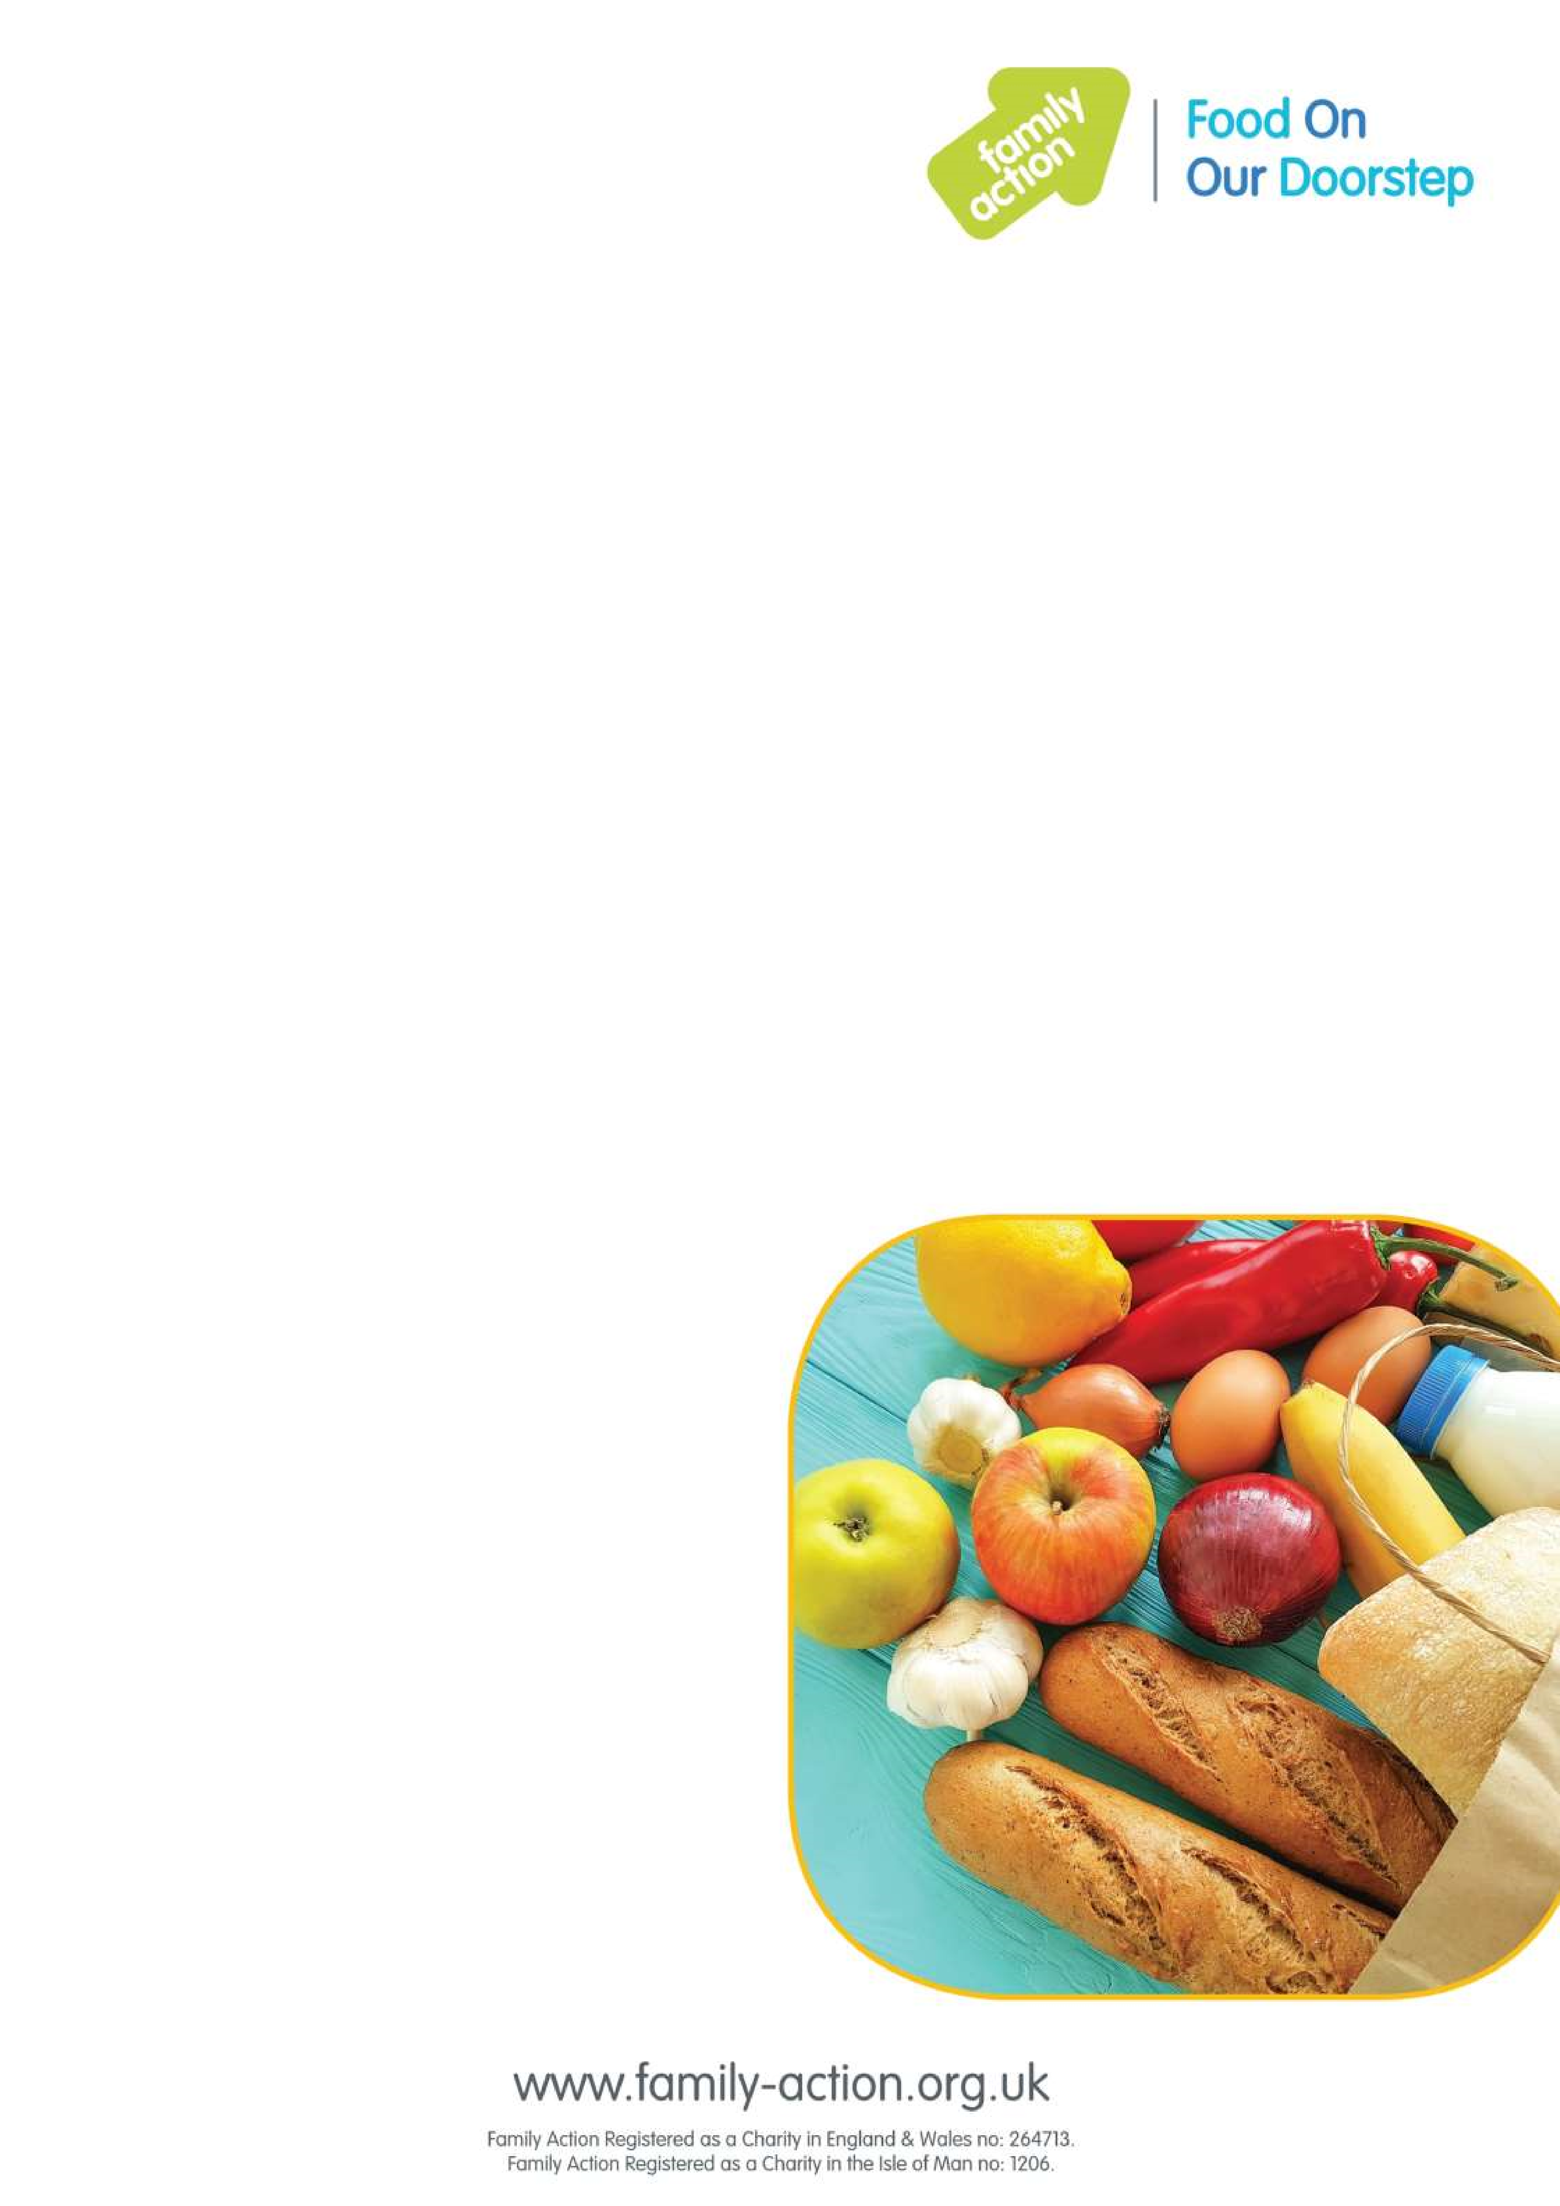

Where and when

•

Ravensdale Children's Centre,

Sanders Avenue, Mansfield, NG18

DN

2

•

Fridays,

10am -12pm

Mansfield FOOD Club

Food On Our Doorstep

Good

-

quality food at a low price

Family Action

has launched

Food

On Our Doorstep (FOOD) clubs

in

Mansfield

to provide families with good

-

quality food at a low

cost, while also reducing food waste.

It costs

just £1

a year for your family to become a member.

Once

you’ve joined, you can

purchase a bag of

tasty

food item

s every

week worth

approx. £15

for just £3.50!

To become a member you

must live or work within 15 minutes of

the club.

Find out more

To find out more, please email

mansfieldfoodclubs@family-action.org.uk