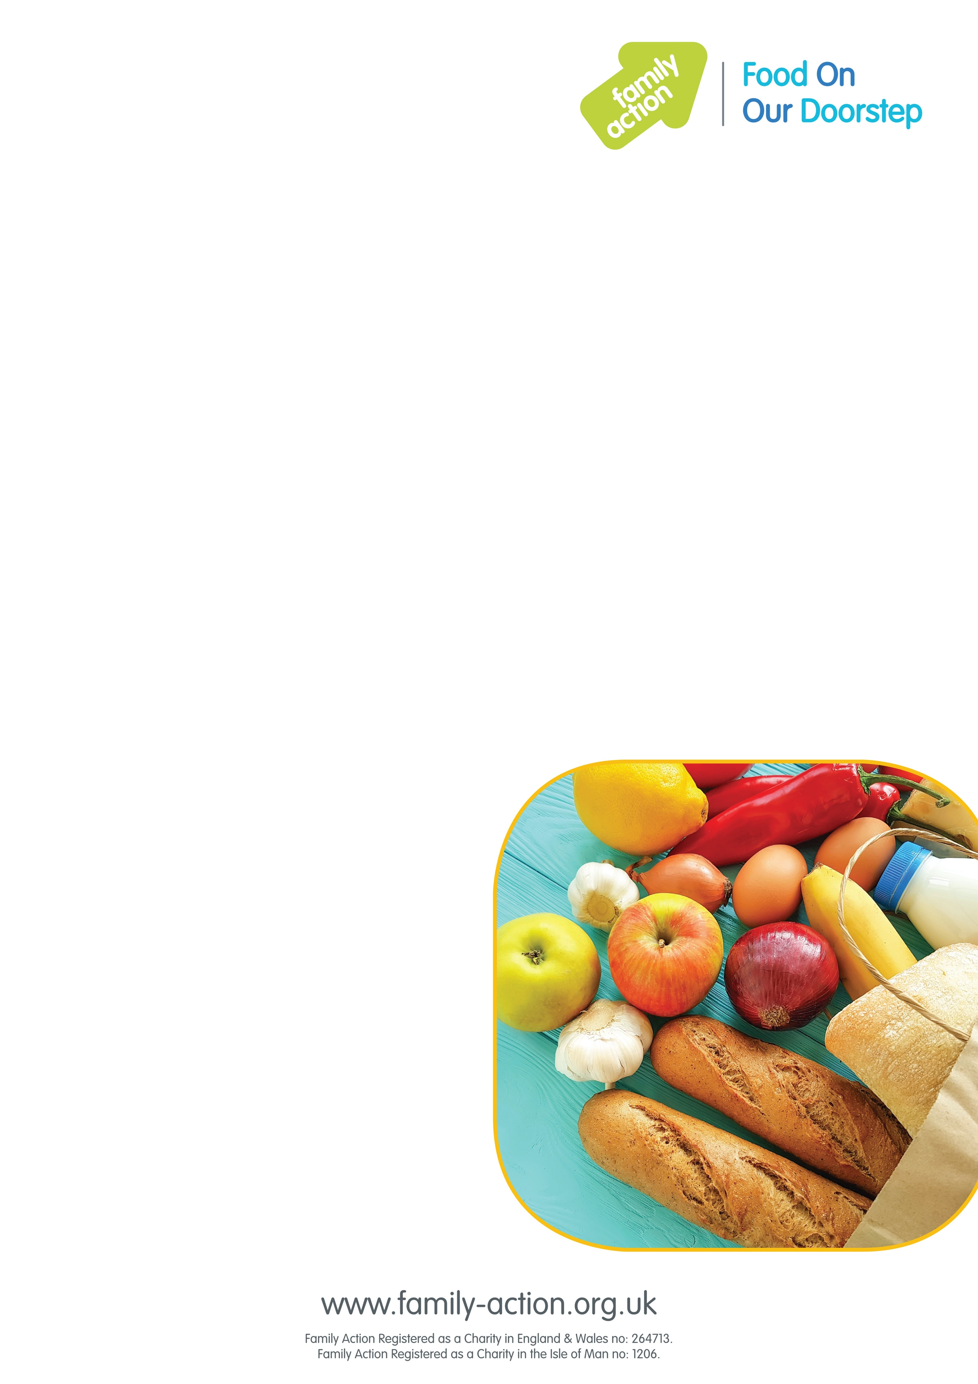

### Find out more

To find out more, please email  [nottsfoodclubs@family-action.org.uk](mailto:%20nottsfoodclubs@family-action.org.uk) or speak to:

#### Netherfield Children’s Centre on: 0115 977 3751

# Nottinghamshire

## Food On Our Doorstep

### Good-quality food at a low price

Family Action is launching weekly Food On Our Doorstep (FOOD)   
clubs at Netherfield Children’s Centre to provide families with good-quality food at a low cost, while also reducing food waste.

It costs just £1 a year for your family to become a member. Once you’ve joined, you can purchase a bag of tasty food items every week worth approx. £15 for just £3.50!

To become a member you must live within the Children’s Centre Catchment area of the club and have at least one child aged 0–5.

### Where and when

#### Netherfield Children’s Centre:

#### Thursday 9:30am to 11:30am 145 Victoria Rd, Netherfield, Nottingham, NG4 2HU