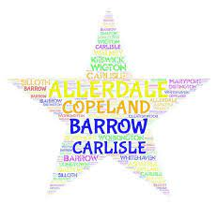

**South Whitehaven Family Hub, Whinlatter Road, Whitehaven, CA28 8BN**

**T:- 01946 64600**

**Millom Family Hub, Lapstone Road, Millom, LA18 4LP T:- 01229 777592**

**Egremont Family Hub, Southey Avenue, Egremont, CA22 2HH T:- 01946 823896**

**North Whitehaven Family Hub, Main Street, Hensingham, CA28 8QZ**

**T:- 01946 690067**

**For more information, advice, groups or activities which may be of interest**

**you can also visit our website at:**

[**www.family-action.org.uk/what-we-do/children-families/0-19/**](http://www.family-action.org.uk/what-we-do/children-families/0-19/)

**or visit our Facebook page at:**

**https://www.facebook.com/CopelandSupport**

**What’s On Guide**

**October to December 2021**

Welcome to our latest newsletter where you can find lots of information about the sessions and activities running within your local community over the next few months.

We would like to welcome all families who have registered with us this year. We feel it is important to be able to continue to provide families with support during this challenging time. **Our teams are continuing to deliver support in a variety of ways and we are now offering many sessions face-to -face in most of our Children’s Centres.** Covid-secure procedures are in place at each centre.

We are available to contact if you feel in need of support or would like further advice or information; you can get in touch by contacting one of our centres, below:-

(YCW 2021)

**Little Explorers: 1-2’s**

Little explorers is a group which provides children age between one and two with the opportunity to grow and learn with other children in the community. The sessions will be fun and exciting, with lots of role play experiences, mark making, crafts and messy play, which are all themed around well-known books and stories. The sessions will also allow parents and carers to connect with others in the local area also.

If you are interested, please feel free to attend our drop in service within one of our centres.

**South Whitehaven Children’s Centre:** Wednesdays @ 11am- 12pm

**Egremont Children’s Centre:** Fridays @ 1-2pm

**Millom Children’s Centre:** Tuesdays @ 1.30-2.30pm

Updates for any cancelled or moved sessions will be posted on our Facebook Page (Family Action Copeland 0-19 Children & Family Support Service)

**Kinship Carers Support Group**

This support group aims to offer support, information and advice to Kinship Carers so that each carer is better equipped to undertake the many aspects of their caring role, best meet the needs of the children in their care, along with the opportunity to meet, discuss and learn from other Kinship Carers in a similar situation. This group will run once a month, starting on the date stated below at our **South Whitehaven Hub**, based next to Valley Primary School.

**The first session will take place on: Friday 8th October @ 10:30am to 11:30am.**

For further information or to book a place, please feel to contact: [Louise.reid@family-action.org.uk](mailto:Louise.reid@family-action.org.uk), alternatively you can call us on 01946 64600.

****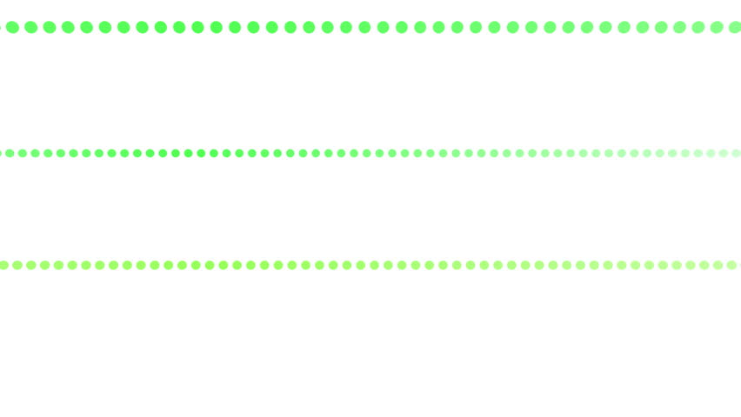

**Little Learners**

Come and join us for some exciting Mini Makers sessions. The sessions will use sensory play, role play and exciting activities to help children develop school readiness skills. The sessions will help support fine and gross motor skills, listening, and communication and language skills. We will engage in songs and rhymes, stories and fun sensory activities together.

Suitable for ages **2-5 years**

**South Whitehaven** Wednesdays @ 4pm

**Egremont** Wednesdays @ 3.30pm

**Millom** Mondays @ 1.30pm and Fridays @ 1pm

**Please contact the following for more information about**

**the sessions at your local children’s centre. Places are limited.**

**South Whitehaven -** **email** [**christina.thurston@family-action.org.uk**](mailto:christina.thurston@family-action.org.uk)

**or telephone 07815688314**

**Egremont – email** [**eleanor.cummings@family-action.org.uk**](mailto:eleanor.cummings@family-action.org.uk)

**or telephone 07815688396**

**Millom – email** [**louise.gregg@family-action.org.uk**](mailto:louise.gregg@family-action.org.uk)

**or telephone 01229 777592**

**Bumps to Babies**

Bumps to Babies is a group which will provide parents/carers with babies aged **0-4 months** with the opportunity to share their experiences and learn about basic development, such as typical sleeping patterns, physical development, crying (communication and language) and milestones your baby may reach during this time period. The sessions will be based on your interests, or needs of these topics. The sessions will also allow you to connect with other parents/carers in the local area.

**South Whitehaven** – Thursdays @ 10.30 - 11.30am

**Egremont-** Tuesdays @ 1 -2pm

**Millom -** Thursdays @ 1 -2pm

**Let’s get physical**

These sessions are aimed at children aged 2-5 years.

In Little Learners: we talk about the importance of healthy eating and physical exercise. We follow this by fun dance and yoga activities. The aim of these sessions is to promote movement and physical exercise to help children’s natural development.

Tuesday 20 April @ 4.30pm (for 4 weeks)

All of the sessions will be virtual accessed via **Zoom**

**Please contact Eleanor Cummings by email on** [**eleanor.cummings@family-action.org.uk**](mailto:eleanor.cummings@family-action.org.uk) **or by telephone 07815688396 for more information or to book onto the sessions.**

**Baby Sensory Group**

These baby sensory sessions are suitable for parents and babies **4 months +**

Join us for sensory play, songs and rhymes. A safe place to meet other parents and spend time with your baby. Sensory play enhances your baby’s learning, creativity and imagination. It’s an opportunity to build a secure bond with your baby through engaging play.

**Egremont** Wednesdays @ 10.30am- 11.30am

**Millom** Mondays @ 10am- 11am

**Please contact the following for more information. These are drop in sessions but please be aware places are limited**

**Egremont – email** [**eleanor.cummings@family-action.org.uk**](mailto:eleanor.cummings@family-action.org.uk)

**or telephone 07815688396**

**Millom – email** [**louise.gregg@family-action.org.uk**](mailto:louise.gregg@family-action.org.uk)

**or telephone 01229 777592**



**SEND Support Group**

Our SEND support group is an opportunity for you and your child to attend fun activities, whilst meeting parents and carers in the local community.

This group is aimed at children age 0-6 years, who have a diagnosed additional need (both physical and educational) or if you are worried about any of your children’s needs and require advice and support from us and other parents or carers. The group will be full of fun activities, sensory play and opportunities for you to share your experiences, or to get advice or any support needed.

The sessions are drop in and booking is not needed.

**South Whitehaven** – Tuesdays @ 4pm-5pm

**Please contact the following for more information**

**Christina Thurston - email** [**christina.thurston@family-action.org.uk**](mailto:christina.thurston@family-action.org.uk) **or by telephone 07815688314.**

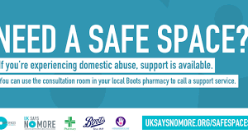

**Recovery Toolkit**

The Recovery Toolkit is a 12-week programme for women who have experienced domestic abuse. It is a closed group programme and therefore participants are expected to attend sessions every week. The programme is based on a psychoeducational model which aims to provide women who have experienced domestic abuse with the resources to maximise their own potential. Women who attend the group have to have left their abusive relationship.

This course is run regularly, please contact us for more information.

**Please contact Johanna Smith by email on** [**johanna.smith@family-action.org.uk**](mailto:johanna.smith@family-action.org.uk) **or by telephone on 07815688469 for more information and when the next programme will begin.**

**Decider Skills**

The Decider Skills is Cognitive Behavioural Therapy to teach children, young people and adults the skills to recognise their own thoughts, feelings and behaviours, enabling them to monitor and manage their own emotions and mental health.

There are 12 skills they will be taught to help manage feelings and emotions with a workbook to make their own as a supportive tool.

**Please contact your local Centre for more information and advice as to start dates for the next sessions.**



**Infant Feeding Group**

Infant feeding Support is a group for those that are breastfeeding, or are thinking about breastfeeding, and also for mothers/carers who are feeding using formula. With the support of a trained Infant Feeding worker parents are offered support and advice both from the Family Action practitioner, and each other.

**Egremont** Thursdays @ 11.30am - 1pm

**Millom** Thursdays @ 11.00am – 12.00noon

**Infant Massage**

Infant Massage is the gentle, rhythmic stroking of your baby's body using your hands. As part of a massage routine, you might gently manipulate your baby's ankles, wrists and fingers. There is widespread belief that infant massage can increase a parent/carer’s awareness of their baby’s needs, supporting an early bond, as well as improving their sense of wellbeing. It can also provide baby with relief from colic and constipation as well as promoting relaxation, and longer sleep.

**South Whitehaven** Dates and times TBC

**Egremont** Dates and times TBC

**Millom** Dates and times TBC

**Great Expectations**

Our new 5 week antenatal group is suitable for all expecting parents. The course will cover the baby brain, birth expectations, safe sleep and routines, infant feeding and attachment and emotional wellbeing. This is a safe, confidential space to make friends and gain support and our facilitator will also be able to answer any questions throughout.

**Egremont** Wednesdays @ 11am-12pm (starting 20th October)

**Millom** Fridays @ 10am-11am (starting 15th October)

**To book places on any of the above sessions please contact:-**

**Egremont – email** [**eleanor.cummings@family-action.org.uk**](mailto:eleanor.cummings@family-action.org.uk) **or telephone 07815688396**

**Millom – email** [**michala.tyson@family-action.org.uk**](mailto:michala.tyson@family-action.org.uk) **or telephone 01229 777592**

**Please note there may be a waiting list for some of the above groups.**



**Let’s Get Talking**

Let’s Get Talking is a six-week programme which supports communication and language development in partnership with the Speech and Language Team.

This group is suitable for children **aged 2 to 4 years** with few or no single words.

**Please contact Christina Thurston by email on:** [**christina.thurston@family-action.org.uk**](mailto:christina.thurston@family-action.org.uk) **or by telephone 07815688314 or email** [**eleanor.cummings@family-action.org.uk**](mailto:eleanor.cummings@family-action.org.uk) **or by telephone 07815688396 for more information on the sessions.**



**Solihull Parenting Course**

The Solihull parenting group is for parents/carers who want to know more about sensitive and effective parenting. It aims to develop a framework of thinking about child/parenting relationships to:

* Promote understanding of children’s behavior within the context of developmental issues
* Promote the development of parent/child reciprocity (being in tune with your child’s needs)
* Increase confidence and self-esteem in both parents/child relationships
* Give parents a strategy for repair when things go wrong
* Develop a framework of thinking about parent/child relationships which can develop into a lifelong skill
* Promote reflective, sensitive and effective parenting

**Please contact Kirsty Treen by email on Kirsty.treen**[**@family-action.org.uk**](mailto:andrea-clarke@family-action.org.uk) **or by telephoning one of the centre’s for more information and when the next programme will begin.**

Family Action Needs YOU!!

Could you be a volunteer with us?

Volunteering has been at the heart of Family Action since we were established in 1869, run solely by volunteers.

As a volunteer you will gain valuable skills and experience working as part of a team making a real difference to the lives of children and young people in your area. With access to a comprehensive learning package, we can help you achieve this with continued support and training.

Looking to gain experience whilst studying or to gain full-time employment? We have lots of flexible options with both short and long-term positions available**.**

**There are lots of ways you can give your time; please contact me to find out more information!!**

**Emma Moorhead, Volunteer & Community Engagement Worker**

**Tel: 01946 64600**

**Mobile: 07815686953**

**Email:** [**emma.moorhead@family-action.org.uk**](mailto:emma.moorhead@family-action.org.uk)



**FamilyLine**

Family Action’s FamilyLine is a **FREE** helpline for all members of the family over the age of 18.. FamilyLine provides support on all aspects of family life, from befriending to counselling services.

Available: Monday – Friday, 9am – 9pm

Contact our helpline by telephone: **0808 802 6666**

Text: **07537 404 282**

Email: [familyline@family-action.org.uk](mailto:familyline@family-action.org.uk)

Visit [www.family-action.org.uk/familyline](http://www.family-action.org.uk/familyline)

**A live chat is also available on our website**



