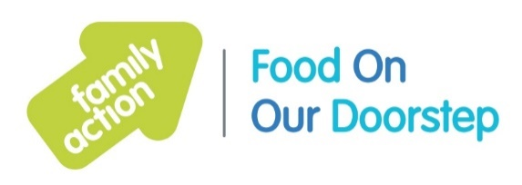

Birmingham Food On Our Doorstep (FOOD) Clubs
Overview of club opening times
Contacts
Marissa: 07816 408755
Becci: 07971 952311
Email: birminghamfoodclubs@familyaction.org.uk
Facebook: @birminghamfoodclubs

As of week commencing 15th November 2021, Birmingham FOOD Club days and times are as follows:

Club | Address | Day | time
Garetts Green | Oasis Academy Blakenhale Infants, Blakenhale Rd B33 0XD | Tuesdays | 12pm – 2pm
Hall Green | Highfield Hall, 127 – 129 Highfield Road, B28 0HS | Tuesday | 3pm – 5pm
Saltley | Saltley Children’s Centre, Ralph Road B8 1NA | Wednesday | 9.30am – 11.00am
Erdington | St Chads Church Centre, Stoneyhurst Rd B24 8HA | Wednesday | 10am – 11.30am
Cobden Hotel | Hagley Rd, Edgbaston | Residents only
Kitts Green | Welcome Change, Kitts Green Road B33 9SL | Wednesday | 12pm – 2pm
Ladywood | Ladywood Children’s Centre, Plough and Harrow Rd B16 8UR | Thursday | 12pm – 2pm
Rubery | Frankley Plus Children’s Centre | Fridays | 12pm – 2.30pm
Acocks Green | Fox Hollies Children’s Centre, Fox Hollies Rd B27 7QA | Fridays | 12pm – 2pm
Falcon Lodge | Falcon Lodge Community Hub, Churchill Rd B75 7LB | Friday | 12pm -2pm

