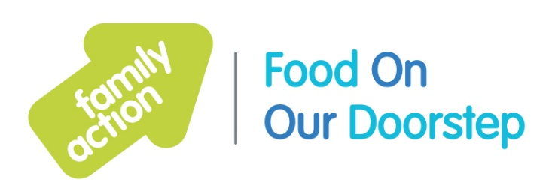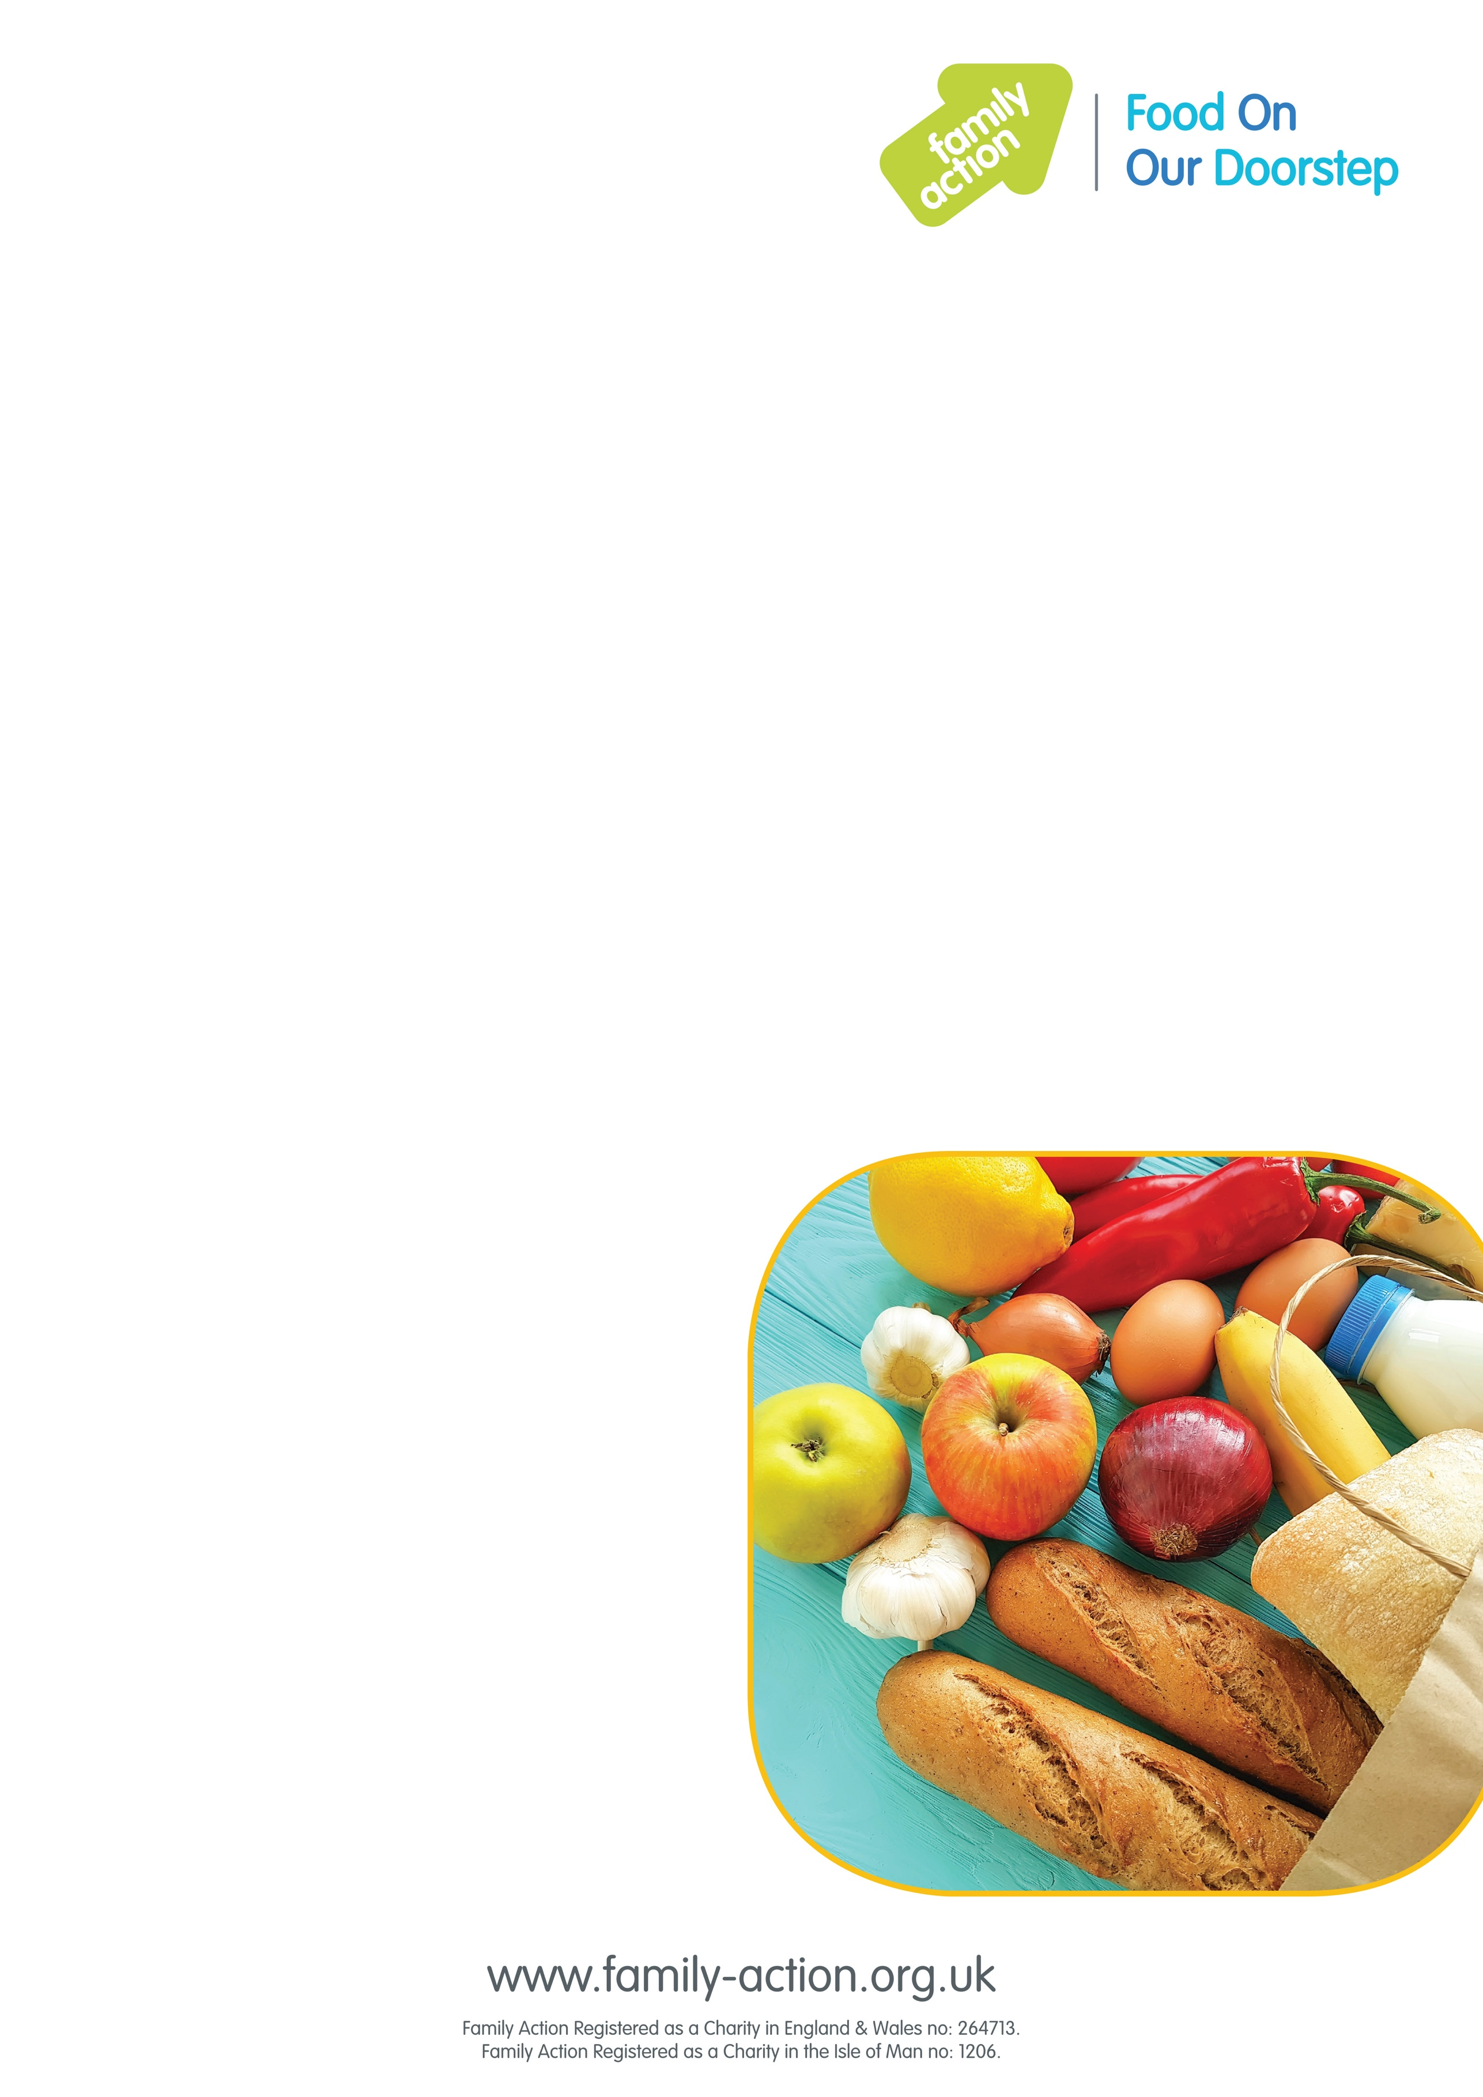

### Where and when

#### Falcon Lodge Community Hub, Churchill Road, Falcon Lodge, Sutton Coldfield, B75 7LB

Time:

#### Friday 1:00pm - 3:00pm

# Birmingham FOOD Club

## Food On Our Doorstep

### Good-quality food at a low price

Family Action has launched FOOD (Food On Our Doorstep) Clubs in Birmingham to provide families with good-quality food at a low cost, while also reducing food waste. It costs just £1 a year for your family to become a member.

Once you’ve joined, you can purchase a bag of tasty food items every week worth approx. £15 for just £3.50!

To become a member you must live or work within 15 minutes of the club.

### To find out more call

#### Marissa: **07816 408755**

#### Becci 07971952311

**Email:** [birminghamfoodclubs@family-action.org.uk](mailto:birminghamfoodclubs@family-action.org.uk)

**Facebook:** @Birminghamfoodclubs